Metal oxides: Worksheet 4.1.3

Atoms and ions
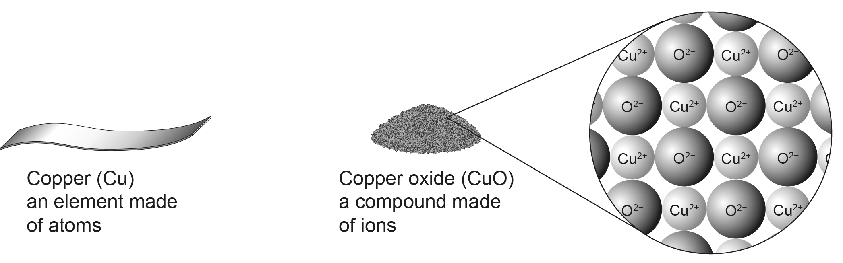
Compounds usually have completely different properties to those of their elements. When metals react to form compounds, their atoms lose electrons and become positively charged ions.

To free a metal from a compound, these ions need to be converted back into atoms. This happens when carbon removes oxygen from copper oxide.
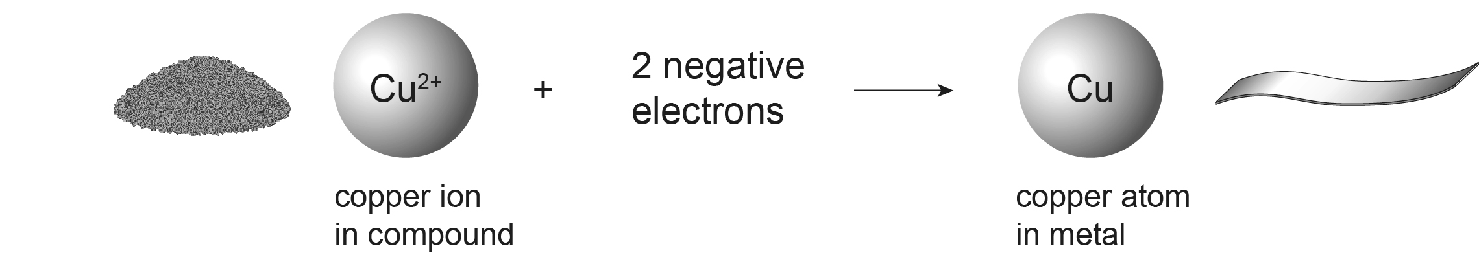

This is reduction – so reduction has two meanings: the loss of oxygen and the gain of electrons.

- The half equation above shows copper ions turning into copper atoms. Is this oxidation or reduction?

- Write a half equation to show what happens to copper atoms when copper burns in oxygen.

- What happens to the electrons that the copper atoms lose?

- Write half equations to show what happens when aluminium atoms are oxidised, and when aluminium ions are reduced.

