Reactivity series: Worksheet 4.2

Comparing metals
1 g of each metal is reacted with an identical volume of acid in this apparatus.
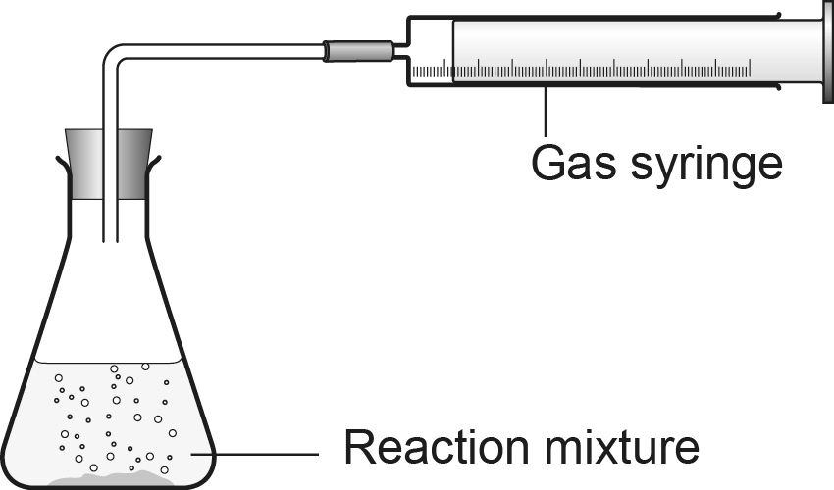

Each metal releases different volumes of hydrogen in the first minute.

Metal used | Volume of hydrogen released in 1 minute (cm³)
 | 1 | 2 | 3 | Mean
Zn | 9 | 15 | 9
Fe | 4 | 5 | 3
Mg | 30 | 31 | 32
Cu | 0 | 0 | 0

- List the dependent, the independent and the control variables in this investigation.

- Calculate the mean result for each metal and put the metals in order of decreasing reactivity.

- Most of these results are repeatable. Identify one that is anomalous and suggest a possible cause.

- Gas syringes are very expensive. Suggest an alternative way of comparing the reactivities of these metals with acids.

