Term 5 Assignment 1
Where I live Total 20 marks

- Unjumble the different places to fill in the Spanish column. Write your answers in the box.

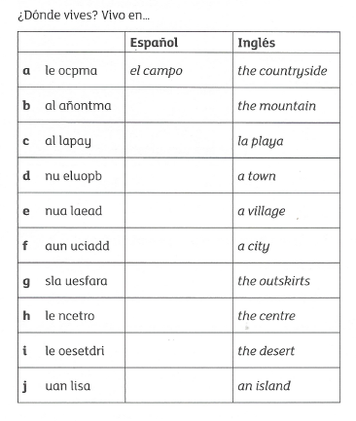
a. el campo
b.
c.
d.
e.
f.
g.
h.
i.
j.
9 marks

- Complete these sentences with the missing words. Delete the dots and type your answers in a different colour.

- I live in a small city. Vivo en una ciudad __________.

- Madrid is an old and beautiful city. Madrid es una ciudad ________ y ________.

- I like Quito because it is big and modern Me gusta Quito porque es ________ y _________.

- Havana is an historic city in Cuba. La Habana es una ________ __________ de Cuba.

- I live on the outskirts of Málaga. Vivo ____ _______ __________ de Málaga.

- I love Seville because it is pretty. Me encanta Sevilla porque es ____________ .

11 marks
Extension task
Find at least 5 facts about one of the places mentioned in today’s lesson (Quito, Madrid, Seville, Havana, Malaga, Santillana del Mar, Barcelona, Logroño)

