Term 5 Assignment 1
Future Holiday Plans
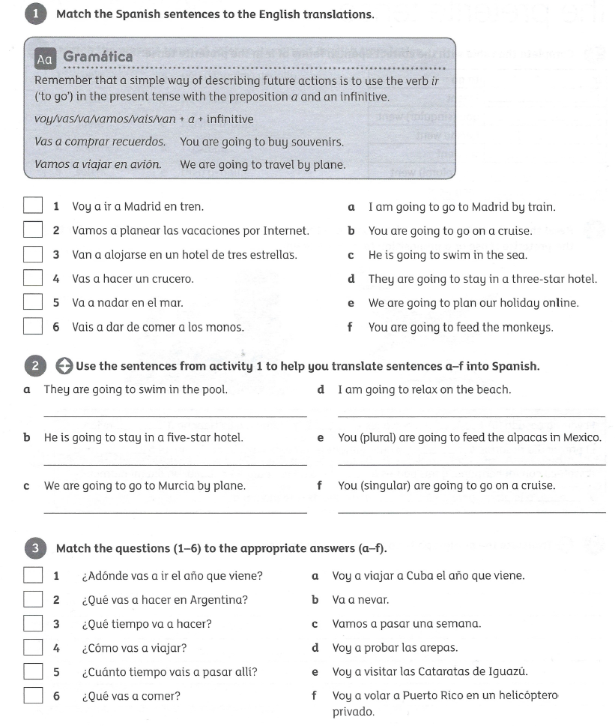
Total 24 marks

Extension task
Translate the text into English
