Term 5 Assignment 1
Future Holiday Plans ANSWERS
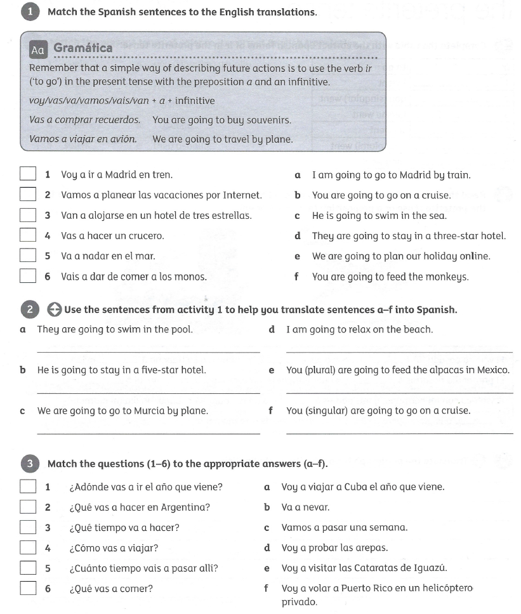
Total 24 marks

Extension task
Translate the text into English
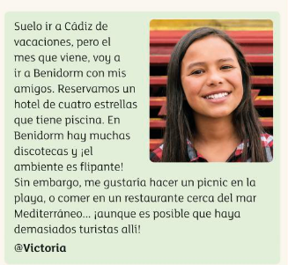
Answers
Question 1 Question 2
1a a. Van a nadar en la piscina
2e b. Va a alojarse en un hotel de cinco estrellas
3d c. Vamos a ir a Murcia en avión.
4b d. Voy a relajarme en la playa.
5c e. Vais a dar de comer a las alpacas en Mexico
6f f. Vas a hacer un crucero.

Question 3
1a
2e
3b
4f
5c
6d

Translation
I usually go to cadiz on holiday, but next month I am going to go to Benidorm with my friends. We have booked a four-star hotel with a pool. In Benidorm there are lots of discos and the atmosphere is amazing! However, I would like to have a picnic on the beach, or eat in a restaurant near the Mediterranean Sea.....although there may be lots of tourists there!

