Idea Development- Year 10

Task:

Use the 3 images below you will need to complete 2 more pages of Idea development. This can be a double page or two singles!

You will need to use your high-level sheet as guidance for presentation and skill. You will also need to use 3 mediums within the work!

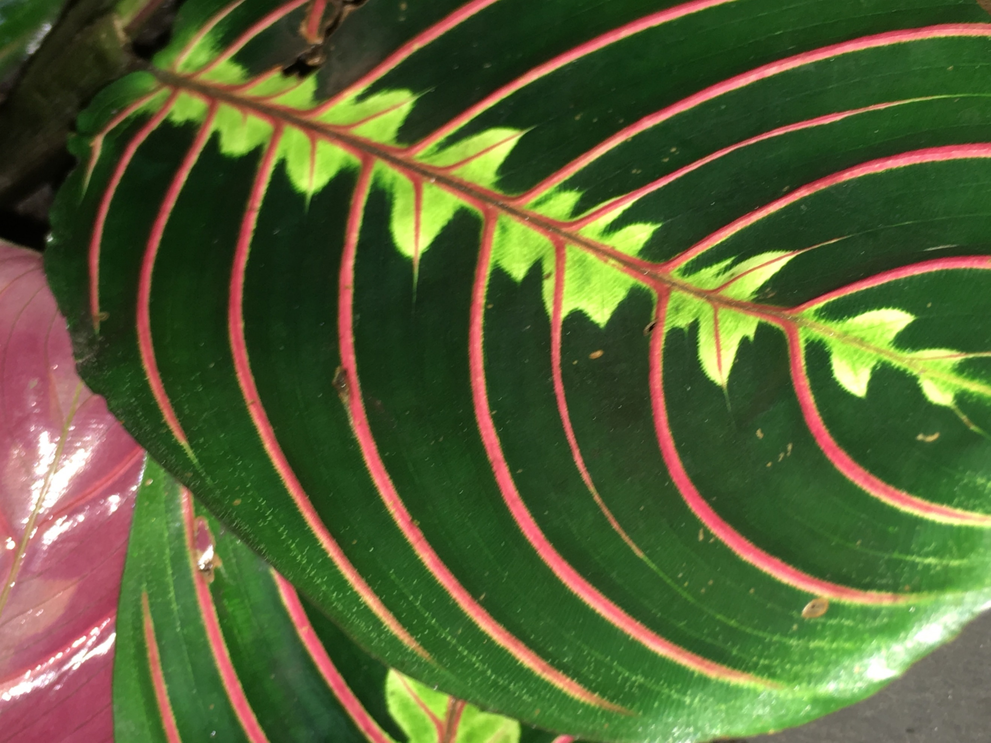
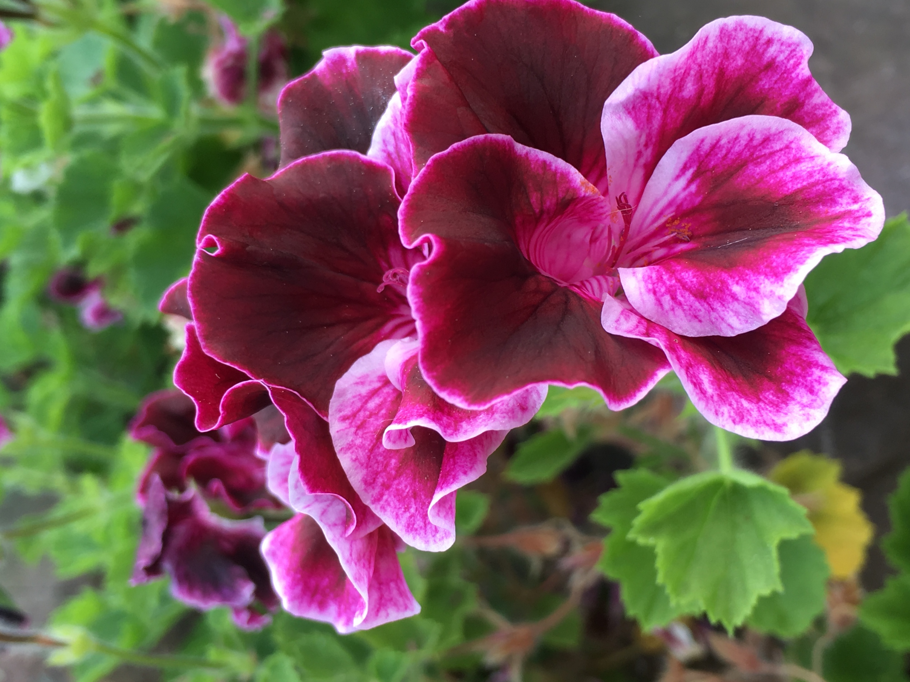
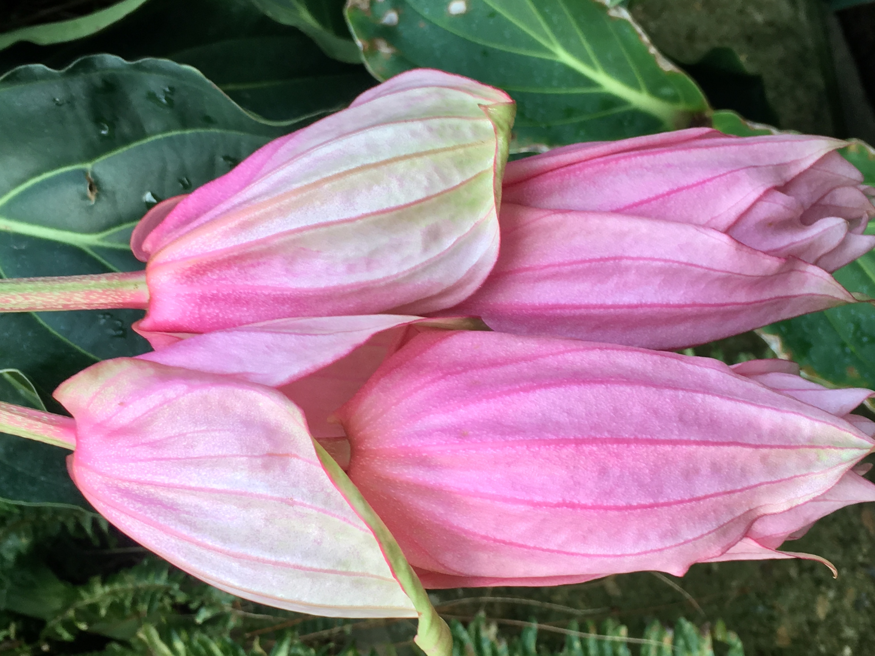
Please make sure you add annotation and the images provided.

