Questions
Q1.
Cholesterol is often measured as part of a health check
Which one of the following is a correct statement about cholesterol?
(1)
A An increase in fat intake will only increase HDL (high density lipoprotein) levels.
B Regular aerobic activity has no effect on cholesterol levels.
C Correct diet can improve cholesterol levels.
D High levels of LDL (low density lipoprotein) are preferable to high levels of HDL (high density lipoprotein).

Q2.
Which one of the following performers relies most heavily on a high level of cardiovascular fitness for success?
(1)
A 200m runner
B 400m runner
C 800m runner
D 1500m runner

Q3.
Tai and Aran both play hockey. Cardiovascular fitness and flexibility are two components of health-related exercise that are needed when playing hockey.
(i) Briefly explain why Tai and Aran need high levels of cardiovascular fitness and flexibility to perform well in their sport.

1 Cardiovascular fitness
(2)
.............................................................................................................................................
.............................................................................................................................................
.............................................................................................................................................
.............................................................................................................................................
2 Flexibility
(2)
.............................................................................................................................................
.............................................................................................................................................
.............................................................................................................................................
.............................................................................................................................................
(ii) Identify another component of health-related exercise that is required when playing hockey.
(1)
.............................................................................................................................................

Q4.
Components of fitness help us to perform well in sport.
Complete Table 4 by:
(a) Stating the component of fitness being described.
(b) Giving a specific example of how the component of fitness is used in a sport of your choice.
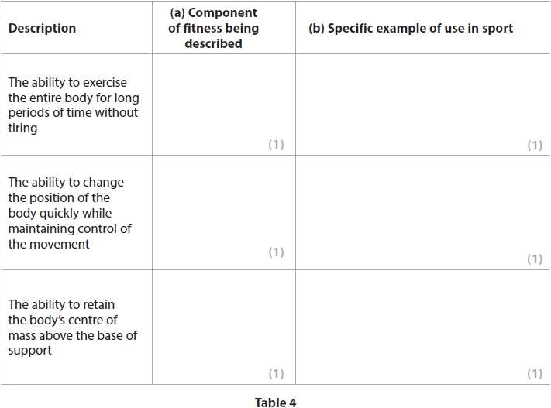

(Total for question = 6 marks)

Q5.
Games players, such as the rugby and netball players shown in Figure 1 and Figure 2, require good levels of agility and balance to be successful in their sports.
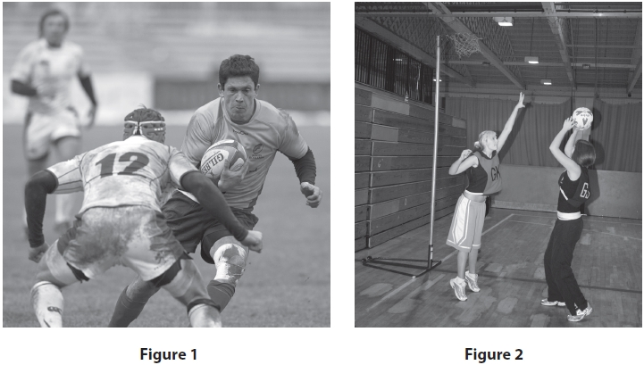
Explain the importance of two components of skill-related fitness other than agility and balance for any games player.
Name of component of skill-related fitness 1
.............................................................................................................................................
Explanation
(2)
.............................................................................................................................................
.............................................................................................................................................
.............................................................................................................................................
.............................................................................................................................................
Name of component of skill-related fitness 2
.............................................................................................................................................
Explanation
(2)
.............................................................................................................................................
.............................................................................................................................................
.............................................................................................................................................
.............................................................................................................................................
Q6.
Health and fitness can be affected by exercise.
(a) Define the terms health and fitness.
(i) Health
(1)
.............................................................................................................................................
.............................................................................................................................................
.............................................................................................................................................
.............................................................................................................................................
.............................................................................................................................................
.............................................................................................................................................
(ii) Fitness
(1)
.............................................................................................................................................
.............................................................................................................................................
.............................................................................................................................................
.............................................................................................................................................
.............................................................................................................................................
(b) State, using an example, how exercise can affect health and fitness.
(2)
(i) Effect of exercise on health
.............................................................................................................................................
.............................................................................................................................................
.............................................................................................................................................
.............................................................................................................................................
.............................................................................................................................................
.............................................................................................................................................
(ii) Effect of exercise on fitness
(2)
.............................................................................................................................................
.............................................................................................................................................
.............................................................................................................................................
.............................................................................................................................................
.............................................................................................................................................
(Total for question = 6 marks)

Q7.
(a) Define the term agility.
(1)
.............................................................................................................................................
.............................................................................................................................................
(b) Give one example of when a basketball player would use agility in a game.
(1)
.............................................................................................................................................
.............................................................................................................................................
.............................................................................................................................................
.............................................................................................................................................

(Total for question = 2 marks)

Q8.
Different activities have different fitness requirements.
Complete Table 1 by:
(a) Identifying the component of fitness most useful to the stated performer.
(2)
(b) Stating the advantage of this component of fitness for performance.
(2)
Table 1
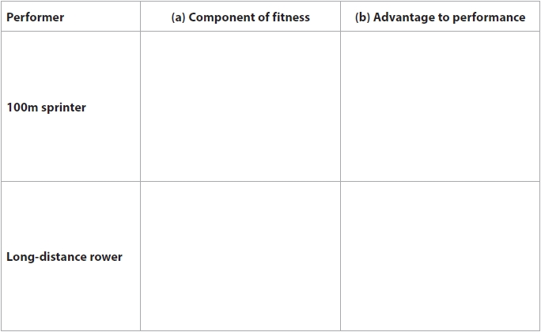

(Total for question = 4 marks)

Q9.
Figure 3 shows a gymnast during her routine on the balance beam.
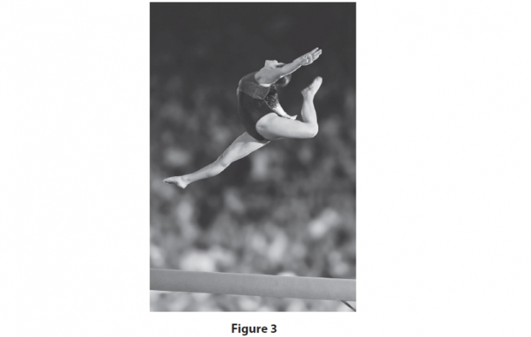
Briefly explain how the gymnast has used power and coordination to achieve the position shown in Figure 3.
(i) Power
(2)
.............................................................................................................................................
.............................................................................................................................................
.............................................................................................................................................
.............................................................................................................................................
(ii) Coordination
(2)
.............................................................................................................................................
.............................................................................................................................................
.............................................................................................................................................
.............................................................................................................................................

Q10.
Muscular endurance and body composition are components of fitness.
Assess the relative importance of each of these components of fitness to a 100 m sprinter.
(3)
(i) Muscular endurance
.............................................................................................................................................
.............................................................................................................................................
.............................................................................................................................................
.............................................................................................................................................
.............................................................................................................................................
.............................................................................................................................................
(ii) Body composition
(3)
.............................................................................................................................................
.............................................................................................................................................
.............................................................................................................................................
.............................................................................................................................................
.............................................................................................................................................
.............................................................................................................................................

(Total for question = 6 marks)

Mark Scheme
Q1.
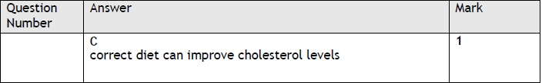

Q2.
 | Answer | Mark
 | D  1500 m runner | 1

Q3.
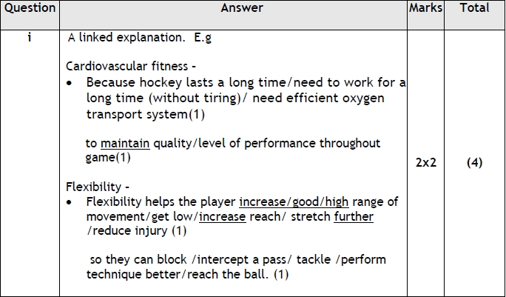
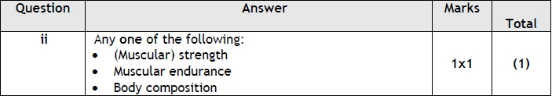

Q4.
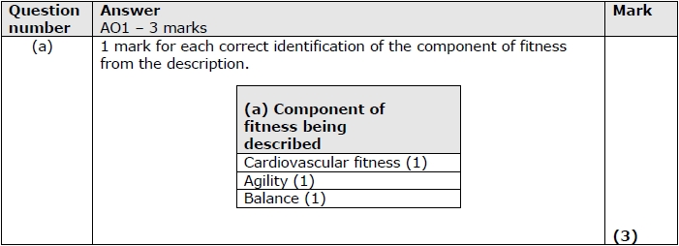
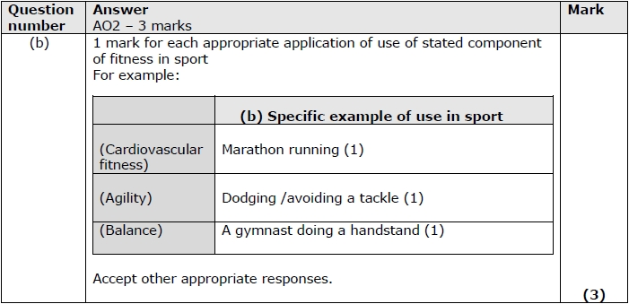

Q5.
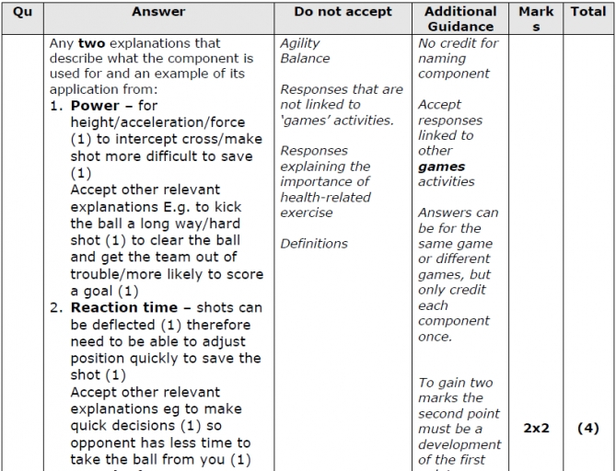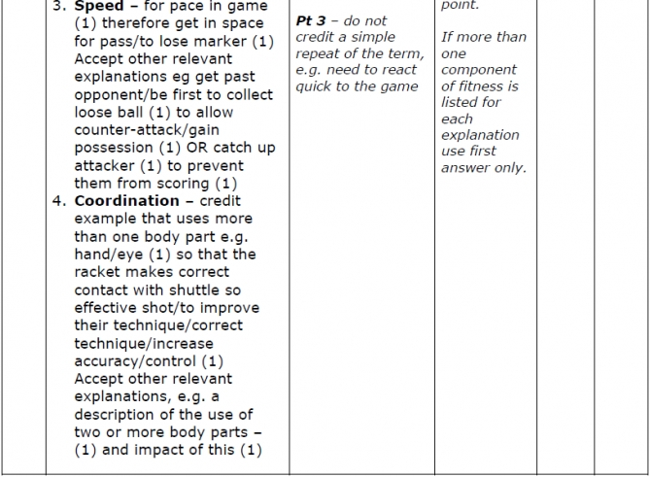

Q6.
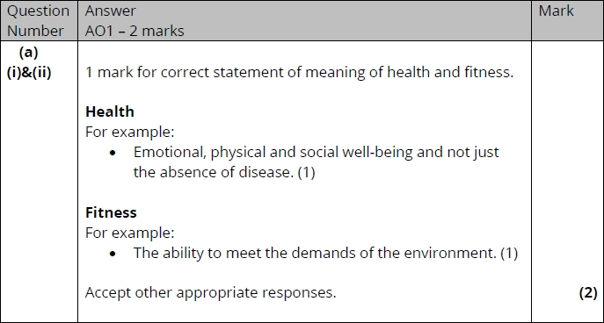
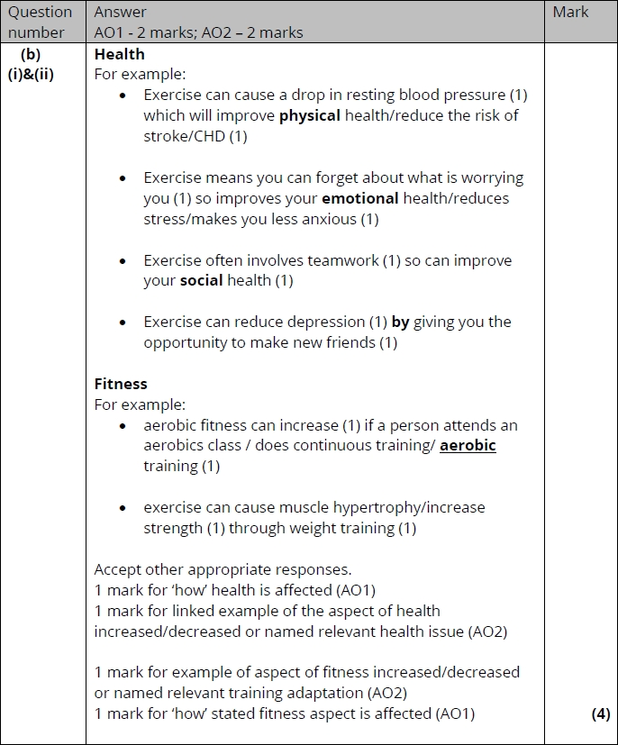

Q7.
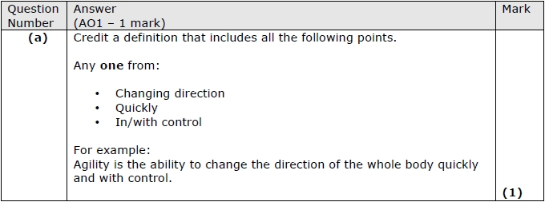
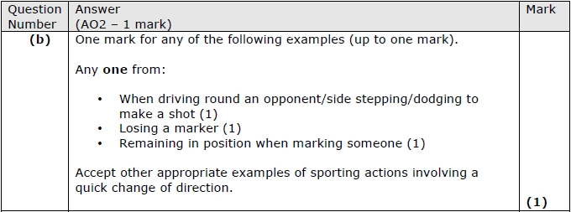

Q8.
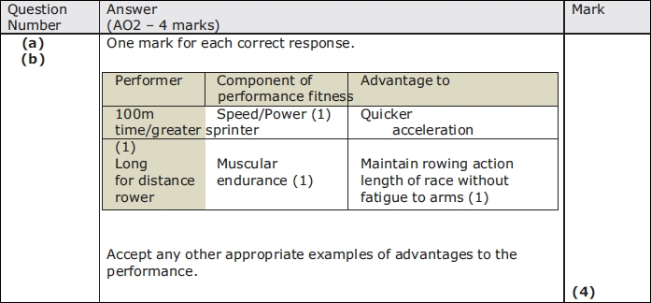

Q9.
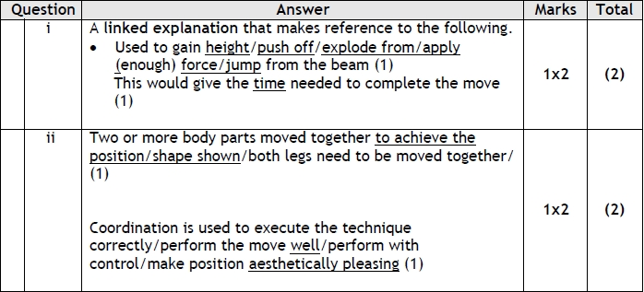

Q10.
