Creative Task: Family Still Image Challenge
Be inspired by this family that use whatever they have laying around the house to recreate moments from some of their favourite films!
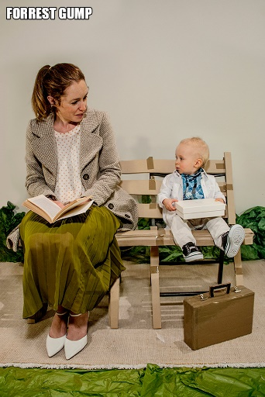
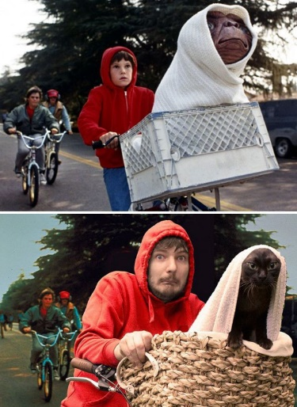
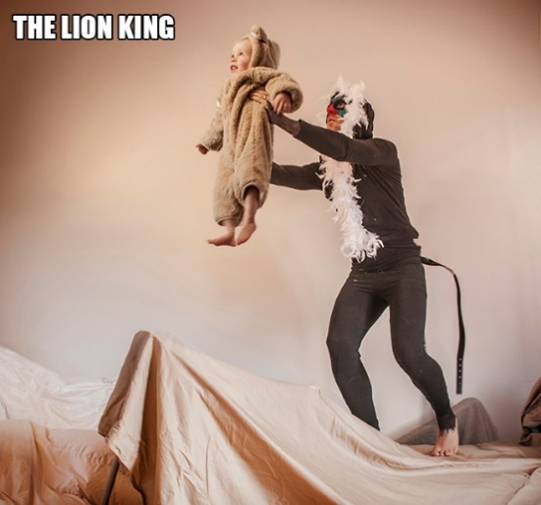

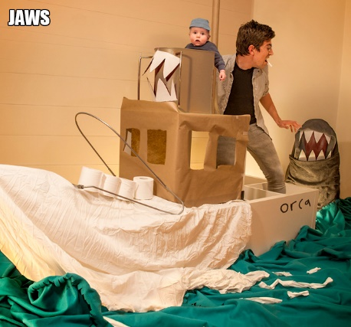
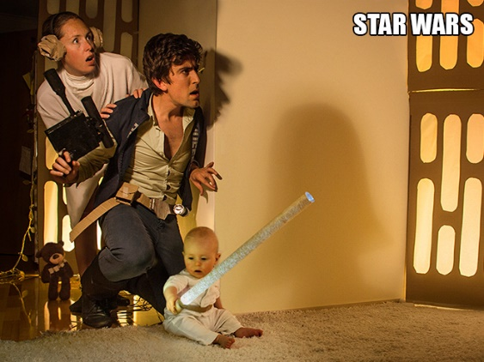

The Challenge:
Create a ‘Guess the Movie’ quiz sheet by recreating 5 -10 images from different movies and taking a photo of the image (photos on a mobile phone will be fine!).
To create the image be as imaginative as possible:
- Dress up – try to recreate the look with anything you can find!
- Make/ create props – use that left over Amazon Box to create the prow of the Titanic!
- Use as many family members as possible – the more the merrier
- Concentrate on the body language and facial expressions
- Most importantly – Have Fun!
When you have created your quiz sheet you can submit it by Email to Miss Harrington (please provide answers too!)– The best quizzes/ images will be displayed on our school social media feeds with your consent- so let me know when you send them if you don’t mind them being shared!

