ROLL AND WRITE A SCRIPT

Creating Task

**Roll a dice and use the instructions below to find out the Given Circumstances! (If you don’t have a dice ask a volunteer to pick a number from 1 to 6)**

Remember that your script must include a description of your setting at the start, character names in the margin and stage directions in brackets or italics.

**Protagonist/s (The main character/s in your script):**

 Students

 A Magician

 An Inventor

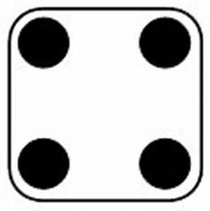 Explorers

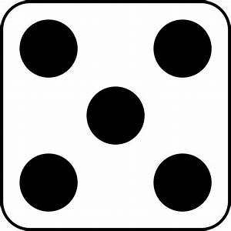 A Detective

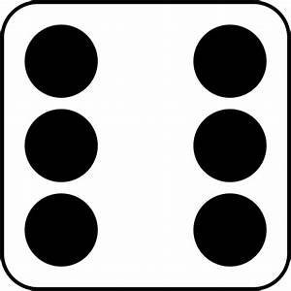 A Ghost

**Antagonist (A character who is against your Protagonist):**

 A pirate

 A Teacher

 A Criminal Mastermind

 An Alien

 A Ghost

 A Scientist

**Setting/location:**

 An old deserted Mansion

 The Jungle

 A Museum

 A Ship

 A Cave

 A School

**Important Object:**

 A Ring

 A Book

 A Painting

 A Goblet

 A Toothbrush

 An Apple

A line of dialogue that must appear in your script:

 Nooooooooooo!

 I am not sure we should be doing this.

 Look out!

 There is no escape now.

 Quick run!

 Oops.

**A drama technique that you must include:**

 Freeze Frame

 Speaking in Unison

 Slow Motion

 Flashback

 A Dramatic Pause.

 A Song.