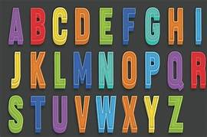
Creating Task
Alphabet Script
Write a scene for two actors using the Alphabet as a stimulus.
Write the full Alphabet in the left hand margin. E.G.
A
B
C
D
Think carefully about your Given Circumstances:
- Who you are
- Where you are
- What you are doing
- Why you are doing it
- How you are doing it
Then use the alphabet this fill in the line for each letter e.g.
- Are you going to walk the dogs?
- But it is raining I will get soaked.
- Can’t you wear a coat?
- Dogs don’t like walking in the rain.

Once you have written your dialogue don’t forget to add appropriate stage directions.

