Read and summarise into your own Mind-Map. You have 30 minutes and then you must me a picture of it.

Lighting is a very technical area and there are many types of lights (or lanterns). Coloured gels can be added to the front of some lanterns so that they throw coloured light onto the stage. Some can also be fitted with what is known as a gobo. This is a sheet inserted on a frame at the front of the light with a design cut into it. It filters the light, creating a picture effect on the stage. For example, a gobo could be used to create a dappled lighting effect to look like the leaves of a forest or could be cut to create strips of light onstage which look like the bars of a prison.

Spot - has a hard-edged effect, used to light characters or elements on the stage. Coloured filters can be used with this lamp.

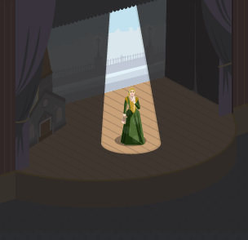

Fresnel - used for a softer edged effect, with a diffusing lens in front of the lamp. It's useful for good overall light when used with others. Coloured filters can be used with this lamp.

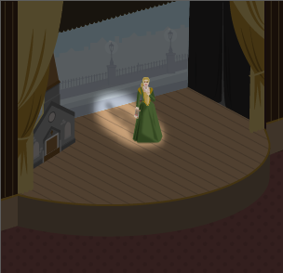

Flood - produces a clear wide-angled light, but there’s little control over the spread of the light. Coloured filters can be used with this lamp.

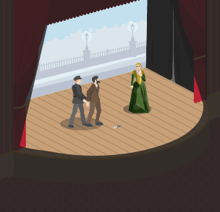

Strobe - a flashing light, used for special effects. It’s often used to give the effect of old movies. It produces a jerky effect on the movements of actors when used on its own.

Staging:

There are many different types of staging, each presenting unique challenges and opportunities when creating a performance:
- proscenium arch
- end-on
- in the round
- traverse
- thrust
- promenade

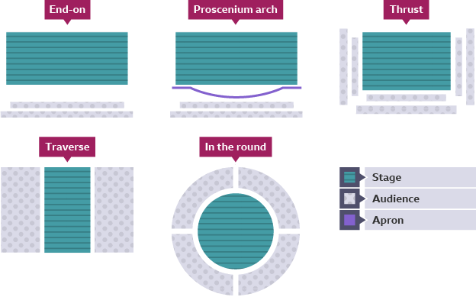

When staging a play, directors, performers and designers have to make creative and practical decisions suitable for the staging configuration to provide the audience with the best possible experience.

Proscenium arch and end-on

Proscenium arch
A proscenium arch describes the frame that surrounds a stage space, separating the audience from the stage. This helps to create a fourth wall, which is particularly appropriate for naturalistic productions.
In a proscenium arch theatre, the audience all sit facing the same way. The stage is often raised and the audience usually sit in raked seating, meaning that drapes and large pieces of scenery can be used without obstructing sightlines. The blocking is relatively easy as the audience sit in one fixed position.
A disadvantage is that the audience can be quite far from the stage, making it difficult for them to see and hear the performers and be as immersed in the action.
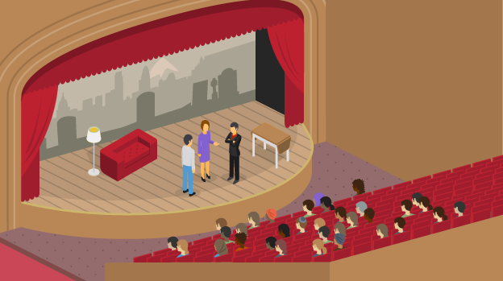

End-on
End-on staging is very similar to proscenium arch, but without the arch frame around the stage space. Many black box studios are set up with end-on staging, meaning that the stage space is on one side of the room and the audience sit on the opposite side. As with proscenium arch staging, blocking is usually simple as the audience all face the same direction and sit in a fixed position.
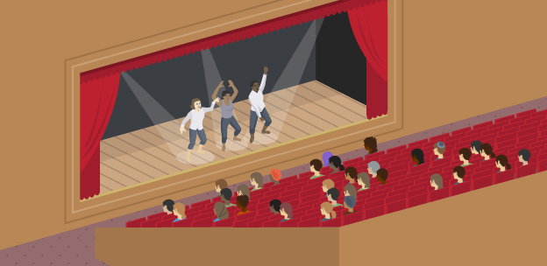

In the round and traverse

In the round
When using in the round staging, the audience sit around the stage on all sides, and the performers enter and exit through the audience on walkways. In the round staging can provide an intimate atmosphere and fully immerse the audience in the play.
When performing in the round, performers need to move and change their positions frequently so that all audience members remain engaged and don’t look at a performer’s back for too long. In terms of design, set pieces cannot be too high or they will obstruct sightlines, and lighting can be challenging. Lanterns need to be positioned carefully so that they don’t shine into the audience’s eyes.
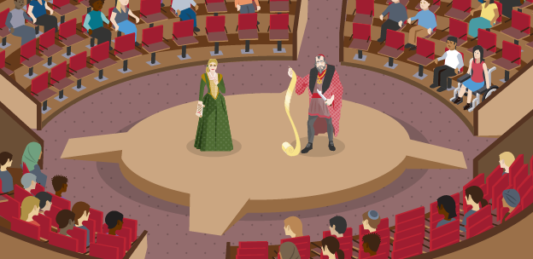

Traverse
A traverse stage is long and narrow with the audience sitting on either side, like a catwalk. As with theatre in the round, the audience can see each other, which helps to remind them that they are at the theatre and immerse them in the action on stage. However, it also means that scenery must be low so that it doesn’t cause obstruction, so backdrops cannot be used.
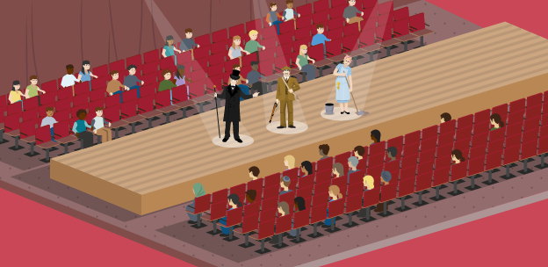

Thrust and promenade

Thrust
A thrust stage sticks out into the audience, who sit on three sides. Like proscenium arch and end-on staging, there is a back wall that can be used for hanging backdrops and large scenery. Blocking is easier than in the round and traverse staging as there is a back wall, so performers don’t have to worry about having their back to the audience.
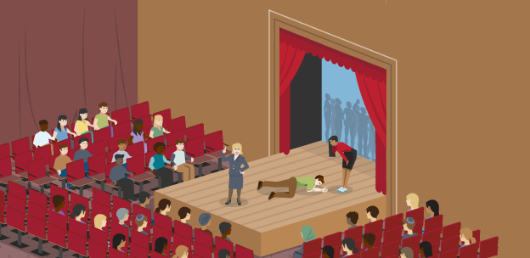

Promenade
In a promenade performance, the audience move to follow the performers around the space. Performances are often site-specific in interesting and unusual locations, even outdoors, rather than in purpose-built theatre spaces.
As the audience shares the space with the performers, performances can be unpredictable and as such, blocking can be particularly challenging. Audiences can tire when following performers, and there is an increased risk of slips, trips and falls. Theatre makers need to be aware of health and safety considerations when staging promenade performances, to prevent accidents.
