Year 7

SPANISH HOME STUDY BOOKLET

PACK 2

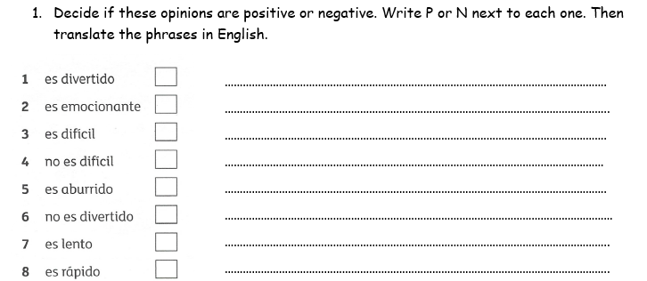

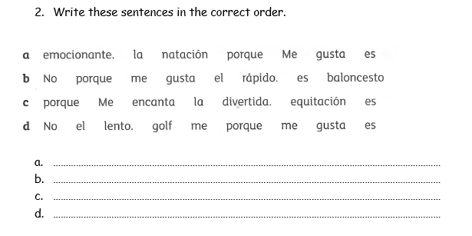

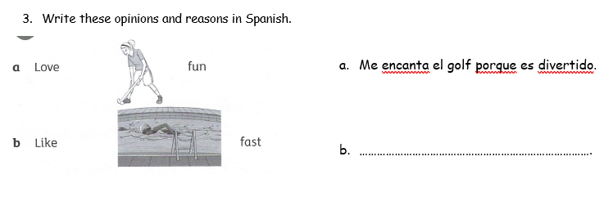



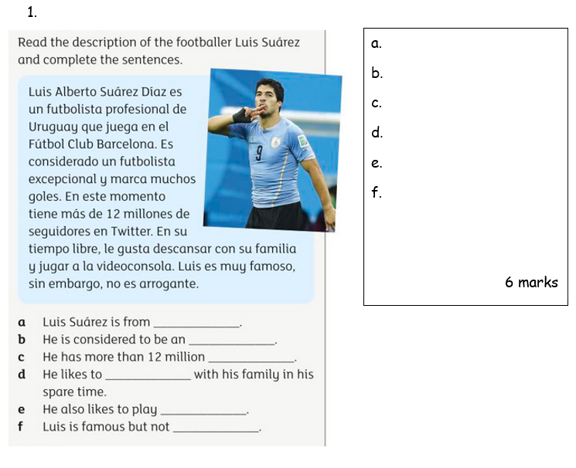

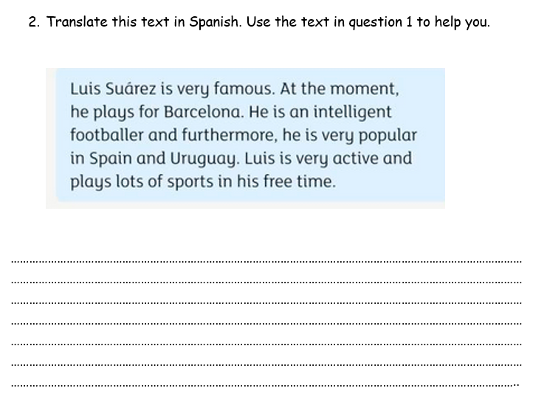

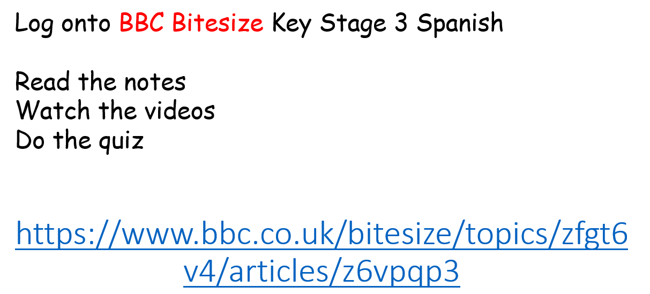

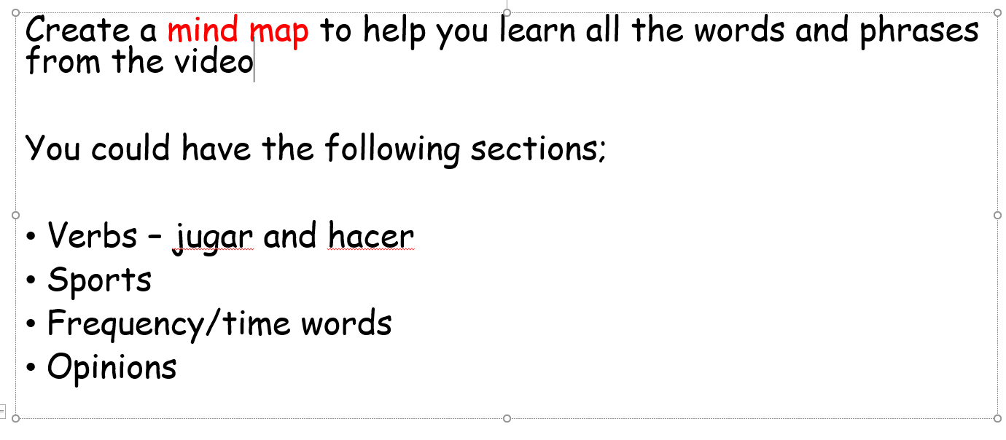

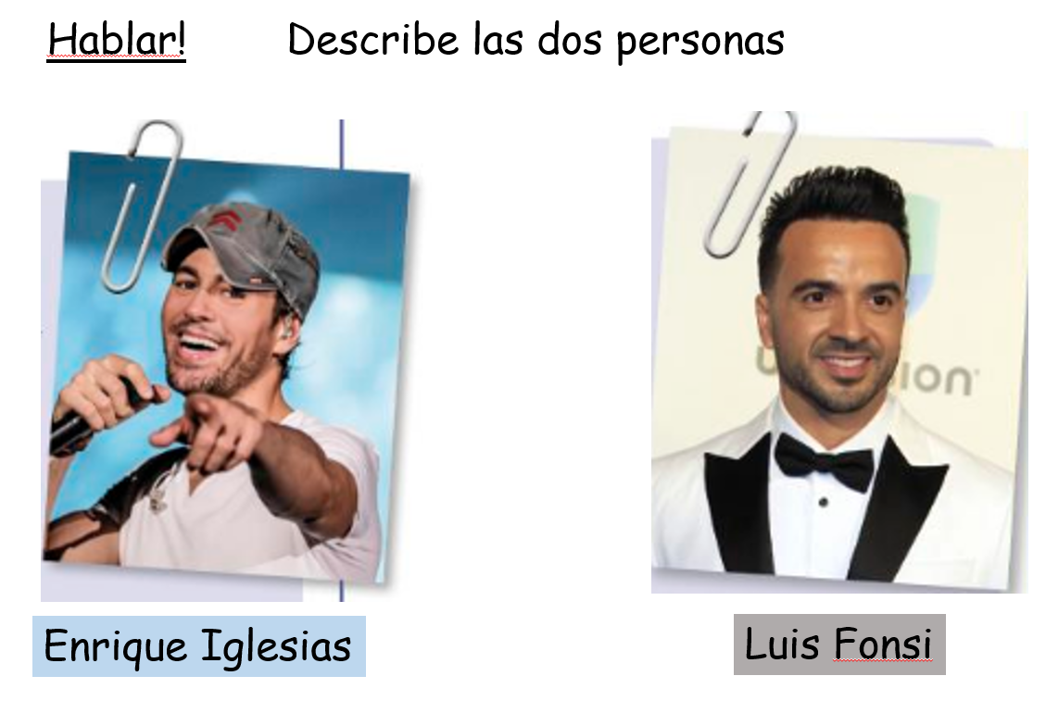

Eg. Se llama… Tiene los ojos… y el pelo …..

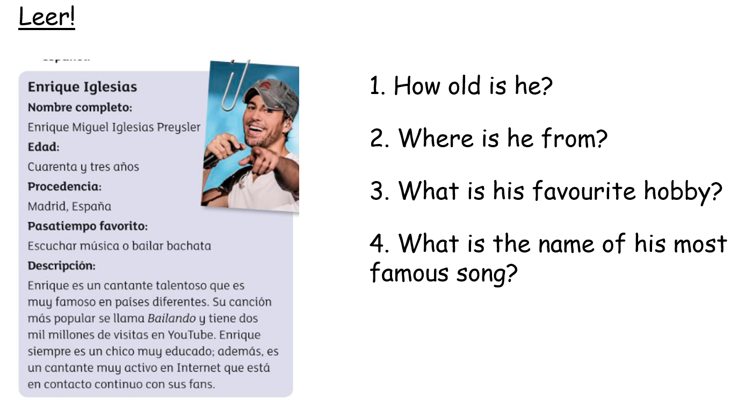

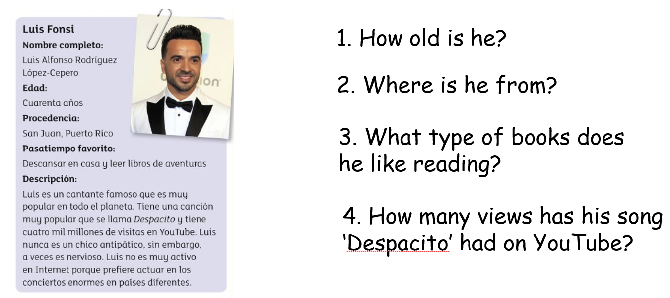

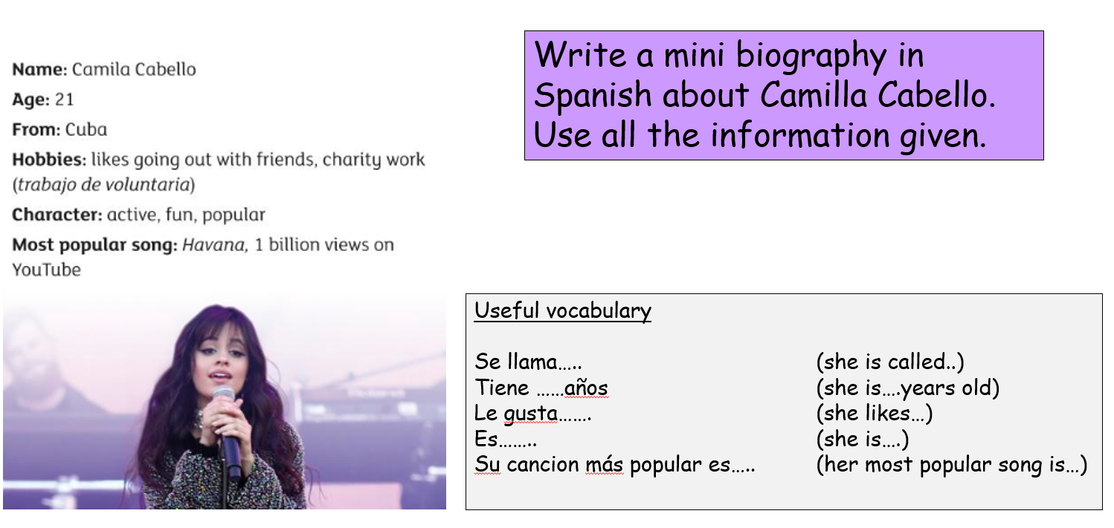

Research a famous Spanish speaking musician and create a fact file about them in Spanish.

Include as many details as you can (age, family, physical appearance, hobbies, most famous song, achievements.

Use your own words – not Google Translate!!!!!!

Email to me either as Word document or Powerpoint