Year 8

SPANISH HOME STUDY BOOKLET

PACK 2

The past tense (1)

LO: to identify and use the preterite (past) tense with regular verbs when describing a past holiday

The preterite (past tense) is used to describe actions completed at a fixed point in time or during a specific period in the past.

* Carlos bought a CD
* María ate a hamburger
* On Friday Jorge went to the swimming pool

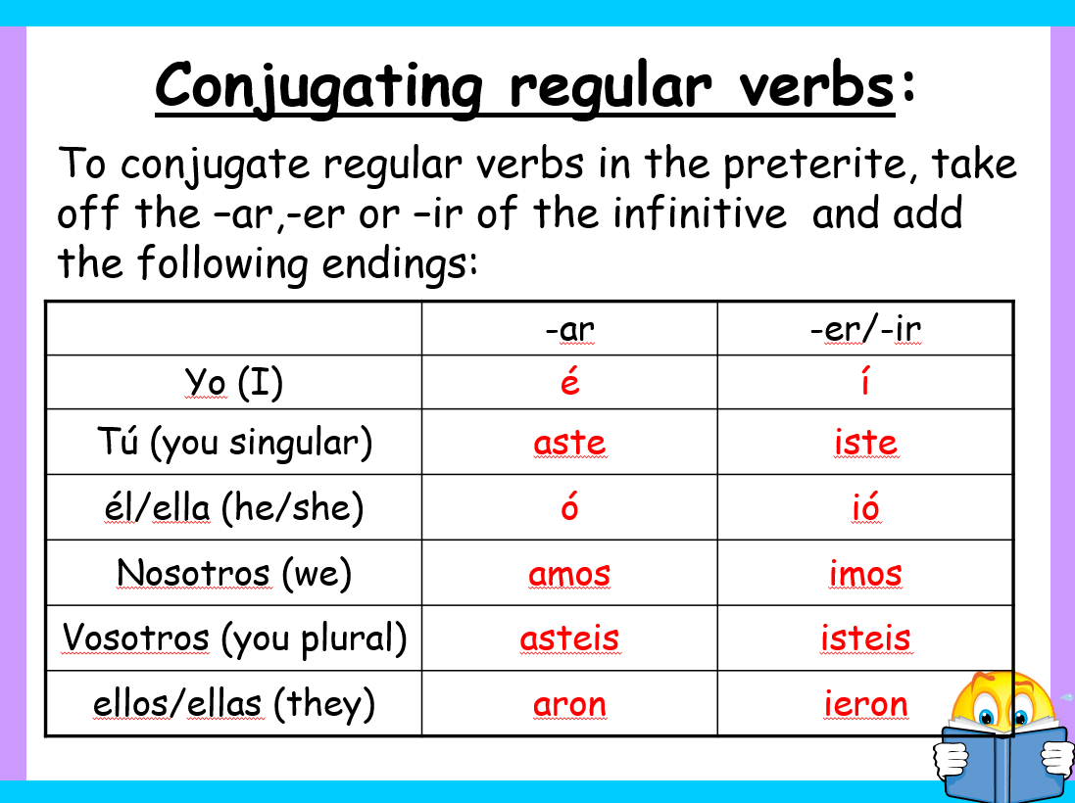

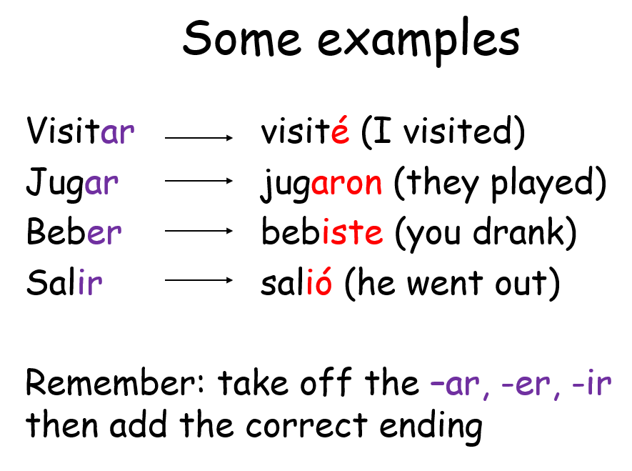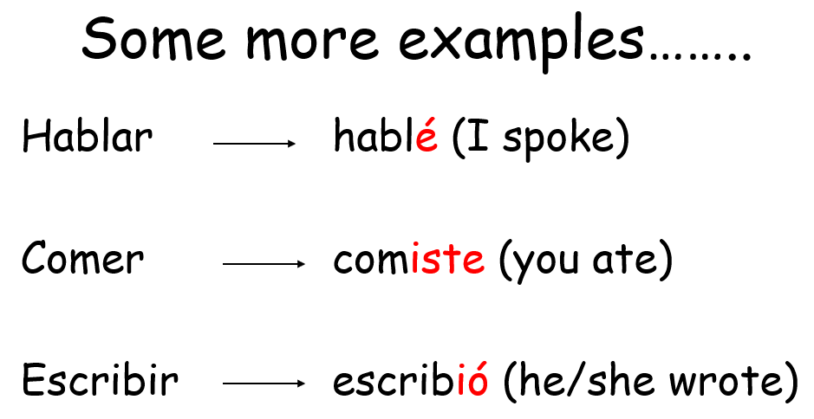

Traduce *Translate these sentences (They are all in the ‘I’ form)*

1. Nadé en la piscina. eg. I swam in the pool

2. Jugué al badminton.

3. Me alojé en un apartamento.

4. Bailé en la discoteca.

5. Salí con mis amigos.

6. Compré regalos para mi abuela.

7. Visité los monumentos.

8. Bebí coca cola.

Now try these….. (the subject or person changes in these sentences)

1. Mi hermana nadió en el mar.

2. Mis amigos y yo sacamos fotos.

3. Mis abuelos vistaron la cathedral.

4. Mi padre compró una hamburguesa.

5. ¿Jugaste al tenis en el hotel?

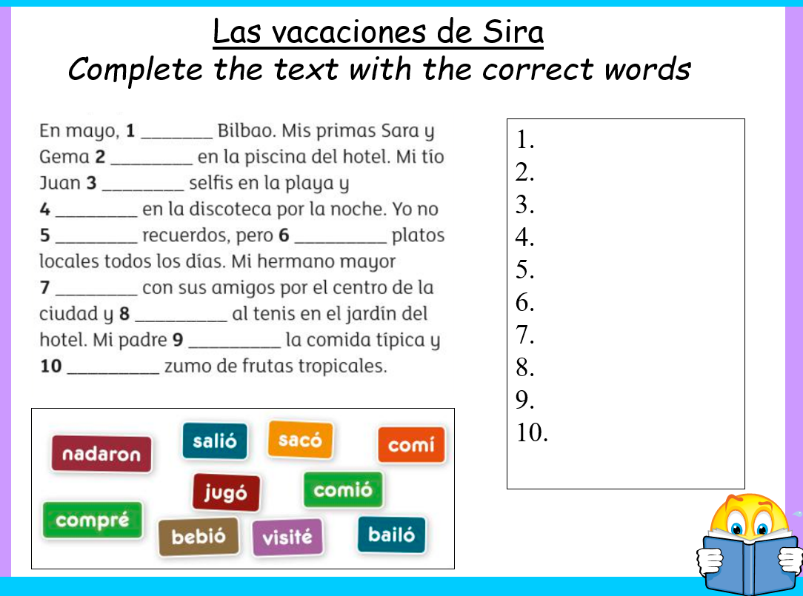

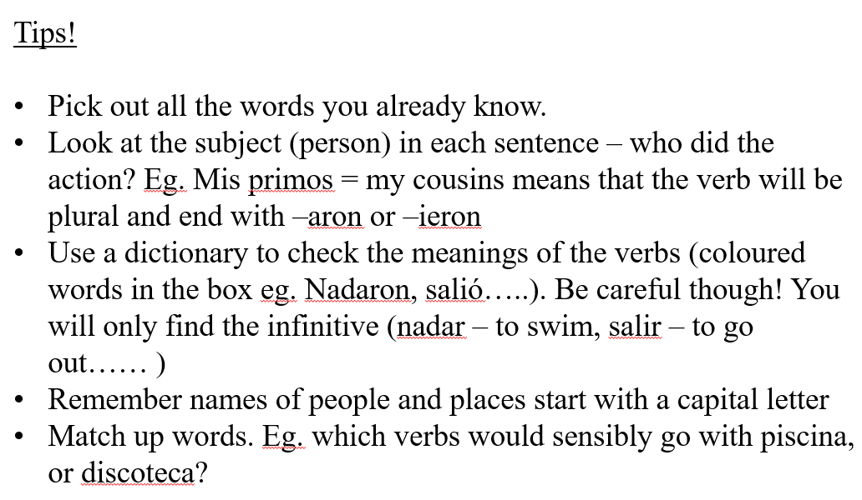

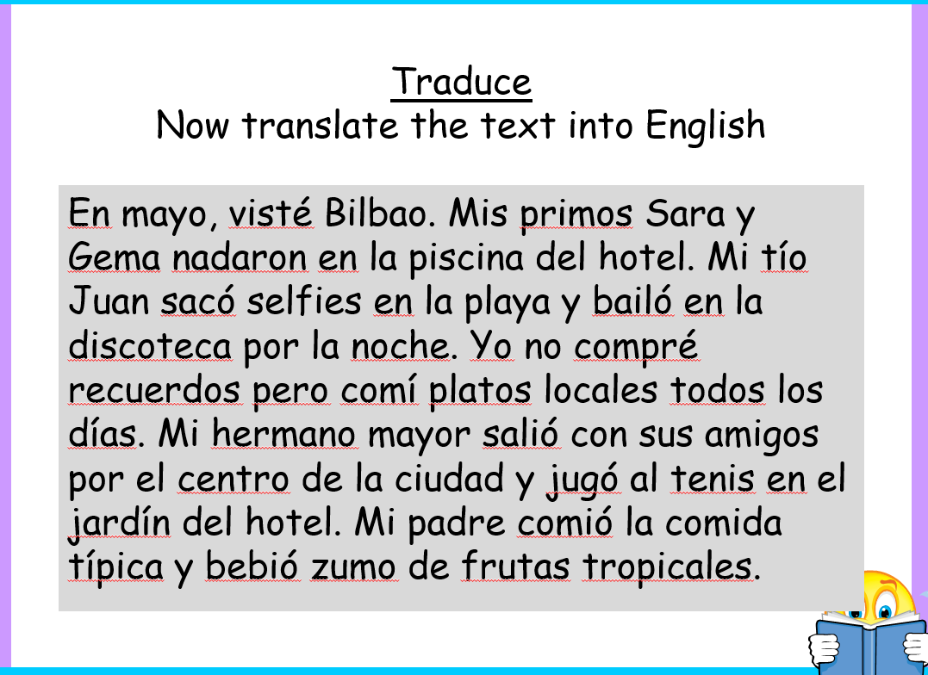

………………………………………………………………………………………………………………………………………………………………………………………………………………………………………………………………………………………………………………………………………………………………………………………………………………………………………………………………………………………………………………………………………………………………………………………………………………………………………………………………………………………………………………………………………………………………………………………………………………………………………………………………………………………………………………………………

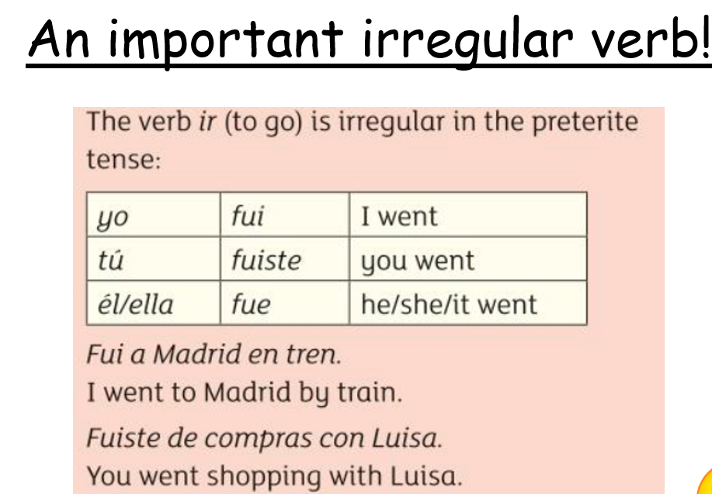

Las vacaciones de Josué Read and answer the questions in English

* El verano pasado fui a Mahón, una ciudad al este de la isla de Menorca en España.
* Me alojé en un camping con mi padre y mi hermana.
* Nadé en el mar y visité el museo de arte balear. Después, mi hermana y yo recogimos conchas en la playa.
* El camping tiene piscina, pista de tenis y barbacoa.
* ¡La gastronomía es excelente! Comí queso de Mahón y probe la coca, un dulce tradicional.
* Vimos un partido de fútbol muy emocionante.

1. When did Josué go on holiday to Mahón?
2. Where exactly is Mahón located on the island of Menorca?
3. What activity did Josué do with his sister?
4. Name three facilities at the campsite.
5. How does Josué describe the football match?

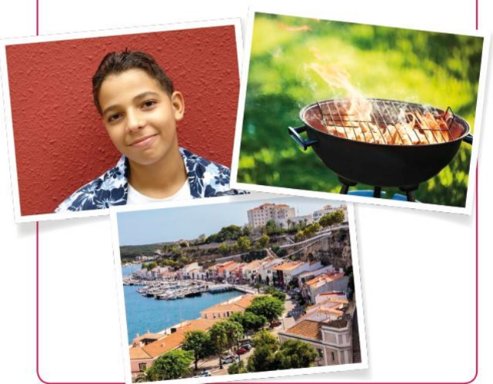

¿Que hay en la foto? Write 5 sentences in Spanish.

1.

2.

3.

4.

5.

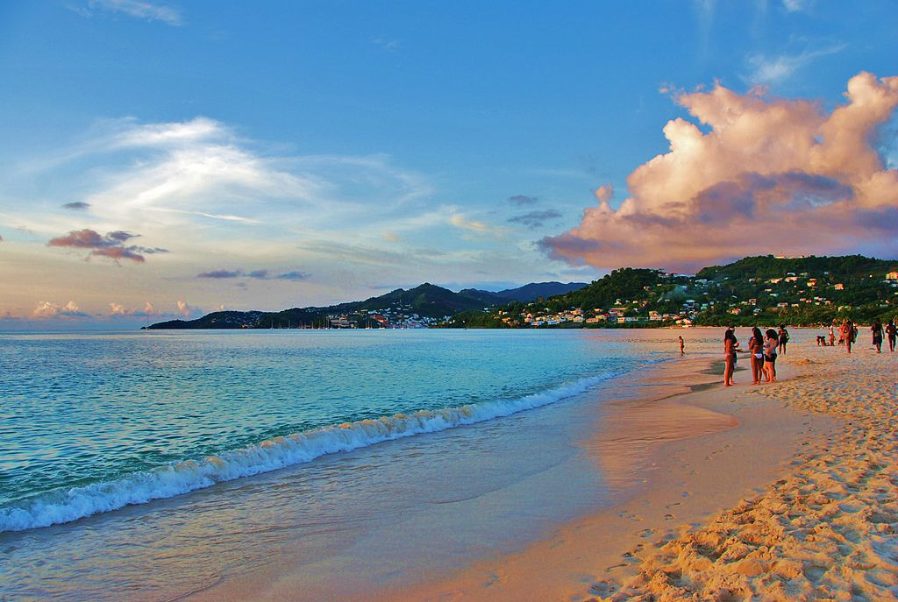

Irregular verbs

Tener to have

Tuve I had

Tuviste you (sing) had

Tuvo he/she had

Tuvimos we had

Tuvisteis you (plural) had

Tuvieron they had

Hacer to do

Hice I did

Hiciste you (sing) did

Hizo he/she did

Hicimos we did

Hicisteis you (plural) did

Hicieron they did

Ir to go

Fui I went

Fuiste you (sing) went

Fue he/she went

Fuimos we went

Fuisteis you (plural) went

Fueron they went

Unjumble the words in bold to make the preterite form of the verb ‘ir’

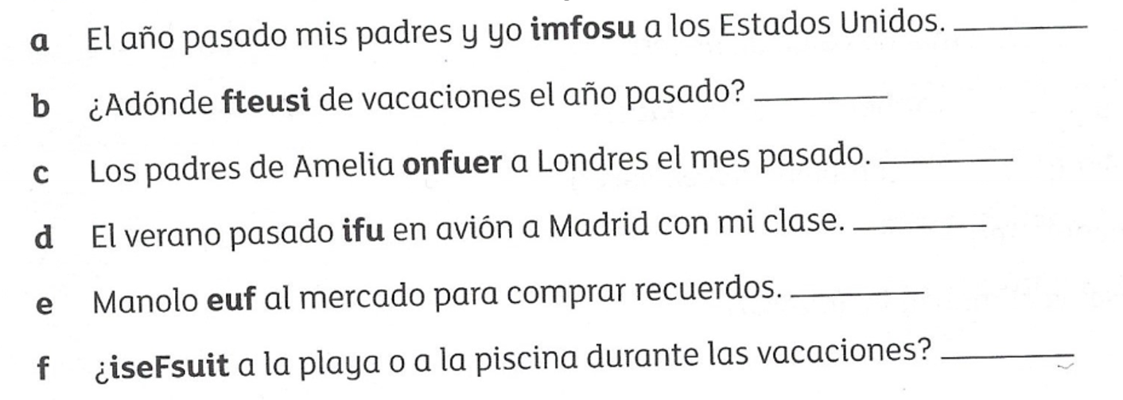

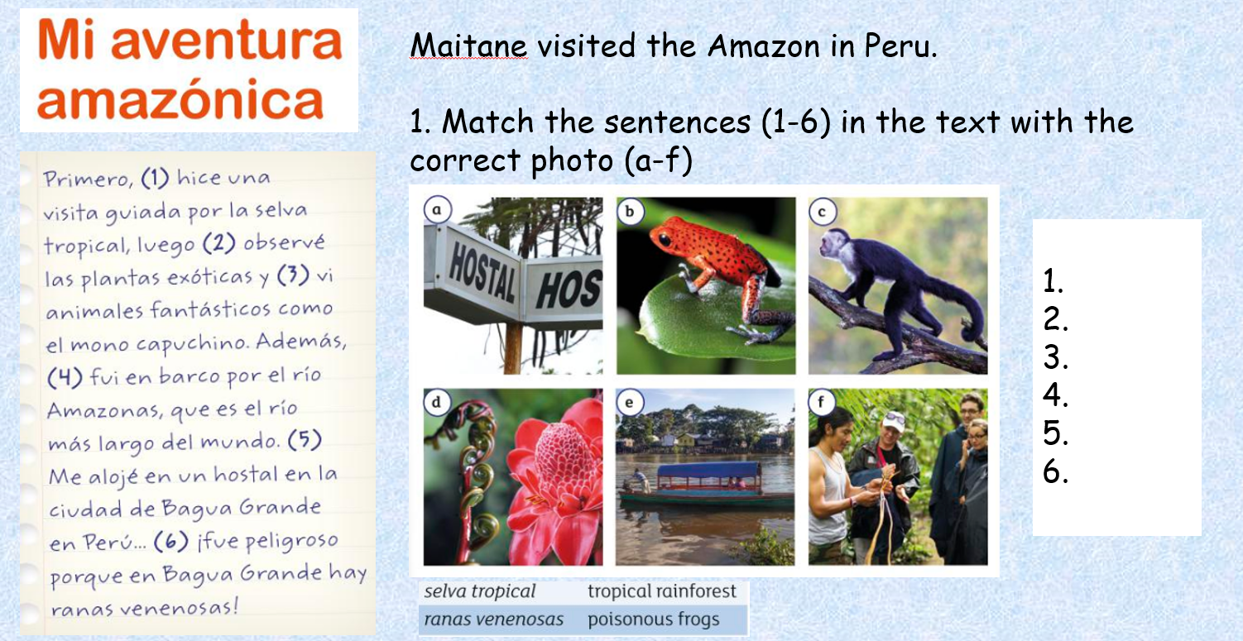

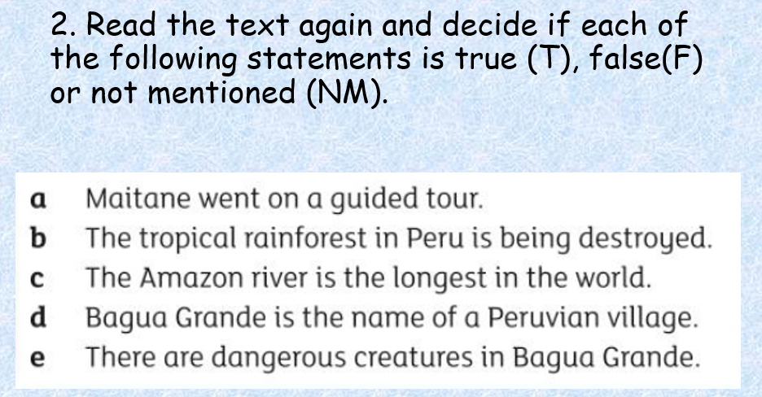

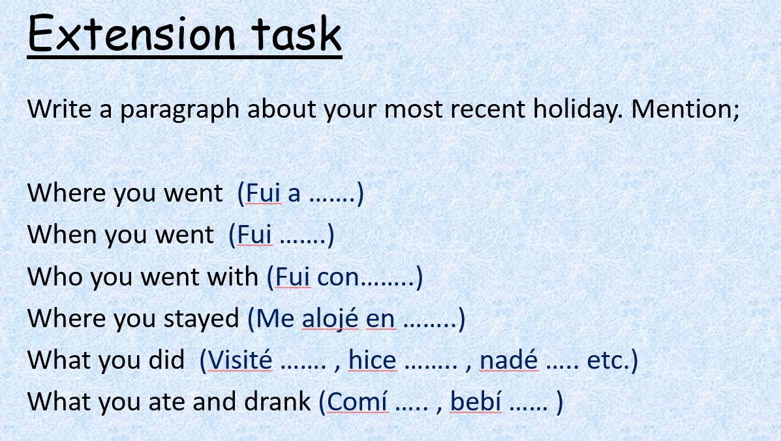

¡Buena suerte!