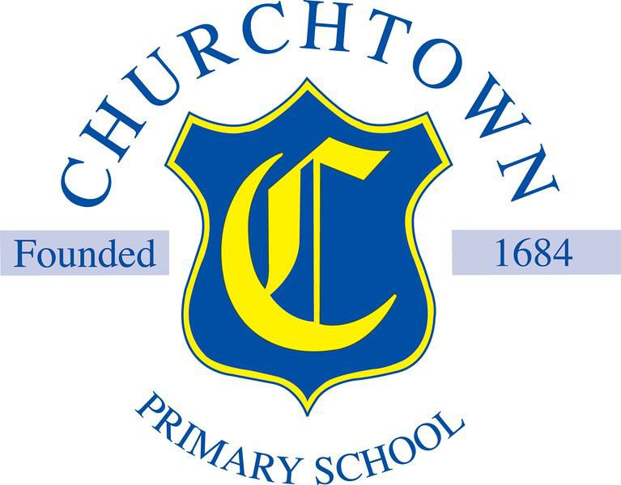

Welcome to Year 3

Ash

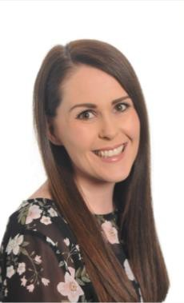  
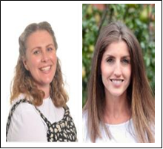Your teacher in Year 3 will be:

Mrs Bowers & Mrs Carroll (Friday)

Mrs Carroll

Mrs Bowers

Here are some other people that will teach you this year:

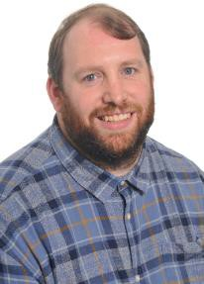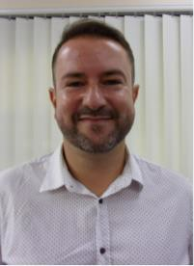Mr Pritchard (Music) Mr Asensi (Spanish)

Mr Pritchard

Mr Asensi

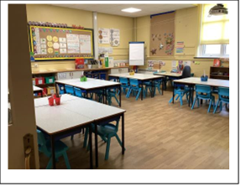

Here are some pictures of your new classroom.

It is located along the main corridor Opposite the staff room.

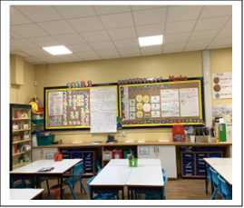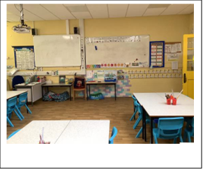

In Year 3 we start school at 8:40am and finish at 3:10pm.

Children in our class come into school at this door: Via The Old Hall.

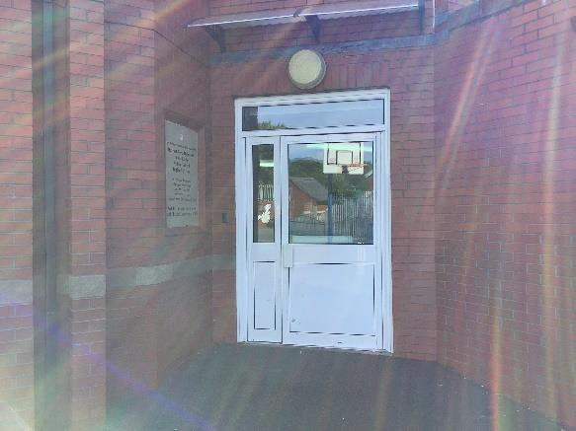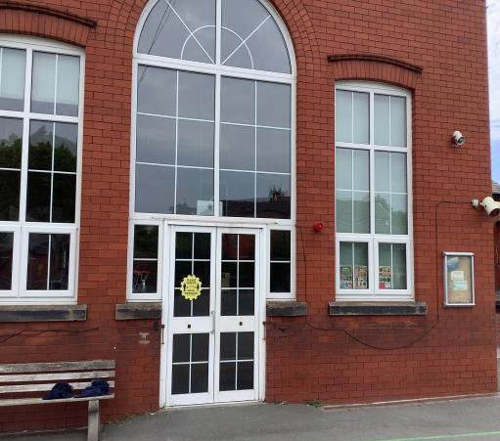

You will be collected at 3:10pm at this door by the MUGA.

You will have your lunch in the canteen. Your time for lunch will be 11:30am.

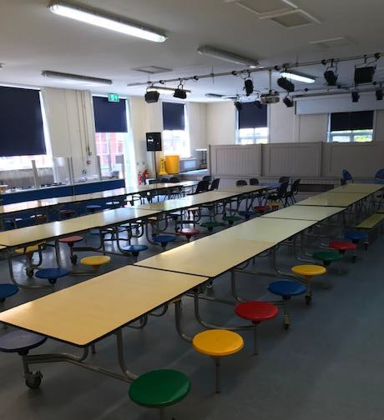

Your class teacher will tell you when your PE day is when we are back in September.

The toilets are located on the main corridor near our classroom.

In Year 3 we will learn about lots of new and exciting things.

In Science we will cover:

* Rocks
* Skeletons and Muscles
* Forces and Magnets
* Plants
* Light
* Nutrition

In history, we will learn all about the Romans and the Vikings. We will study the human and physical features of a variety of countries across Europe in geography. We also cover a range of exciting topics in art and design technology where we will be developing our skills of drawing and sculpture and making pneumatic toys and electric posters.

Other useful information:

In Key Stage 2, children are not provided with a morning snack. Children are allowed to bring fruit into school for morning break. Children should also bring in a named water bottle which can be refilled throughout the day.

Class Production: Summer 2

School Trip: Deva Chester: Autumn 2 Sports Day: Summer 2

**We hope you have a lovely summer holiday, and we look forward to seeing you in September!**