

Early Years Practitioner (Level 2)

Churchtown Primary School

and Nursery

Dear Applicant,

Thank you for your interest in the position of Early Years Practitioner at Churchtown Primary School.

The Endeavour Learning Trust board and I are delighted to provide the enclosed information about the role and our School. I hope you find it helpful and on behalf of the whole school community, I would like to take this opportunity to extend a very warm welcome.

Endeavour Learning Trust is a growing Trust in the North West, currently spanning South Ribble, West Lancashire and North Sefton. In our family of schools at this point in our growth, we have four secondary schools and two primary schools formally within the Trust.

Our mission and values provide a clear framework for us to work to. We are absolutely committed to serving our communities to ensure that every child achieves their potential by providing the highest quality educational experience in a truly inclusive way.

As a Trust, we don’t believe in a one-size-fits-all approach for our schools or our students. We respect and celebrate individuality, working with a clear determination to support our children, colleagues and communities both collectively, and individually, to flourish and thrive through a rich and transformational provision.

We believe in the value of collaboration, and everybody working with the Trust shares a collective responsibility for the success of all of our children. We also recognise that we will never be successful in delivering our vision for our young people unless our colleagues are supported, nurtured and developed to achieve their full potential with us. That’s why we are equally committed to ensuring every colleague benefits from the best possible employment experience where high-quality CPD and a sincere approach to supporting wellbeing enable our colleagues to achieve their own aspirations for their career.

We hope the enclosed information will give you good insight into our School & Trust.

We look forward to viewing your application.

Yours faithfully,



David Clayton

Chief Executive

**Endeavour Learning Trust’s Mission and Values**

**We will serve our communities to ensure that every child realises their potential**

We pledge that our schools will be transformational places of academic excellence that offer a true richness of experience, providing all children with the same opportunities to flourish and develop their unique skills, qualities and talents.

We will work collaboratively with our colleagues, parents and carers and our partners to remove any barriers that place limitations on our children, creating schools that are happy and harmonious places at the centre of their community.

**Our Values**

**Individuality**

We are firmly committed to recognising, celebrating and investing in the individuality of all of our children and young people, each of our colleagues and the distinct ethos and identity of each of our schools, whilst remaining united by our core values. We don’t believe in a “one size fits all” approach, and will adapt our provision to meet individual needs.

**People centred**

Our work is driven by our responsibility to every individual within our Trust community. Every person deserves to be treated with respect, dignity and kindness. We demonstrate empathy and humility in our approach, ensuring that our Trust provides an environment where every individual feels confident to be their true authentic self.

**Belonging**

Equity of opportunity is central to our practice and we will be relentless in our endeavour to identify and remove barriers that prevent full inclusion. Our culture extends beyond tolerance to one where difference is embraced and every individual is valued and celebrated for their unique contribution to our community. Every individual is a full member in our community.

**Transformational**

We believe in the promise of each individual across the Trust and will ensure we inspire, support and challenge in proportionate measure, so that we all thrive and are able to achieve our own individual successes. We are bold in our approach, stretching perceived boundaries, to go further for our children, colleagues and communities. We continually develop our approach to respond to changes in the communities we operate within to support every child, colleague and partners to realise their potential.

**Togetherness**

We are a proud family of schools bonded by our Trust vision, priorities and values. We work as one team in school, across our Trust and with our wider partners for the benefit of the communities we serve. Our collaborative approach inspires us to be bold and brings us together in ways that help us to make a difference. We are better together.

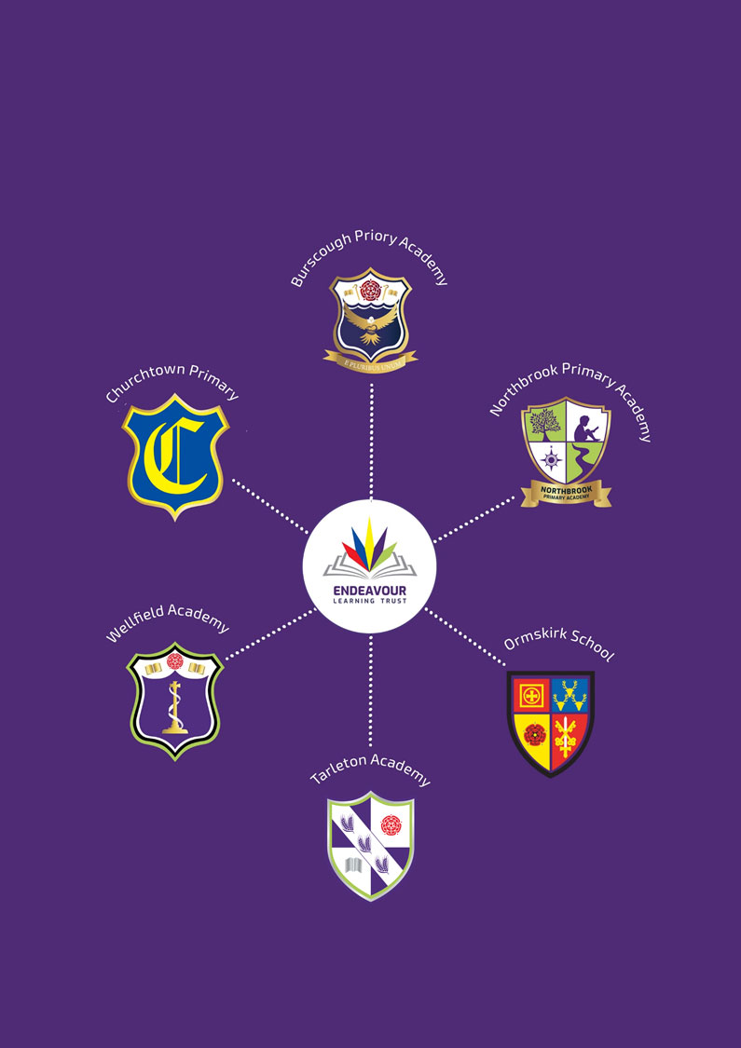

**ENDEAVOUR LEARNING TRUST**

**OUR SCHOOLS**

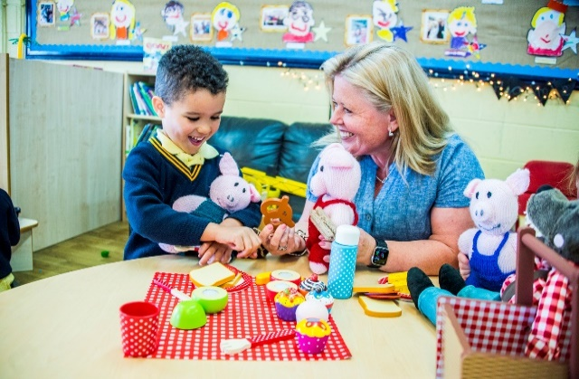

Dear Applicant,

Thank you for your interest in the position of Early Years Practitioner at Churchtown Primary School.

I am delighted to send you the enclosed information about our school.  I hope you will find it helpful and on behalf of the whole school community, we would like to take this opportunity to extend a very warm welcome.

Churchtown Primary is part of Endeavour Learning Trust and has thrived as part of a successful family of schools. Our children are hardworking, enthusiastic and keen to work with their teachers and the support staff to get the very best out of each and every day at school.

Ours is a happy school; we work together for the good of the team and we are a team where everyone is valued as an individual. In our school we have high expectations but also a pragmatic emphasis on challenge and support.  This counts for children and staff, teaching and non-teaching, everyone wants the best for everyone else.

In our team, our staff are committed to improving the experience of our children with a genuine desire to help them become the best person they can be. They are wholly optimistic and driven to making the school the very best it can be. Underpinning all we do is a commitment to developing the children in our school to become kind, well rounded and confident learners.  We want to develop young people who believe in, and have the skills, to realise their own worth and potential.

The Trustees and our Local Academy Council are extremely proud of the school’s journey and successes to date. We are committed to promoting an ethos and culture of high aspiration and celebration, whilst providing a friendly and inclusive environment underpinned by a pastoral care system that values every member of the school community.

At the core of these roles lie curriculum and teaching and learning. The successful candidates will have experience of leading a broad, balanced and inspiring curriculum and high quality teaching and learning. Most important to this end is a genuine sense of collaborative effort. The impact of the curriculum will be evidenced through the analysis of student performance and outcomes.

If you would like to visit us or if you would like to discuss any aspect of this post further, please do not hesitate to contact us.

Yours faithfully,

Mrs Jinnie Payne

Headteacher

**Early Years Practitioner (Level 2)**

**Full time, Permanent & All year round**

**Grade 4 SCP 4-6**

**£23,151.49 - £23,893 per annum**

**Required for September 2024**

A truly exciting opportunity has arisen to join our incredibly supportive and committed team within our new nursery setting for 2-year olds. As an Early Years Practitioner at Churchtown Primary School and Nursery, you will play a vital role in shaping the educational experiences of our youngest learners. You will work with children aged 2 years, fostering their social, emotional and cognitive development through engaging activities, interactive play and thoughtful guidance. The role will involve facilitating suitable activities and experiences for the children in your care, providing a safe and stimulating environment for them to develop.

All of our staff are ambitious for our young people and are driven to ensure that they receive the very best education possible, in a calm and nurturing environment. We are leaving no stone unturned to raise standards across our school, as we strive to provide our children with the experiences and outcomes that they deserve. We welcome applications from highly motivated and enthusiastic practitioners who are eager to be a part of our exciting journey.

Our school is on a journey of continuous improvement and we are keen to recruit people who are passionate about supporting children to learn and develop both academically and personally. We welcome staff who share our commitment to help children experience better days and better lives. Through ongoing development and training, we ensure our staff are well prepared for their jobs and given every opportunity to extend their skills.

Why join us?

* Join a truly supportive and encouraging team
* Full and continued support from specialist staff within Central Trust team.
* Access to the Local Government Pension Scheme
* Free on-site parking
* Access to company car lease scheme
* A modern, well-resourced school environment
* 24/7 access to employee wellbeing package
* Encouragement of further and continued professional development
* 50% off Endeavour Children’s Holiday Camps

This post is full time hours across 4 days, permanent and all year round. 7:15am to 5:45pm (3 days) & 10:15am to 5:45pm (1 day)

**HOW TO APPLY**

To apply, please complete our application form and include a personal statement to support your application and outline the relevant skills and experience you can bring to Endeavour Learning Trust. Please return to [vacancies@endeavourlearning.org](mailto:vacancies@endeavourlearning.org)

Applications should be submitted by 9.00am on Thursday 6th June 2024

Interviews are to be held on 13th and 14th June 2024

If you require any further information please contact our Recruitment Manager, Mollie at [m.fairhurst@endeavourlearning.org](mailto:m.fairhurst@endeavourlearning.org)

**SAFEGUARDING**

Endeavour Learning Trust is committed to safeguarding and promoting the welfare of children, young people and vulnerable adults and expects all staff and volunteers to share this commitment and individually take responsibility for doing so.

Please note that in line with Keeping Children Safe in Education, an online search will be carried out as part of our due diligence on shortlisted candidates.

**JOB DESCRIPTION**



**Main Duties and Responsibilities**

* To deliver the highest quality provision implementing the EYFS curriculum in accordance with the children’s social, emotional, physical and intellectual needs.
* To keep informative, accurate and up to date records and assessments, including records of progress and any behavioural and developmental reports.
* To carry out any recommendations made following regulatory inspections.
* To work within the setting’s policies and procedures.
* To respond to each child’s need for individual care and attention and provide the highest level of care and supervision that will enhance the children’s development in addition to their general health and well-being.
* To act as a Key Person to a group of children and to ensure their needs are reflected in the planning of routines and activities. To support the work of other staff in their role as key person as required.
* To liaise closely with parents and carers as a Key Person to inform parents of their children’s progress and encouraging them to become involved in their children’s learning.
* To be aware of children’s special educational needs and disabilities, and work with other staff and external agencies to support these children effectively.
* To liaise and work in partnership with other agencies, both statutory and voluntary where appropriate.
* To promote positive values, attitudes and good child behaviour, dealing promptly with conflict and incidents in line with established policy and encouraging children to take responsibility for their own behaviour.
* To undertake any reasonable duties as directed by the Head.
* To attend whole staff meetings outside of normal opening hours up to seven times a year.
* To attend any relevant training events or meetings as advised by the Head /Committee and to keep up to date with current good practice.

**PERSON SPECIFICATION**

|  |  |  |  |
| --- | --- | --- | --- |
| **Personal Attributes required**  **(on the basis of the job description)** | **Essential (E)**  **or**  **Desirable (D)** | **App Form** | **Interview** |
| **Qualifications** |  |  |  |
| NVQ EYFS/ Childcare Qualification Level 2 | E |  |  |
| **Experience** |  |  |  |
| Experience of working in a relevant classroom/service environment | E |  |  |
| A good sound knowledge and understanding of EYFS | D |  |  |
| Sound understanding of child development and of children’s needs and current legislation relevant to the Early Years | E |  |  |
| Ability and experience of implementing an Early Years curriculum, taking into account the SEND Code of Practice, child protection procedures, religious and cultural diversity and equal opportunities  considerations | E |  |  |
| Strong time management skills and ability to prioritise workload. | E |  |  |
| **Knowledge, Skills & Abilities** |  |  |  |
| Ability to foster strong working relationships with staff, volunteers and other professionals. | E |  |  |
| Ability to work with parents and encourage their involvement | E |  |  |
| Ability to work as part of a team | E |  |  |
| Good communication skills | E |  |  |
| Ability to relate well to parents/carers | E |  |  |
| Ability to supervise and assist pupils | E |  |  |
| Time management skills | E |  |  |
| Organisational skills | E |  |  |
| Knowledge of classroom roles and responsibilities | E |  |  |
| Knowledge of the concept of confidentiality | E |  |  |
| Ability to adapt own approach in accordance with pupil needs | E |  |  |
| Administrative skills | E |  |  |
| Knowledge of Foundation Stage/National Curriculum | E |  |  |
| Knowledge of numeracy and literacy strategies | E |  |  |
| Ability to assess and report on the progress of children | E |  |  |
| Ability to make effective use of ICT | E |  |  |
| Ability to assess children’s development | E |  |  |
| Ability to plan and deliver work programmes | E |  |  |
| **Personal Attributes** |  |  |  |
| To have high expectations of all pupils, respect for their social, cultural, linguistic, religious and ethnic backgrounds; commitment to raising educational achievements. | E |  |  |
| Demonstrate and promote the positive value, attitudes and behaviour they expect from the pupils with whom they work | E |  |  |
| Able to improve their own practise through evaluation and discussion with colleagues. | E |  |  |
| Flexible attitude to work | E |  |  |
| **Other** |  |  |  |
| Commitment to safeguarding and protecting the welfare of children and young people | E |  |  |
| Commitment to equality and diversity | E |  |  |
| Commitment to health and safety | E |  |  |
| Commitment to attendance at work | E |  |  |
| Commitment to undertake in–service development | E |  |  |
| Commitment to gain clearance through the Disclosure and Barring Service – (clearance is required before confirmation of employment) | E |  |  |