

Welcome to Year 6 Cedar Class

Your teacher in year 6 will be …



Here are some other people that will teach you this year.

**Mr Pritchard Mr Asensi**

Music Spanish

Here are some pictures of your new classroom (although it may look a little different in September!)

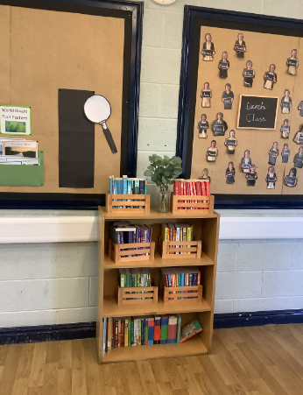 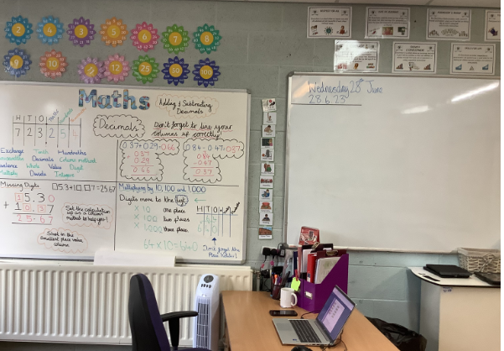

In year 6 we start school at 8:40am and finish at 3:20pm.

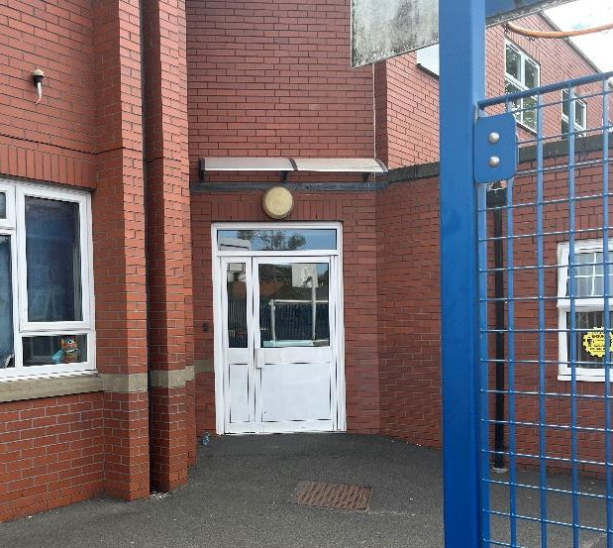Children in year 6 come into school and are

collected at the door by the MUGA.

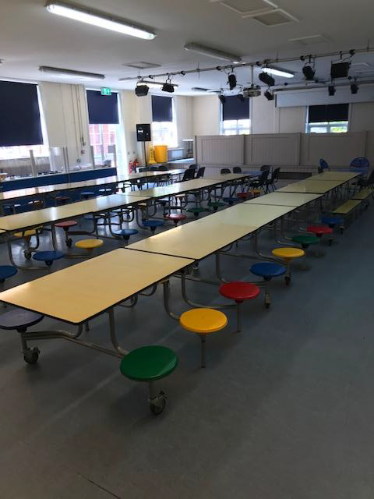You will have your lunch in the canteen. Your time for lunch will be 12:00 – 1:00pm.

Our P.E. days will be confirmed in September.

In Year 6 we will learn about lots of new and exciting things.

Below is an outline of some of the learning that will take place, as well as daily mathematics and English lessons.

|  |  |  |  |  |  |  |  |
| --- | --- | --- | --- | --- | --- | --- | --- |
| **Science** | **RE** | **Geography** | **History** | **Art & DT** | **Computing** | **PSHE** | **PE** |
| Electricity | What matters most? | Natural Disasters | WW1 and WW2 | Make My Voice Heard | Online Safety | Emotions | Swimming |
| Materials | Racism and Prejudice | Energy | The Islamic Golden Age | Cooking | Safety in coding (Bletchley Park) | Keeping Safe and Healthy | Athletics |
| Evolution and Inheritance | Eternity |  |  | Art and Design Skills | Programming (Nested Loops) | Our Working World | Invasion Games |
| Animals including humans |  |  |  | Playgrounds | Computer Networks | A World Without Judgement | OAA |
| Living things and their habitats |  |  |  | Textiles | The History of Computers | Growing and Changing | Dance |
|  |  |  |  | Sculpture |  |  | Striking and fielding |

Other useful information

* Homework is handed out on a Friday and due back in on a Wednesday.
* At the end of the year we will put on a fantastic show at the Atkinson theatre in Southport.
* We will have an end of year trip to celebrate your time

at Churchtown, along with an end of year leavers’ service at St Cuthbert’s Church.

* Swimming will take place in the Autumn term at Tarleton Academy (this will replace one of your PE lessons for the whole of the Autumn term).

**We hope you have a lovely summer holiday, and we look forward to seeing you in September**