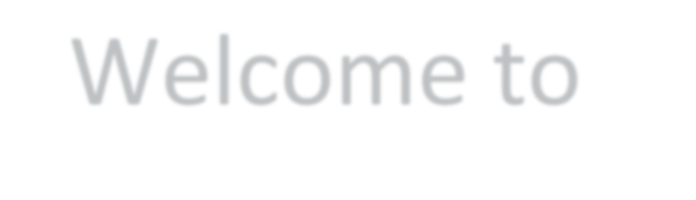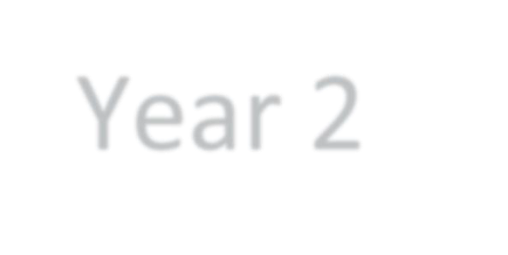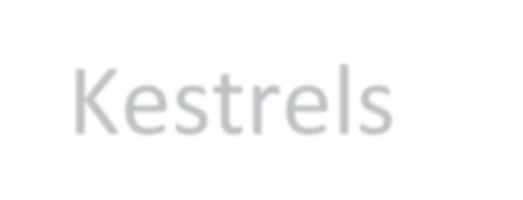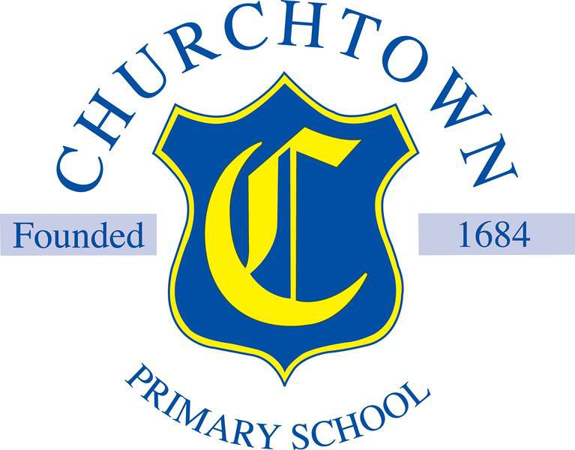

Welcome to Year 2 Kestrels

Your teacher in Year 2 will be Mrs Bowen.

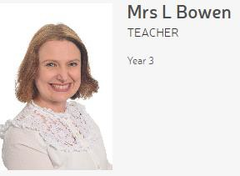

Here are some pictures of your new classroom.

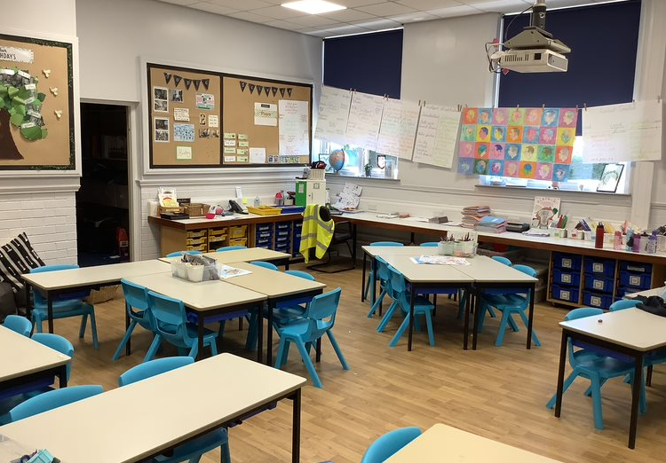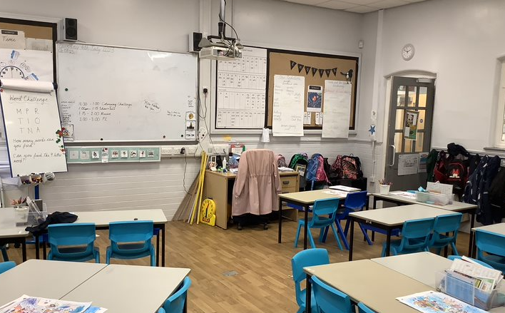

In Year 2 we start school at 8:40am and finish at 3:10pm.

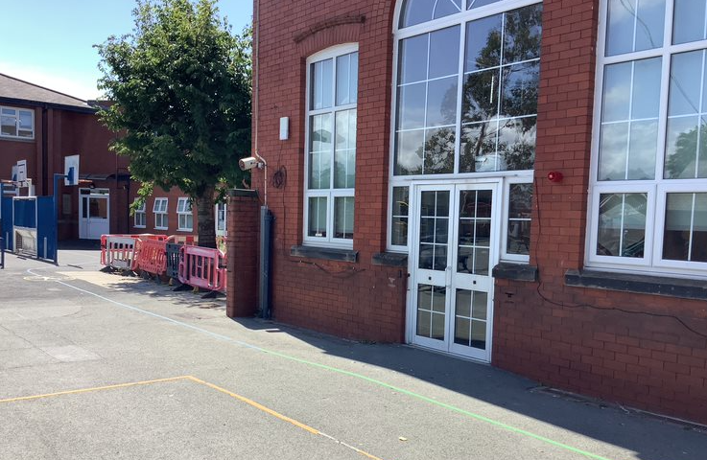

Children in Year 2 come into school and are collected at this door.

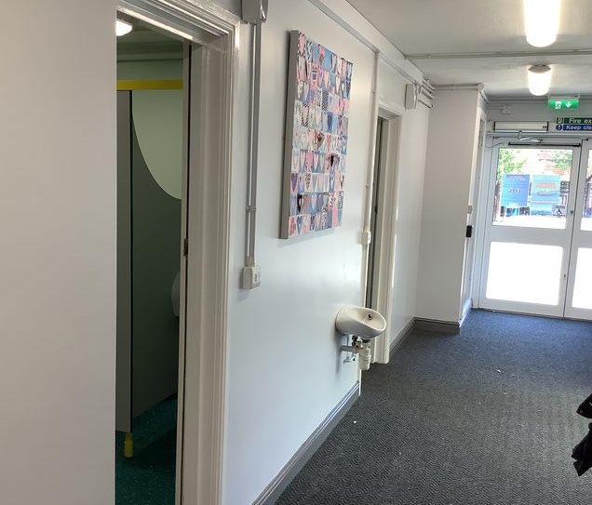

Children in Year 2 will use these toilets.

Coats, bookbags and lunchboxes go on pegs inside the classroom.

Year 2 will have lunch in the dining hall.

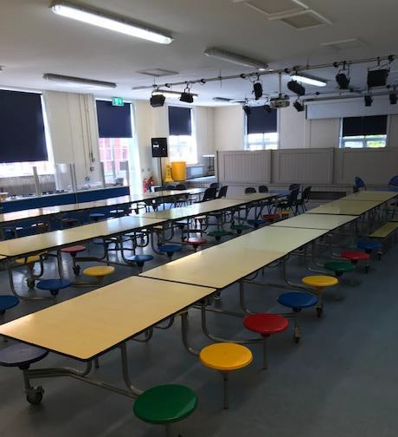

In Year 2 we will learn about lots of new and exciting things!

**Some** of the things we will learn this year are:

In **Science** we will be learning all about:

* Animals including humans.
* Uses of everyday materials.
* Living things and their habitats.
* Plants.
* Working scientifically.

In **History** we will be learning all about:

* Why do we remember Guy Fawkes?
* Was Columbus a hero or a villain?
* How did these nurses contribute to the world?

In **Geography** we will be learning about:

* Geography skills and locational knowledge in our local park by creating maps with symbols of the Botanic Gardens.
* Name and locate the continents, main oceans, equators and tropics,
* Comparing hot and cold regions such as Antarctica & Australia to the United Kingdom.
* Human and physical features.

In **Design and Technology,** we will be using the process of design, make and evaluate to make:

* Structure: A character’s chair
* Mechanisms: Making a moving monster
* Food: A balanced diet – making a healthy wrap.

In **Art** we will be learning about:

* Painting and mixed media – Life in Colour: Developing colour mixing skills, learning about the work of artist Romare Bearden and creating textured paper using paint to compose a collage.
* Drawing - Tell a story: Using storybook illustrations as a stimulus, children develop their mark-making to explore a wider range of tools and to add detail to drawings.
* Craft and design - Map it out: The children will learn three techniques for working creatively with materials.

In **Physical Education** we learn about-

* Fundamental skills
* Athletics
* Dance
* Gymnastics.

In **Religious Education** we will be looking at the questions:

* What does it mean to belong to a faith community?
* What can we learn from sacred books?
* Who is Jewish and what do they believe?
* How and why do we celebrate special and sacred times?
* Who is a Muslim and what do they believe?

**Music** is taught by Mr Pritchard.

**Special visits and trips:**

* Science Show
* Christmas play production
* School trip (To be confirmed)

**We hope you have a lovely summer holiday, and we look forward to seeing you in September.**