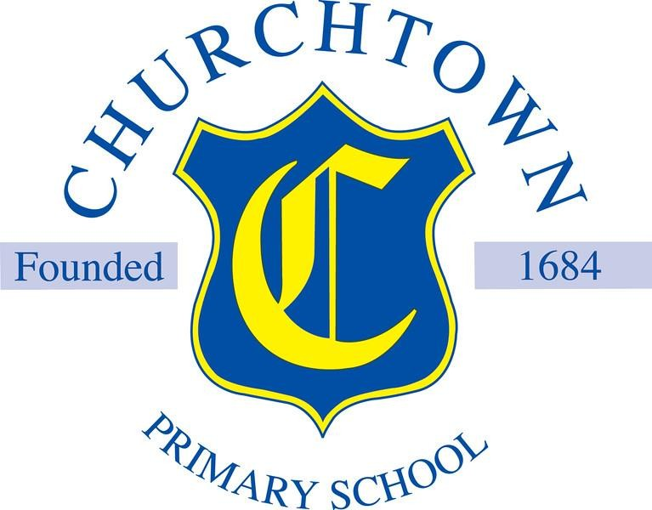

Welcome to

Reception Class name Sunflowers

Your teacher in Reception will be Mr Cocks.



Here are some other people that will teach you this year.

Mr Cocks (Sunflowers) Mrs O’Grady (Bluebells), Miss Wilson (Tulips) and Mrs Langley (Bluebells)

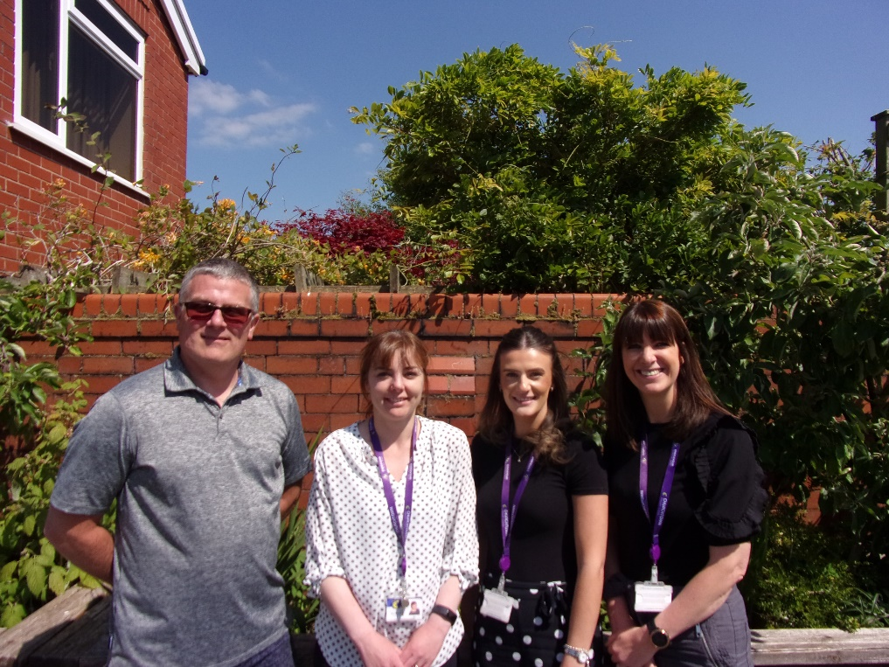

Mr Pritchard - Music Teacher



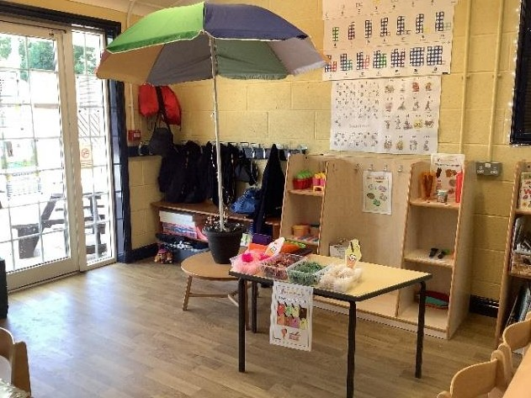Here are some pictures of your new classroom.

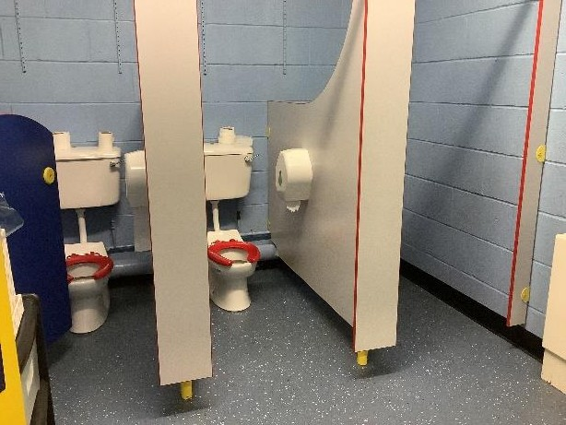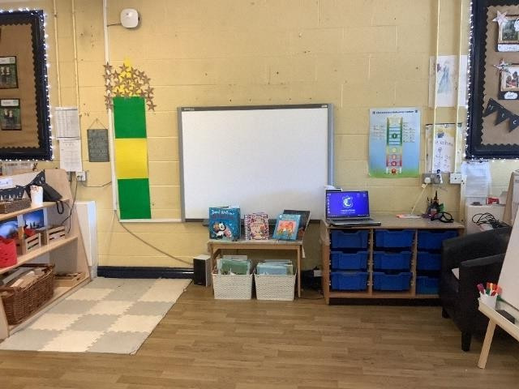Our Role-Play area changes throughout the year, here it is as an Ice-Cream parlour.

In Reception we start school at 8:50 and finish at 3:10.

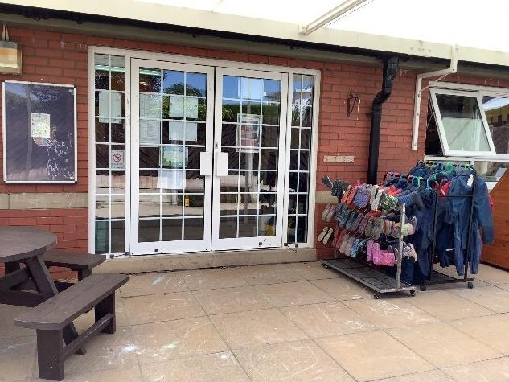

Children in Sunflowers come into school and are collected at this door. It is the third door on the left from the Botanic Gardens gate.

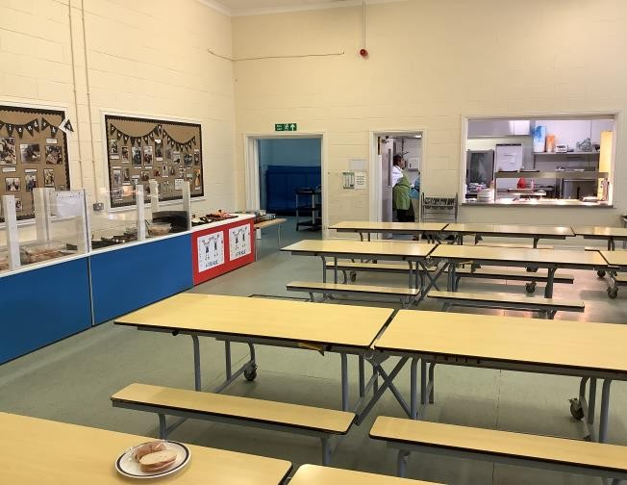You will have your lunch in the canteen. Your time for lunch will be 11:30 – 12:30.

Our P.E. days are Wednesday for PE in the hall and Thursday for field.

On those days the children come into school wearing their kit for the day. On Thursdays this will be field kit including jogging bottoms, white shirt and field jumper. On their PE day this means white shirt and PE shorts, with jogging bottoms and field jumper on top.

In Reception we will learn about lots of new and exciting things.

Our topics will be:

All About Me Autumn Festivals

Oi! – based on the delightful Oi Frog series of books. Growth and Life Cycles

Once Opon a Time… - based on traditional tales.

Other useful information

The Reception curriculum is based on the government

guidance ‘Development Matters’ which you can search on the internet for more details. Woven into the topics above will be lots of teaching, child led learning and play to

facilitate the children’s development.

We also teach reading through the Read Write Inc phonics scheme.

**We hope you have a lovely summer holiday, and we look forward to seeing you in September!**