Dance and Performing Arts:
 | Dance Sensation
Dance Sensation offers a wide range of dance and musical theatre classes for children, helping them develop skills, confidence and creativity in a fun and supportive environment. Through expert teaching, performance opportunities and accredited dance training, children are encouraged to express themselves, make friends and enjoy the many benefits of dance.
For children from 2.5 years to 18 years
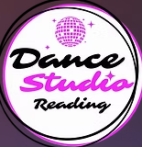 | Dance Studio Reading
Dance Studio Reading offers a welcoming range of dance classes for children and adults, helping participants develop confidence, coordination and performance skills through ballroom and Latin dance. With experienced teaching and an inclusive approach, the studio encourages people of all ages to enjoy dancing, stay active and achieve their personal best
For children from 4 years to 18 years
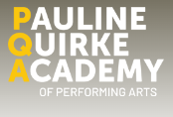 | PQA Academy
PQA Reading provides engaging performing arts classes for children and young people, combining drama, musical theatre, comedy, filmmaking and television. In a safe and nurturing environment, participants develop confidence, creativity, communication skills and resilience while making friends and exploring a wide range of performance opportunities.
For children from 4 years to 18 years
 | Perform.org
Perform helps children develop their potential through a unique blend of drama, dance and singing. With small class sizes and supportive, highly skilled teachers, each child receives individual attention and encouragement. Through engaging activities, children build confidence, improve concentration and develop a greater understanding of what they can achieve.
For children from 4 years to 12 years
 | Rabble Theatre
RABBLE Theatre provides engaging theatre, musical theatre and performance opportunities for children, young people and adults. Through acting, public speaking and LAMDA programmes, participants are supported to develop confidence, creativity, communication skills and performance experience in a welcoming and inclusive environment
For children from 8 years and up
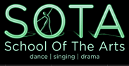 | School of the Arts
SOTA Reading offers a wide range of dance, singing, drama and musical theatre classes for children and young people aged 3–18. Through expert tuition, performance opportunities and nationally recognised qualifications, SOTA helps young people build confidence, develop creative skills and express themselves in a supportive and inspiring environment
For children from 3 years to 18 years
 | Stagecoach
Stagecoach Reading Caversham offers exciting performing arts classes in singing, dancing and acting for children and young. Through a supportive and welcoming environment, students are encouraged to build confidence, develop creativity, learn new skills and take part in inspiring performance opportunities throughout the year
For children from 4 years to 18 years
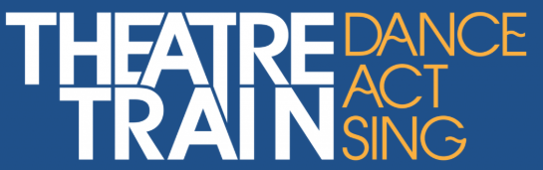 | Theatretrain
Theatretrain Reading provides professional yet fun training in singing, dancing and acting for children and young people. Through high-quality tuition, performance opportunities and a supportive environment, students develop confidence, creativity and theatrical skills while building friendships and enjoying the performing arts.
For children from 6 years to 18 years

