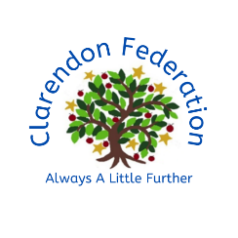

About me:

Meet your Teacher!

Mrs Peill

Hello! My name is Mrs Peill and I will be your teacher in Pandas class. I can’t wait to meet you and be in Year 3 together!

Fun facts:

Colour: Purple  
Season: Autumn (I love the colour of the leaves)

Book: Goodnight Mr Tom

Food: Chocolate

Flower - Sunflowers

I hope you have a great summer and I am really looking forward to getting know in September!

See you soon

In Year 3 we become more independent in our learning and get to enjoy lots of new experiences! We will work together as a team to be the best we can be and develop as positive members of our Clarendon community.

What to Expect:

My Favourites:

I grew up in Cardiff and love going to home to visit my family who still live there.

I love reading, drinking tea, listening to music and walking my dog with the rest of my family.

I am a Girl Guide leader and help with a Guides and Rangers unit.