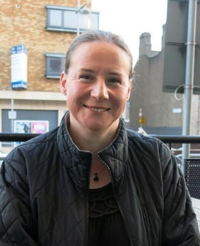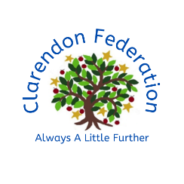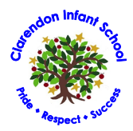

Meet your Teacher!

About me:

Hello! My name is Mrs Longbourne and I will be your teacher in Polar Bears class.

I have been at Clarendon for 10 years and so I may well have taught some of your older brothers and sisters!

Mrs Longbourne

I am was brought up on a farm in the very South West corner of Wiltshire, it was my job to milk the cows!

I like riding horses, reading and walking in the countryside with my camera.

My family and I spent a year in Canada when I did a teaching exchange and my daughter now lives there.

Fun facts:

I am really looking forward to getting know you when we are together in September!

See you soon

In Polar Bears we have both year 3 and year 4 children. This year we will be following the year 4 curriculum for subjects like Science, History and Geography but don’t worry, we will be doing Maths and English at the correct level for you and your learning. This is a really exciting opportunity and we will have lots of fun!

What to Expect:

Colour: Blue

Book: The Secret Garden

Food: Caesar Salad

Flower: Sunflowers

My Favourites: