Clarendon Federation Writing Curriculum – Year 1

Term | Autumn 1 | Autumn 2 | Spring 1 | Spring 2 | Summer 1 | Summer 2
Text | Drawing Club  The Colour Monster (Anna Llenas)  Not Now Bernard (David McKee)  The Gingerbread Man (Traditional Tale)  Beegu (Alexi Deacon)  Stuck (Oliver Jeffers)  Jack and the Beanstalk (Traditional Tale)  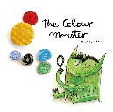  `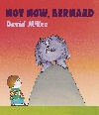  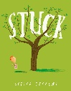  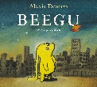 | Drawing Club  Lost and Found (Oliver Jeffers)  Superworm (Julia Donaldson)  The Three Little Pigs (Traditional Tale)  The Tiger who came to tea (Judith Kerr)  Where the Wild Things are (Maurice Sedndak)  Goldilocks (Traditional Tale)  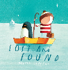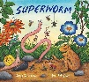  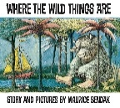 | Mala’s Magic Pencil  (Malala Yousafzai)   | Room on the Broom  (Julia Donaldson)  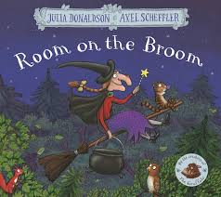 | Little Red  (Bethan Woolvin)   | Leaf  (Sandra Dieckmann)  
Fiction outcome | Outcomes linked to Drawing Club principles – setting, character and adventure | Outcomes linked to Drawing Club principles – setting, character and adventure | Retell the story – changing the setting | Retell the story (creating new characters) | Retelling of a traditional tale using story language | Create their own story about getting home
Fiction SPaG focus | Simple sentence construction – full stop and capital letter | Simple sentence construction – full stop and capital letter | ? to demarcate a question  ! to demarcate an exclamation | Adjectives to describe a noun  ‘and’ to join words in a list | Adjectives to describe a noun  ‘and’ coordinating conjunction | ‘and’ to join words in a list  ‘and’ coordinating conjunction
Faction outcome | n/a | n/a | Recount – diary entry as the little girl and her aims | Instructions - Magical potion recipe | Instructions – How to catch the wolf | Recount - diary entry from the polar bear
Faction SPaG focus | n/a | n/a | Past tense  full stop and capital letter | Imperative verbs  ! to demarcate an exclamation | Present tense  imperative verbs | First person – I  Past tense
Milestones | Use names of people places and things e.g. identify nouns and that they are different to verbs/adjectives | Join words using 'and' e.g. to list in a sentence | Use past tense accurately e.g. subject verb agreement I was/we were | Use simple language features for fiction .g. use this term to revisit previous grammar skill not yet secured (complete sentences, accurate tense, adjectives, nouns, narrative devices ) | Use simple language features for fiction .g. use this term to revisit previous grammar skill not yet secured (complete sentences, accurate tense, adjectives, nouns, narrative devices ) | Use simple language features for fiction .g. use this term to revisit previous grammar skill not yet secured (complete sentences, accurate tense, adjectives, nouns, narrative devices )
Milestones | Captions to communicate ideas | Use ‘and’ to join simple sentences e.g. I went to the park and I met my friend/compound sentences | Use the present tense accurately e.g. subject verb agreement I am/we are | Use simple language features for non-fiction e.g. use this term to revisit previous grammar skill not yet secured (complete sentences, accurate tense, non-fiction devices such as imperatives for instructions) | Use simple language features for non-fiction e.g. use this term to revisit previous grammar skill not yet secured (complete sentences, accurate tense, non-fiction devices such as imperatives for instructions) | Use simple language features for non-fiction e.g. use this term to revisit previous grammar skill not yet secured (complete sentences, accurate tense, non-fiction devices such as imperatives for instructions)
Milestones | Write a range of simple sentences | Demarcate sentences using a capital letter e.g. mostly accurate esp. for simple sentences | Begin to demarcate sentences using question mark e.g. sometimes accurate | Add verbs using -ing, -ed, and er where no change is needed in the spelling of root words e.g. can include edited writing | Apply spellings of adjectives ending in er and est e.g. can include edited writing | Apply spellings of words using the prefix un e.g. can include edited writing
Milestones | Demarcate sentences using a capital letter e.g. mostly accurate esp. for simple sentences | Demarcate sentences using a full stop e.g. mostly accurate esp. for simple sentences | Begin to demarcate sentences using exclamation mark e.g. sometimes accurate | Apply spellings of common exception words and compound words | Apply spellings of plural nouns by adding s and es e.g. can include edited writing
Milestones | Demarcate sentences using a full stop e.g. mostly accurate esp. for simple sentences |  | Demarcate using capital letters and full stops
Ongoing skills –
ORAL retelling is done in EVERY unit.
Read back work to check it makes sense (model this in every lesson)
Re-visit the objectives across units
Capital letters for proper nouns
Build in CEWs
Length of writing builds as you go through the year to build stamina

