  Project objective  Design, make and evaluate an alarm system (product) ________(user) To protect their building (purpose). | Design and Technology Knowledge Organiser  Year 4– Electrical systems – Simple Circuits
 | 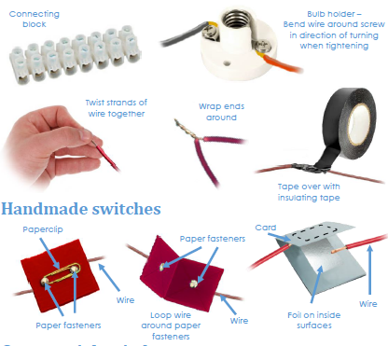 | Technical Knowledge and understanding.
• Understand and use electrical systems in their products, such as series circuits incorporating switches, bulbs and buzzers.
• Apply their understanding of computing to program and control their products.
• Know and use technical vocabulary relevant to the project.
 |  | Focused skills
- Recap how to make manually controlled, simple series circuits with batteries and different types of switches, bulbs and buzzers. Discuss which of the components in the circuit are input devices e.g. switches, and which are output devices e.g. bulbs and buzzers.
- Demonstrate how to find a fault in a simple circuit and correct it.
- Use a simple computer control program with an interface box or standalone control box to physically control output devices e.g. bulbs and buzzers.
- Make a variety of switches by using simple classroom materials e.g. card, corrugated plastic, aluminium foil, paper fasteners and paper clips. Make switches that operate in different ways e.g. when you press them, when you turn them, when you push them from side to side. Test switches in a simple series circuit.
- Discuss how to avoid making short circuits.
Vocabulary |  | Key Learning
series circuit, fault, connection, toggle switch, push-to-make switch,  push-to-break switch, battery, battery holder, bulb, bulb holder, wire, insulator, conductor, crocodile clip  control, program, system, input device, output device  user, purpose, function, prototype, design criteria, innovative, appealing, design brief |  | Prior Learning  • Constructed a simple series electrical circuit in science, using bulbs, switches and buzzers.  • Cut and joined a variety of construction materials, such as wood, card, plastic, reclaimed materials and glue. | Designing  • Gather information about needs and wants, and develop design criteria to inform the design of products that are fit for purpose, aimed at particular individuals or groups.  • Generate, develop, model and communicate realistic ideas through discussion and, as appropriate, annotated sketches, cross-sectional and exploded diagrams.
 |  | Making  • Order the main stages of making.  • Select from and use tools and equipment to cut, shape, join and finish with some accuracy.  • Select from and use materials and components, including construction materials and electrical components according to their functional properties and aesthetic qualities. | Evaluating  • Investigate and analyse a range of existing battery-powered products.  • Evaluate their ideas and products against their own design criteria and identify the strengths and areas for improvement in their work.

