  Project objective  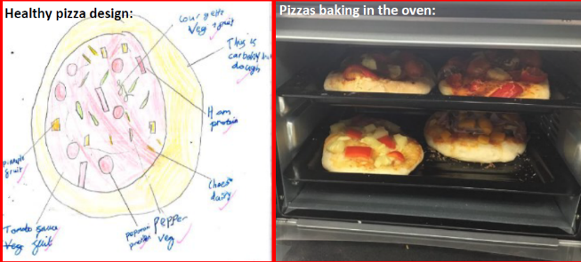  To design, make and evaluate a pizza for our end of term celebration | Design and Technology Knowledge Organiser  Year 4 Summer 2 – Food- Healthy and varied diet
 | To chop, peel and grate vegetables safely using the most appropriate techniques  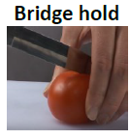  Bridge hold  To chop using the ‘bridge hold’— Using one  hand, make a bridge over the vegetable or fruit with fingers on one side and thumb on the other, cut down under the ’bridge’.  ‘Knife goes under the bridge, through the tunnel, then chops down”  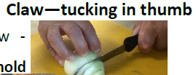  Claw—tucking in thumb  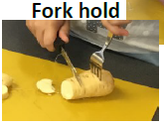  To chop safely— using the claw - tucking in thumb or fork  Fork hold  hold techniques.  Grate  To grate safely using a grater— grate away from self, grater positioned downwards against chopping board.  Peel  To peel safely using a peeler— peel away from self, peel middle of vegetable, rotate vegetable.  To measure accurately using both: Measuring jug (ml) And electronic scale (g).- fill liquid until it reaches required amount looking at the line carefully, pour some away if there is too much.    Knead  To knead dough— using the ‘heel, flip, turn’ method.  To roll dough— using a rolling pin and regularly Roll – applying flour to the surface and rolling pin to prevent sticking. .  Oven  Bake using a hot oven and handle  Oven gloves  -a hot baking tray safely wearing oven gloves. | Technical Knowledge and understanding.
• Know how to use appropriate equipment and utensils to prepare and combine food.
• Know about a range of fresh and processed ingredients appropriate for their product, and whether they are grown, reared or caught.
• Know and use relevant technical and sensory vocabulary appropriately.
 |  | Focused skills
• Learn to select and use a range of utensils and use a range of techniques as appropriate to prepare ingredients hygienically including the bridge and claw technique, grating, peeling, chopping, slicing, mixing, spreading, kneading and baking.
• Food preparation and cooking techniques could be practised by making a food product using an existing recipe.
• Discuss basic food hygiene practices when handling food including the importance of following instructions to control risk e.g. What should we do before we work with food? Why is following instructions important?
Vocabulary |  | Key Learning
Word Definition  Rolling pin A hard, smooth cylinder of wood or marble with handles at each end. It is  used to roll out dough.  Oven gloves A padded glove or mitten used to handle cooking utensils and dishes when they are too hot to touch with bare hands; oven mitt.  Bridge hold Cutting technique whereby one hand is used to make a bridge over the vegetable or fruit with fingers on one side and thumb on the other.  Dough A thick mixture of flour and a liquid such as water or milk that is prepared for baking into bread or cake.  Knead To work and press dough with the palms of the hands or mechanically, to develop the gluten in the flour.  Roll Applying pressure to dough using a rolling pin to flatten dough and make it even in thickness.  Cooling rack A kitchen tool used to allow various cooked items such as breads, cakes, meats etc. to be placed and cooled or rested immediately after the cooking process.  Bake To cook by dry heat, usually in the oven.  Pinch A pinch is the trifling amount you can hold between your thumb and forefinger.  Combine To bring or join together into a whole. |  | Prior Learning  • Know some ways to prepare ingredients safely and hygienically.  • Have some basic knowledge and understanding about healthy eating and The Eatwell plate.  • Have used some equipment and utensils and prepared and combined ingredients to make a product. | Designing  • Generate and clarify ideas through discussion with peers and adults to develop design criteria including appearance, taste, texture and aroma for an appealing product for a particular user and purpose.  • Use annotated sketches and appropriate information and communication technology, such as web-based recipes, to develop and communicate ideas.
 |  | Making  • Plan the main stages of a recipe, listing ingredients, utensils and equipment.  • Select and use appropriate utensils and equipment to prepare and combine ingredients.  • Select from a range of ingredients to make appropriate food products, thinking about sensory characteristics. | Evaluating  • Carry out sensory evaluations of a variety of ingredients and products. Record the evaluations using e.g. tables and simple graphs.  • Evaluate the ongoing work and the final product with reference to the design criteria and the views of others.

