  Project objective  To design, make and evaluate a new biscuit based on changing an existing biscuit recipe. | Design and Technology Knowledge Organiser  Year 5 – Summer 2 Food – Feasts and festivals – Biscuits
 | 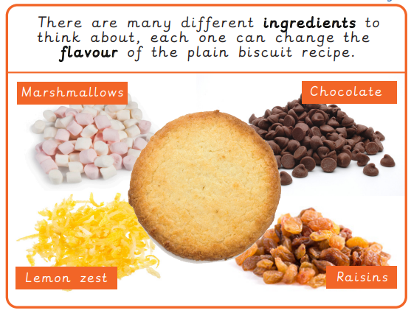 | Technical Knowledge and understanding.
• Know how to use utensils and equipment including heat sources to prepare and cook food.
• Understand about seasonality in relation to food products and the source of different food products.
• Know and use relevant technical and sensory vocabulary.
 |  | Focused skills
• Demonstrate how to measure out, cut, shape and combine e.g. knead, beat, rub and mix ingredients.
• Demonstrate how to use appropriate utensils and equipment that the children may use safely and hygienically.
• Techniques practised following a basic recipe to prepare and cook a savoury food product.
• Ask questions about which ingredients could be changed or added in a basic recipe such as types of flour, seeds, garlic, vegetables.
Consider texture, taste, appearance and smell.
• When using a basic dough recipe, explore making different shapes
Vocabulary |  | Key Learning
allergy carbohydrate dairy dough fat flour gluten healthy ingredients intolerance nutrients nutrition protein savoury seasonality source sugar utensils varied vitamins  beat combine crumble fold knead mix pour roll out rubbing in shape sprinkle stir whisk  design brief design specification evaluate innovative research |  | Prior Learning  • Have knowledge and understanding about food hygiene, nutrition, healthy eating and a varied diet.  • Be able to use appropriate equipment and utensils, and apply a range of techniques for measuring out, preparing and combining ingredients. | Designing  • Generate innovative ideas through research and discussion with peers and adults to develop a design brief and criteria for a design specification.  • Explore a range of initial ideas, and make design decisions to develop a final product linked to user and purpose.  • Use words, annotated sketches and information and communication technology as appropriate to develop and communicate ideas.
 |  | Making  • Write a step-by-step recipe, including a list of ingredients, equipment and utensils  • Select and use appropriate utensils and equipment accurately to measure and combine appropriate ingredients.  • Make, decorate and present the food product appropriately for the intended user and purpose. | Evaluating  • Carry out sensory evaluations of a range of relevant products and ingredients. Record the evaluations using e.g. tables/graphs/charts such as star diagrams.  • Evaluate the final product with reference back to the design brief and design specification, taking into account the views of others when identifying improvements.  • Understand how key chefs have influenced eating habits to promote varied and healthy diets.

