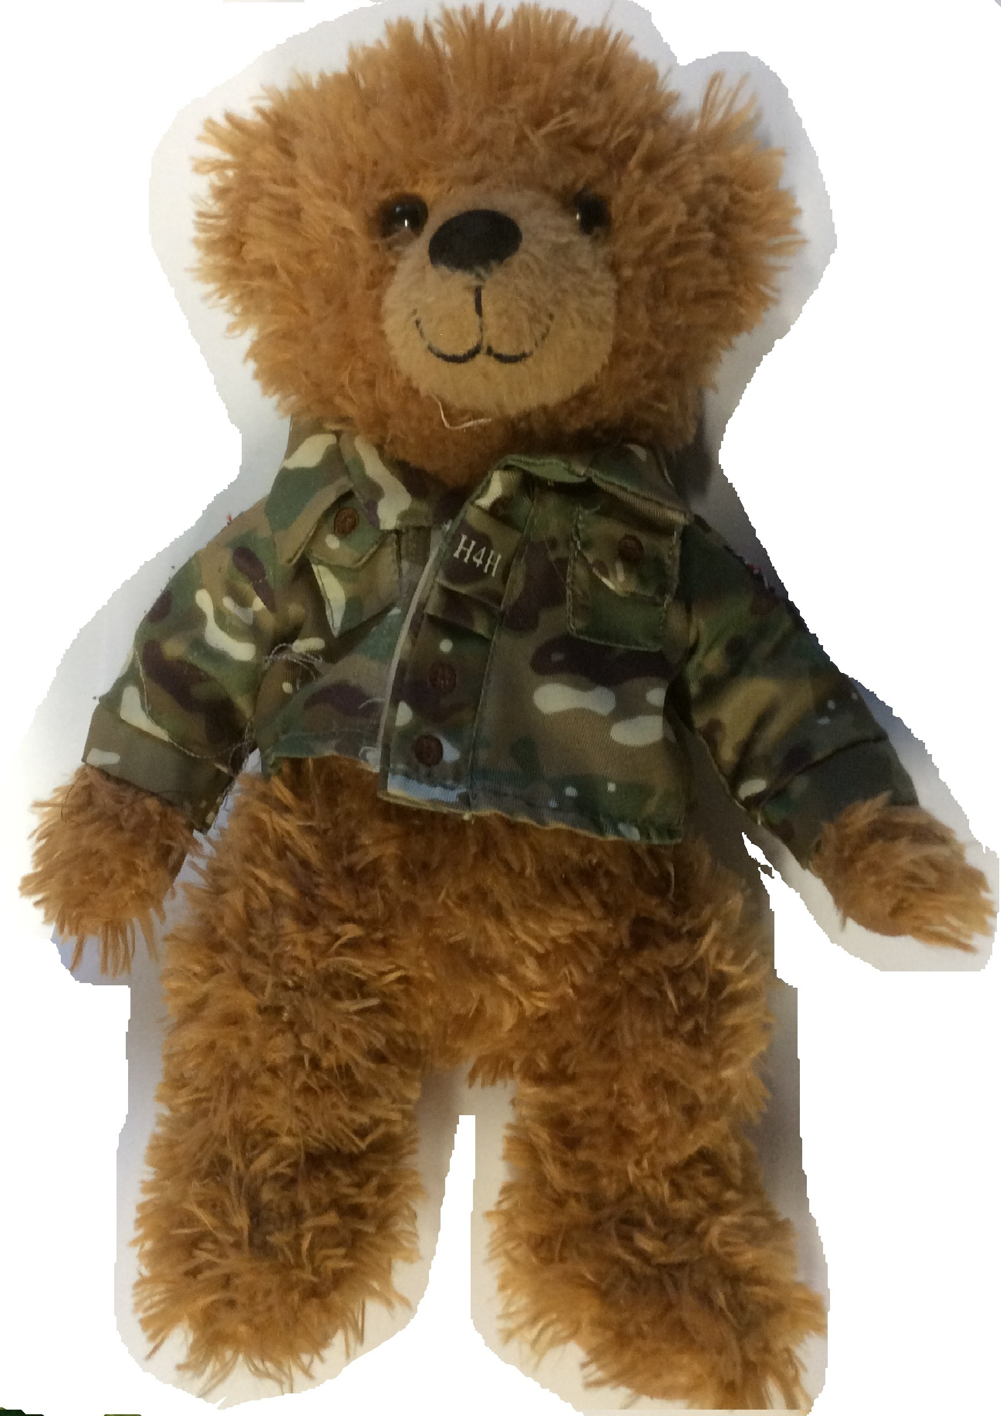

Hi, I am Clarrie the Travelling Bear. Please take me with you if you go away and then email us some photos and a short description of what the place you are in is like.

Things to write about: what country you are in, which continent it is in, if you are near the equator or the North or South Pole. Please describe the weather and tell us what season it is there. Have you seen any animals? We would love to know how the place is different to Tidworth. Some of the features we learn about in school are: beach, cliff, forest, hill, mountain, ocean, river, valley, city, town, village, factory, farm, house, port, harbour and shop. Perhaps you can see some of these features and tell us about them.

Please email your photos to: admin@clarendon-inf.wilts.sch.uk and include your child’s name and/or class in the subject bar.