Parent Portal Guidance

Contents

Accessing the Parent Portal 2

Registering / Logging in for the first time 2

Logging in 4

Resetting your password 5

Logging Out 6

Home Page 6

Free School Meals Application 6

Identification 7

About you and your child 7

More About your child 8

Add Another child 9

Consent to Eligibility Check 9

Summary 9

Submit your application 10

Your Account 10

Change Password 11

Form Options 11

*This guidance is subject to change as processes develop*

# Accessing the Parent Portal

**Locating the Parent Portal**

The parent Portal is available online through a secure web page, this will replace the way parent/guardian(s) apply for Free School Meals. You may see additional applications that can be made in this portal however, these will not become active until future upgrades.

Click on link below or paste into your web browser.

<https://parentportal.wiltshire.gov.uk/web/portal/pages/home>

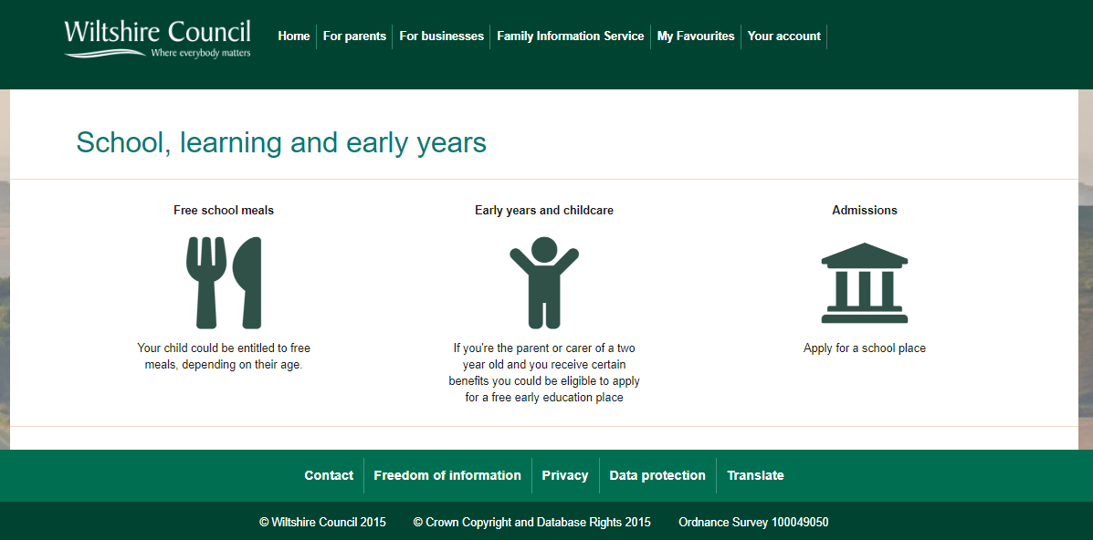

To access the login screen, click the ‘home’ icon on top left.

# Registering / Logging in for the first time

Before you can access the parent portal, you must first register as a new user.

Click the ‘Your Account’ and ‘Register for a new account;

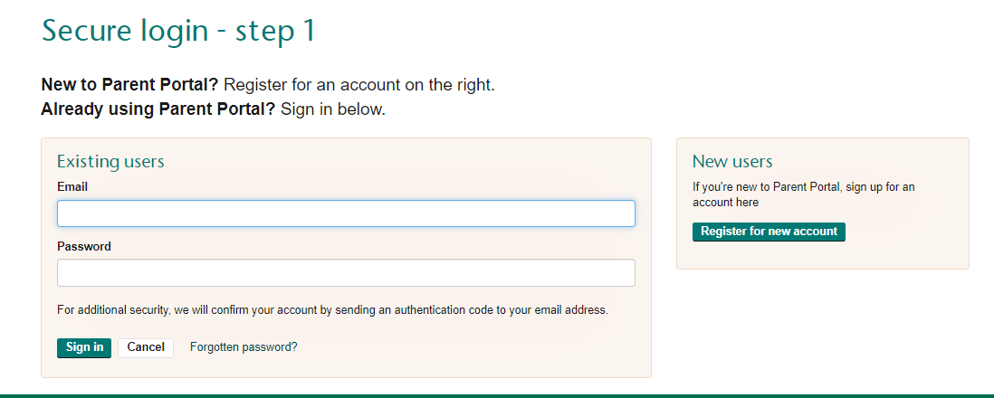

Then add your name and click ‘Next’

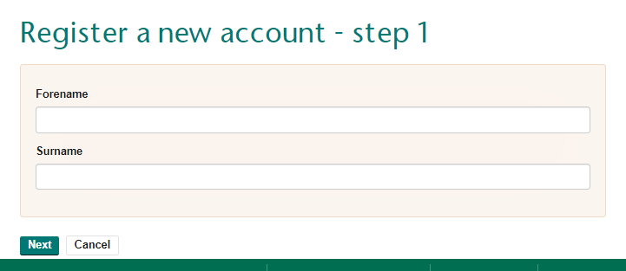

Then put in your email address. You must also choose a password that meets the described level of protection. Once chosen select ‘Next’

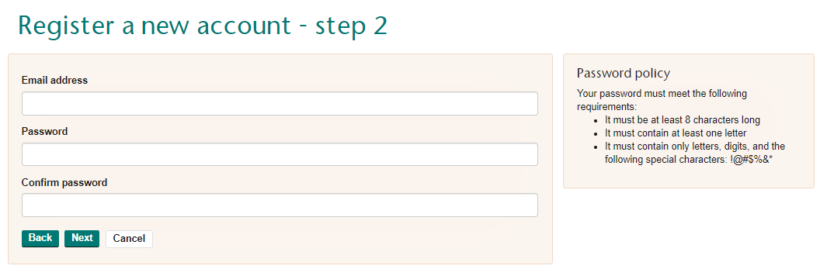

The Parent Portal will then send you a 6-digit code to your registered email address. You must input the code and select ‘Next.

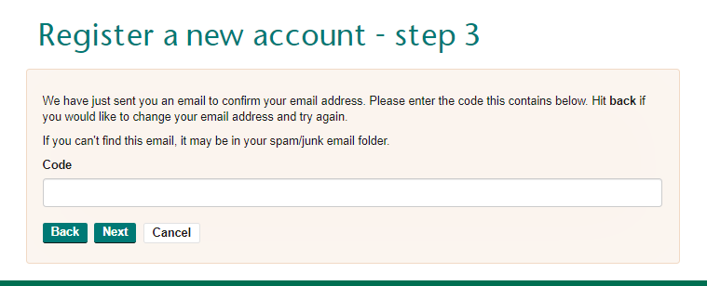

Your registration is complete, you will now be taken to the home screen.

# Logging in

Once registered, you can log in whenever you need to, by following these steps:

Secure Login – Step 1 - Enter your registered email address and password. Then click ‘Sign In’.

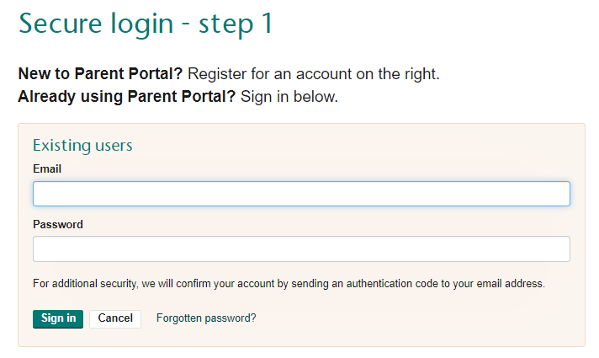

Secure Login – Step 2 - Enter the authentication code sent to your email address. Then click ‘Finish.

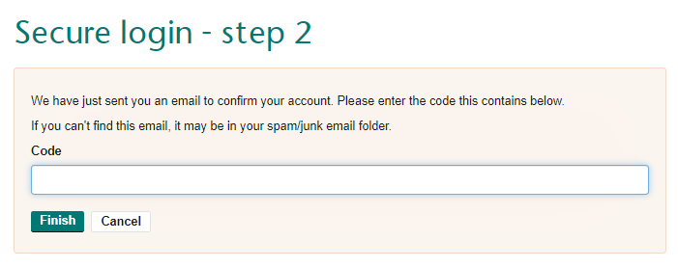

In addition to your password, an authentication code will be sent to your email address. Step 2 needs to be carried out within 10 minutes of receiving the emailed code.

# Resetting your password

If you have forgotten your password, you can click ‘Forgotten Password’.

Reset Password – Step 1 Simply enter your email address and click ‘Next’.

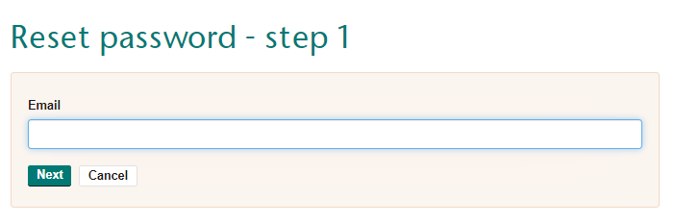

Reset Password – Step 2 - A verification code will be emailed which you need to enter. The click ‘Next’.

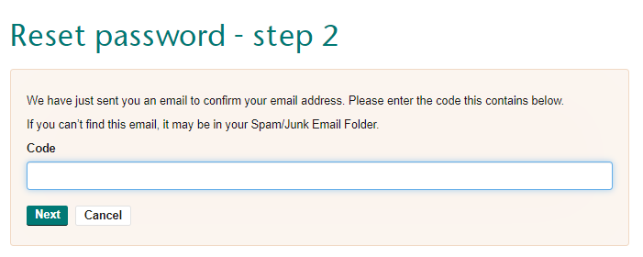

Reset Password – Step 3 – Create a new password and click ‘Finish’.

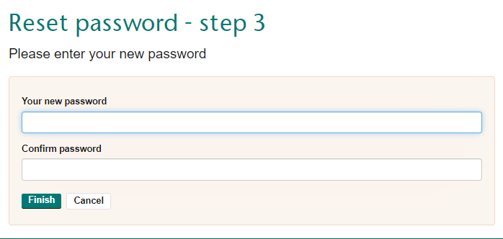

Click OK to return to the login page.

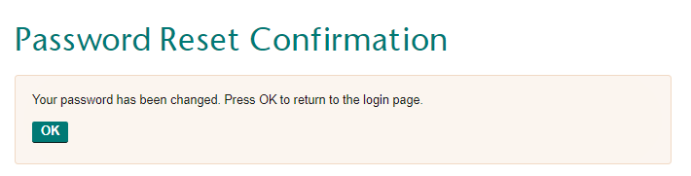

# Logging Out

To log out of the system, either close your webpage or click ‘Log Out’.

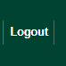

If there is no activity for longer than 60 minutes, you will automatically be logged out.

# Home Page

The home page is your landing page, from here you can navigate to all sections of the Parent Portal, including Free School Meal applications, family information service and your recent applications made. NOTE: additional services will be available in future upgrades.

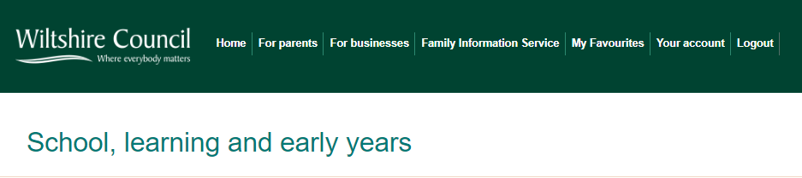

# Free School Meals Application

A Parent/Guardian can make a Free School Meal application if they receive certain benefits, making them eligible to apply.

To begin an application, select ‘Free School Meals’

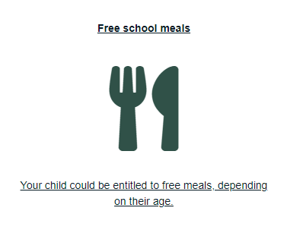

You will be taken to the Free School Meals application page: There will be additional information regarding ‘Who can apply’

**Application Form**

There are 8 small stages of the Free School Meal application form.

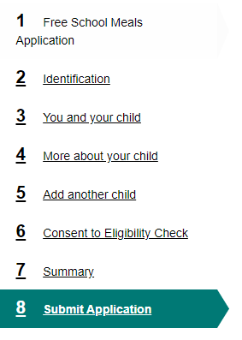

# Identification

Please complete all fields in this section. Any questions that have a **\*** marked next to them mean they are mandatory questions that need to be completed prior to progressing to the next stage of the application form. Once this section has been correctly recorded select ‘Next’

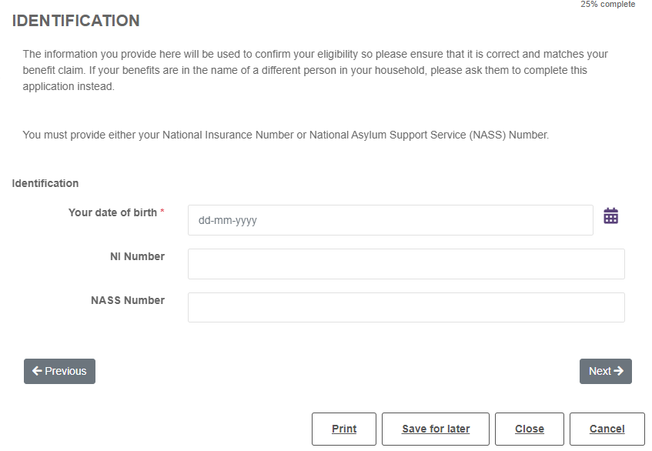

# About you and your child

Please complete all fields in this section, the Portal will pre-populate your first name, surname and email address.

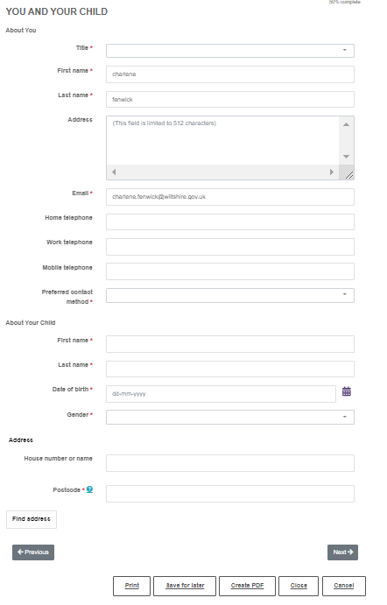

When entering your address begin by entering your postcode and select ‘Find Address’, the system holds all Wiltshire addresses. The house name and number will populate with a drop-down list of all first line addresses within the post code area, select the correct one. Alternatively, you can ‘Enter Address’ manually or ‘Search again’ if the system did not find the correct addresses the first time.

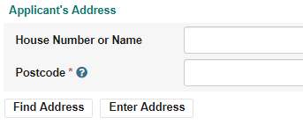

Once you have selected your address the system will confirm, allowing you to ‘reset’ or ‘search’ again.

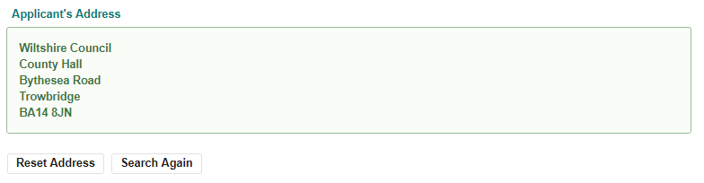

You now need to begin entering your child’s details.

Once all sections are complete select ‘Next’

# More About your child

Here the system is asking you what School your child attends, if you do not see the school in the list it may mean they administer their own Free School Meals, please contact them directly.

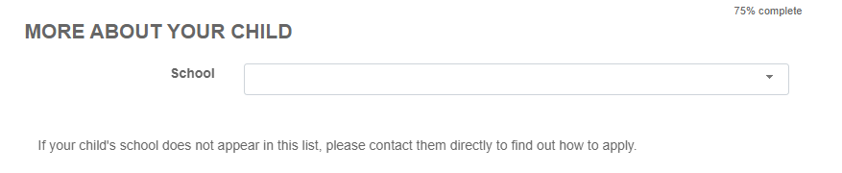

The next questions asks whether you have Parental Responsibility

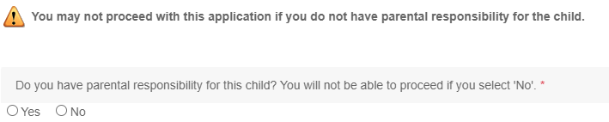

Answer the question and select **next**

# Add Another child

The system will allow you to add multiple children in the same Free School Meal Application

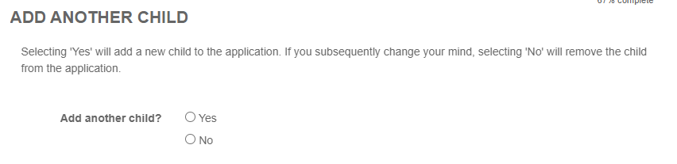

Selecting yes will allow you to add the second child’s information.

# Consent to Eligibility Check

**NOTE: if you answer ‘no’ we cannot accept your application and check your eligibility through the Eligibility Checking Service.

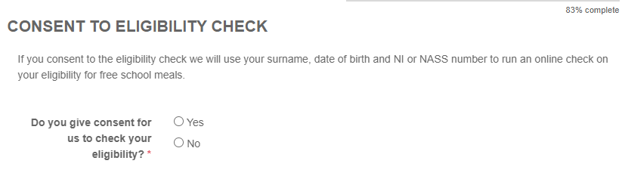

# Summary

This section will provide you with a summary of the application form, this is a read only section, if you wish to make amendments to the application form select ‘previous’



# Submit your application

Select **submit application**

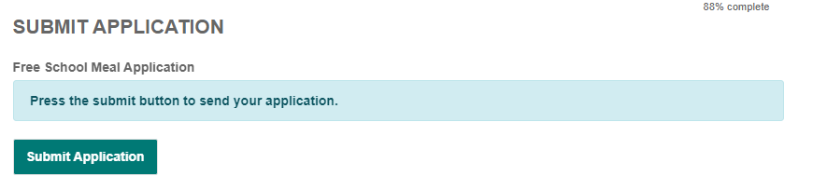

You will be taken to a screen to confirm you have entered all the information you need to as you will not be able to make any further changes once the application has been submitted. If you are happy select ‘Submit’ if further changes need to be made select ‘Cancel’ which will take you back to the application form.

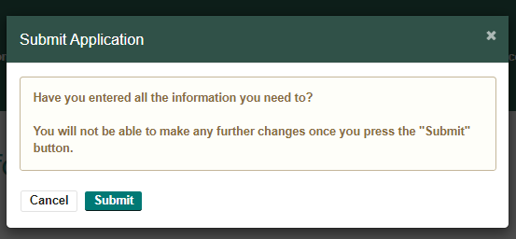

You will shortly receive a confirmation email confirming your submitted application form. The hyperlink in this email will take you to the Parent Portal. Within your submitted application.

# Your Account

You can view the progress of your application(s) by selecting ‘Your Account’ you can also view any messages that have been sent from the Free School Meals Team to your portal account, view any applications made, retrieve any saved forms and change your password.



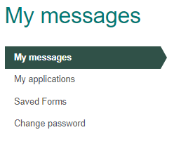

**My Messages:** Will show all your successful applications.

**My Applications:** Will show all applications made to Wiltshire Council with the date submitted, reference number, the type of application and the status. **Submitted Successfully** means the applicatyion has been received into the Wiltshire Council. **Application Successful** means you are eligible for Free School Meals; depending on the contact method you will recive a letter,email or Portal Message.

**Saved Forms:** will show any saved forms that have not been submitted, it will also show you how many days you have left to submit the application successfully. To complete any saved form, select the required application which will take you to the form to edit and submit.

# Change Password

Here you can change the password you initially created when registering for an account.

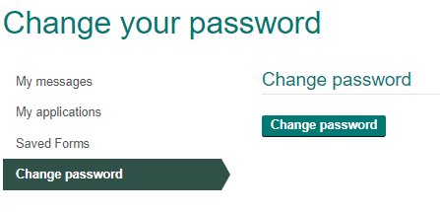

The system will ask you to enter your current password, new password and confirmation of the new password

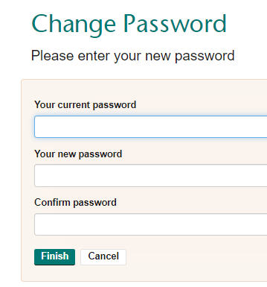

# Form Options

Within the Free School Meal application form you have options to ‘Print’, ‘Contact Us’, ‘Save for later’, PDF, ‘Close’ and ‘Cancel



**Print:** Will allow you to print the entire form.

**Contact Us:** Will take you to a contact screen where you can contact the Wiltshire Council.

***NOTE: this section needs to be developed further, please contact the council via telephone.***

**Save for later:** will save the form into your saved forms section.

**PDF:** will save the form into your saved forms section.

**Close:** will close the application without saving.

**Cancel:** will close the application without saving.