St Mary’s Catholic Primary School
Smithy Lane
A
small school with a
big heart
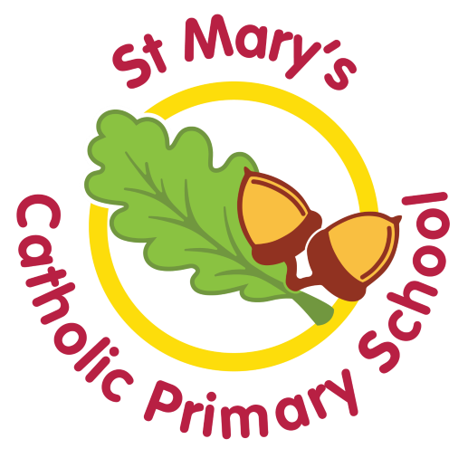
Claughton-on-Brock
Preston
PR3 0PN
***

01995 640258
head@st-marysclaughton.lancs.sch.uk
bursar@st-marysclaughton.lancs.sch.uk
www.claughtonprimary.co.uk

ADMISSION TO ST MARY’S CATHOLIC PRIMARY SCHOOL
SUPPLEMENTARY INFORMATION FORM

If you are applying for an in-year place for your child at St Mary’s Catholic Primary School on faith grounds please complete this form in addition to the in-year application form. This supplementary information form will assist the Governors of the school in deciding whether your child qualifies for a place. Failure to complete the form may affect where your child is placed within the oversubscription criteria in a situation where there are more in-year applications than places. This form should be completed by the parent/guardian and signed by a priest or a minister of religion. Please return the completed form to school, along with the in-year application.

PART A (To be completed by applicant’s parent or guardian)

A1 Name of applicant:

A2 Address of applicant:

A3 Parish/area of faith community in which you live:

A4 Name of Parish/area of faith community in which you regularly worship, fulfilling the requirement of the Church:

A5 Name(s) of any sibling(s) who will be attending St Mary’s Catholic Primary School at the applicants planned admission:

Name: Date of Birth:
Name: Date of Birth:
Name: Date of Birth:

A6 If a Roman Catholic, I confirm that the applicant is a baptised Catholic and enclose proof of baptism (Baptismal Certificate) obtained from the parish where the applicant was baptised. (Circle as appropriate)

Yes No

Please ask the parish priest of the parish where you live or where you worship to confirm this information below.

I confirm that, to the best of my knowledge, the above information is correct.

Name (please print):

Signature:

Parish:

Date:

