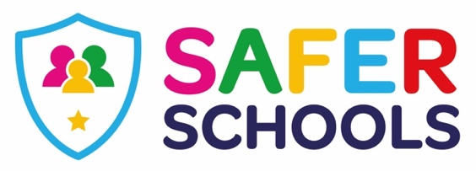

Dear parents, carers & guardians of KS2 children at St. Mary's!

We are delighted to tell you we have linked up with Zurich Insurance to bring our parents a personalised Safer Schools App. The online world can be a bit overwhelming at times but it is important we understand what our children are doing online so we can help make them safer. The Safer Schools App aims to help with this.
We are delighted to invite you to download our new Safer Schools App provided
by our school insurance provider Zurich Municipal.

About the App
The App is for school leaders, staff, parents and children. It is designed to support and protect children by educating and empowering them, schools and parents both at school and at home. Through the log-ins, you and your children get access to information that is relevant and you will receive tips and advice on how to keep them safer online.
Excited? Ready to make
your children safer?
Download the Safer
Schools App now!

Make sure to enable push
notifications to keep up-to-date
with our tips, advice and guidance
on how to make your children safer.

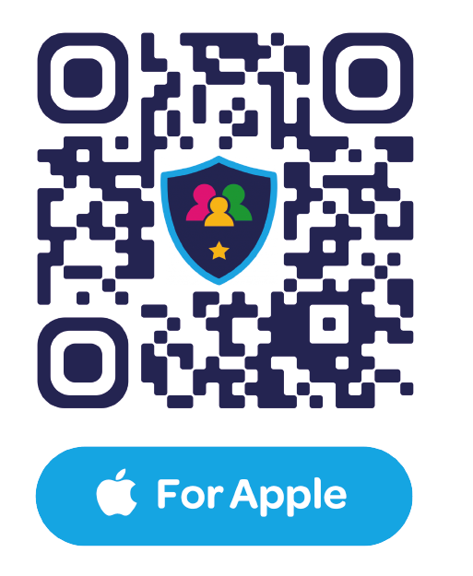
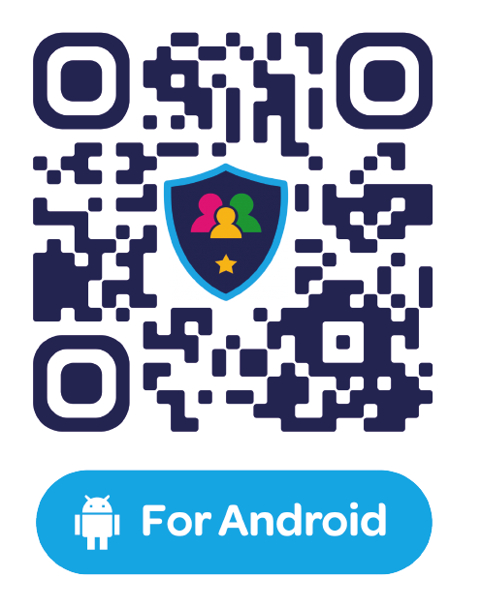

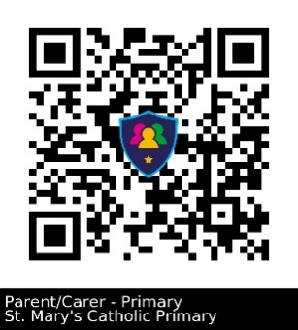
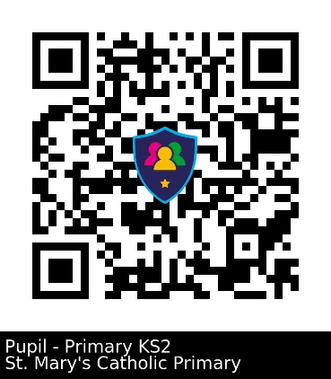

PARENT APP
St. Mary’s Catholic Primary School
Code: 7440
KS2 PUPIL APP
St. Mary’s Catholic Primary School
Code: 9342
Download the app, by using the QR Code for either Android or Apple or by searching for the safer schools app.

You access the St. Mary’s App by scanning the relevant QR code (parent or child) or search the school name and enter the relevant code (parent code or child code)
