Year 1 Long term Art Overview.
Year 1’s Art topics, in brackets are the codes from the Year 1 progression document.

Term | Autumn | Spring | Summer
Topic | Where I Live | Extinction | Memory Box
Artist | Janette Summerfield  (KU1, KU5) | Jim Gary  (KU1, KU5) | Paul Klee  (KU1, KU5)
Skills | Children to create a colour wheel of primary colours. Using different types of tools for effect.  (GE1, GE3, KU3, P1, P3,)  Use sponges, corks, for repeated patterns using paint.  (GE1, GE3, KU3, PR1, PR2, PR3) | Children to practice cutting skills, making shapes out of paper, cardboard, playdough, clay.  (GE1, GE3, KU3, 3D1, 3D2, 3D3)  Children practice manipulating pipe cleaners and playdough.  (3D1, 3D2, 3D3) | Children to practice colouring skills with different types of drawing tools. Practice drawing simple shapes I.e circles, triangles, rectangle.  Practice sketching faces using scaffolding and modelling.  Experiment with oil pastels, drawing lines, shapes and also inventing lines in order to block colour.  (GE1, GE3, KU3, D1, D3, D5)
Imitation | 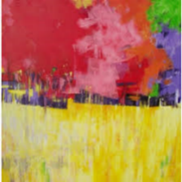  Imitating this piece of art using paint and brushes.  (P1, P3, P6)  Evaluate the piece of Art. Using questioning and sentence stems.  (GE5, KU1, KU5) | 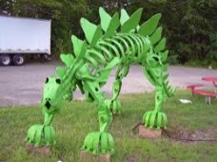  Imitating the 3D sculpture using pipe cleaners.  (3D1, 3D3, P6, D6)  Evaluate the piece of Art. Using questioning and sentence stems.  (GE5, KU1, KU5) | 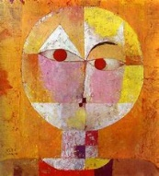  Imitating this piece of art using different drawing tools, pastels, crayons and pencils.  (D1, D3, D6)  Evaluate the piece of Art. Using questioning and sentence stems.  (GE5, KU1, KU5)
Innovation | Innovating the previous piece of art by using different tool for effect, sponges, fingers, corks. Building on their skills from previous lesson. (P6, PR1, PR2, PR3, GE5, KU3) | Innovating the material to a malleable material such as playdough.  Building on their skills from previous lesson.  (3D1, 3D2, GE5, KU3) | Innovating the material slightly and adding tissue paper or crepe paper.  Building on skill from previous lesson.  (D1, D3, D6, C1, C2, C5, KU3)
Independent Application | Create a landscape using painting and printing, based on ‘Where I live’ using photos and first-hand observations.  (D3, P3, P6, PR1, PR2, PR3, GE5) | Build your own 3D sculpture of a dinosaur or another animal. Select the malleable material you want to use. (D3, P3, P5, GE5) | To create a portrait in the style of Paul Klee of Florence Nightingale.  (D1, D3, D5, C1, C2, C5, GE5)

Year 2 Long term Art Overview.
Year 2’s Art topics, in brackets are the codes from the Year 2 progression document.

Term | Autumn | Spring | Summer
Topic | Bright Lights, Big City | The Great Fire of London | Off to the Beach!
Artist | Stephen Wiltshire  KU1, KU5 | Henri Matisse  KU1, KU5 | Kaffee Fassett  KU1, KU5
Skills | To practice line drawing, shading with different types of drawing tools. Mark making and patterns using vocabulary to describe, hatching, shading.  (GE2, GE4, KU4, D2, D4, D7)  To create a primary colour wheel using water colours. Looking at tone and shade.  (GE2, GE4, KU4, P2, P4, P5) | To practice cutting skills, cutting different types of materials trying to create shapes, simple structures. Over lapping a variety of media. Grouping them into colours and texture.  (GE2, GE4, KU4, C3, C4, C5) | To practice weaving skills using paper, sugar paper to create patterns.  Practice simple sewing skills with felt and thread.  (T1, T2, T3)
Imitation | 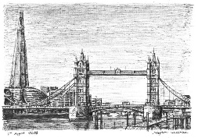  To imitate the piece of art using sketching and drawing techniques. Using pencil and markers.  (D2, D4, D7)  Evaluate the piece of Art. Using questioning and sentence stems.  (GE5, KU2, KU6) | 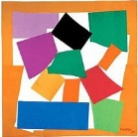  To imitate the piece of art using cutting skills. Using one media, tissue paper or sugar paper grouping for colour and shape.  (C3, C4, C5)  Evaluate the piece of Art. Using questioning and sentence stems.  GE5, KU2, KU6) | 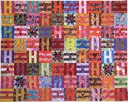  To imitate the piece of art as a collaborative class piece. Using the weaving of paper. To create a small square shape of a woven pattern.  (T1, T2, T3, C3)  Evaluate the piece of Art. Using questioning and sentence stems.  (GE5, KU2, KU6)
Innovation | Innovating the previous piece of Art by adding colour. Using water colours.  (D2, D4, D7, P4, P5, P6, GE5, KU4) | Innovating the previous piece of art by using different media and colours.  (C3, C4, C5) | Innovating the previous piece of art using felt and thread.  (T1, T2, T3, C3)
Independent Application | Create a city scape of Birmingham drawing landmarks and painting with water colours in the style of Stephen Wiltshire.  (D4, D7, P4, P5, P6, GE5) | Create a collage based on The Great Fire of London. Using a mixture of media and shapes to create a landscape picture in the style of Henri Matisse.  (D2, D4, C3, C4, C5, GE5) | Create as a collaborative class piece of a coastal habitat using fabric and thread to create sea creatures. (fish) in the style of Kaffee Fassett.  (T1, T2, T3, C3, GE5)
Year 3 Long term Art Overview.
Year 3’s Art topics, in brackets are the codes from the Year 3 progression document.

Term | Autumn | Spring | Summer
Topic | Stone Age to Iron Age | Ancient Greece | Active Planet
Artist | Banksy  (GE3, KU1) | Lucie Rie  (GE3, KU1) | George Seurat / Hokusai  (GE3, KU1)
Skills | Children to use stencils to create a repeated pattern using a variety of implements. To experiment with marks and lines Children to create a primary and secondary colour wheel.  (GE1, GE2, KU4, PR1, P3, D5, D7) | Children to create a colour wheel focusing on tint and shade. Of neutral colours. Children to draw Greek art and repeated patterns.  (GE1, GE2, KU4, PR1 D1, D5, D7) | Children to create a pointillism, colour wheel using tint and shade. Children to draw simple 3D shapes to create perspective drawing.  (GE1, GE2, KU4, P3, P5, D3)
Imitation | 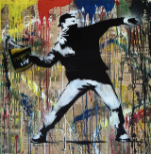  Children to imitate the piece of art using a stencil and focusing on the background and the colours used.  (D3, D5, D7, PR1, P3)  Evaluate the piece of Art. Using questioning and sentence stems.  (GE3, KU1, KU3, KU4) | 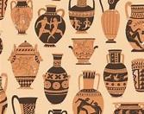  Children to imitate a paper version of a Greek Vase focusing on the repeated patterns and drawings.  (PR1, D1, D5, D7)  Evaluate the piece of Art. Using questioning and sentence stems.  (GE3, KU1, KU3, KU4) | 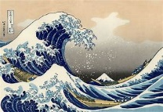  Children to imitate the piece of art using perspective drawing and painting using shade and tint. (D1, D3, P3, P5)  Evaluate the piece of Art. Using questioning and sentence stems.  (GE3, KU1, KU3, KU4)
Innovation | Children to innovate the piece of art by using oil pastels. Using smudging and blending for effect.  (D3, D5, D7, PR1, GE3, KU3) | Children to innovate the piece of art by making the vase into a 3D sculpture using Modroc in the style of Lucie Rie.  (DM1, 3D1, 3D2, GE3, KU3) | Children to innovate the piece of art by using different materials to create effect. Using tearing and layering.  (D1, D3, C1, GE3, KU3)
Independent Application | Create a modern style cave painting in the style of Banksy, using cave stencils with a modern landscape.  (D3, D5, D7, P3, PR1, KU3, GE3) | To create a modern Greek vase in the style of Lucie Rie Using the vase previously made and paint it in the style of Ancient Greece.  (PR1, D5, D7, P1, KU3, GE3) | To create the Hokusai wave in the style of George Seurat, using different materials for a textured effect.  (D1, D3, P5, C1, KU3, GE3)

Year 4 Long term Talk4Art Overview.
Year 4’s Art topics, in brackets are the codes from the Year 4 progression document.

Term | Autumn | Spring | Summer
Topic | I Am Warrior | From the Depths to the Summit | Ancient Egyptians
Artist | Alison Lambert  (GE3, KU2) | Jamie Hageman  (GE3, KU2) | Andy Warhol  (GE3, KU2)
Skills | Children to practice drawing skills. Experimenting with lines, marks on different shapes or objects. Use a range of drawing implements for effect (chalk, charcoal, pencil, rubber).  (GE1, GE2, KU2, KU5, D2, D8) | Children to create a colour wheel of primary and secondary colours.  Children to practice making 3D shapes out of clay looking at joining, modelling and extending.  (GE1, GE2, KU2, KU5, 3D3, 3D4, P4) | Children to practice screen printing, experimenting with colours/differing thicknesses of paint.  To use a range of implements to create texture and effect. (different thickness of paint and oil pastels  (GE1, GE2, KU2, KU5, PR2, PR3, PR4, D8)
Imitation | 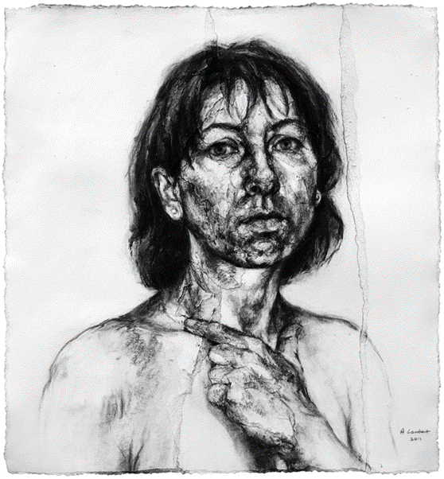  Children to imitate this piece of art. Using a range of drawing implements, charcoal, rubber, pencil.  (D2, D4, D6, D8)  Evaluate the piece of Art. Using questioning and sentence stems.  (GE3, KU2, KU5, KU6) | 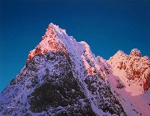  Children to imitate this piece of art. Using different effects with paint. Looking at back ground and foreground colours and lines.  (D4, P4, P6)  Evaluate the piece of Art. Using questioning and sentence stems.  (GE3, KU2, KU5, KU6) | 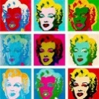  Children to substitute this piece of art with a theme drawing of a hieroglyphic word but imitate it in the style of Andy Warhol, as a class collaboration. Using paint and Styrofoam for effect. (D6, PR3, PR4, D8)  Evaluate the piece of Art. Using questioning and sentence stems.  (GE3, KU2, KU5, KU6)
Innovation | Innovating the previous piece of art using a different black background and a range of drawing implements, chalk, crayon, pencil, pastel.  (DM1, D2, D4, D6, D8, GE3, KU5) | Innovating the previous piece of art using clay to create a 3D model. Painting the model using a range of paintbrush sizes, thinking about tint and shade.  (DM1, 3D1, 3D4, P2, P4, P6, GE3, KU5) | Innovating the previous piece of art by children creating an Ancient Egyptian Relic out of Styrofoam printing block. Experimenting with colours/differing thicknesses of paint. (PR2, PR3, PR4, P2, GE3, KU5)
Independent Application | Create a portrait picture of Boudicca in the style of Alison Lambert.  (D2, D4, D6, D8 GE3, KU5) | To create a 3d mountain sculpture in the style of Jamie Hageman.  (P2, P4, P6, GE3, KU5) | To create a Pop Art image of a Hieroglyphic word, using printing techniques.  (PR2, PR3, PR4, P2, GE3, KU5)

Year 5 Long term Talk4Art Overview.
Term | Autumn | Spring | Summer
Topic | Invaders and Traders | Off with Their Heads | Hola Mexico
Artist | Norse Art/ Anglo Saxon  (GE3, KU1) | Charles Macintosh  (GE3, KU1) | Frieda Kahlo  (GE3, KU1)
Skills | Children to practice drawing Anglo Saxon symbols.  Practice cutting skills of cardboard and foam, experiment impressed method.  (GE1, GE2, KU2, D1, PR1, PR2, T2) | Children to practice simple 2D shapes using lines and marks. With a range of implements.  Practice simple cutting and sewing skills attaching fabrics to each other.  (GE1, GE2, KU2, D1, D5, T1, T2) | Children to practice painting skills using a variety of brush sizes, creating tone and shade. Practice drawing skills of flowers and then experiment with paint.  (GE1, GE2, KU2, D1, D3, D5, P1, P2, P5)
Imitation | 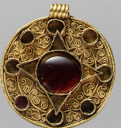  Children to imitate the piece of jewellery by drawing the Anglo-Saxon jewellery. Then transfer onto cardboard to create a stencil. Building up the foam to create a 3D effect, then use the impressed method.  (D1, PR1, PR2, P1)  Evaluate the piece of Art. Using questioning and sentence stems.  (GE5, KU1, KU2) | Children to imitate the piece of artwork focusing on drawing with layering for effect and painting use tints and shades to create texture.  (D1, D5, P1, P2, P5)  Evaluate the piece of Art. Using questioning and sentence stems.  (GE3, KU1, KU2) | 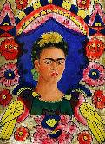  Children to imitate the piece of art using a range of drawing skills.  They will then use a range of paint choosing specifically for the outcome they want to achieve  (D3, P1, P2, P5)  Evaluate the piece of Art. Using questioning and sentence stems.  (GE3, KU1, KU2)
Innovation | To innovate the previous piece of art work by adding paint to change the effect of the impressed method and creating texture.  (DM1, D1, PR1, PR2, P1, GE3, KU1, KU3) | To innovate the previous piece of art by sewing and using different materials joining them together for effect and create texture with layering.  (DM1, D1, T1, T2, GE3, KU1, KU3) | To innovate the previous piece of art work by using oil – pastels, pen and crayons to create a different texture and pattern. Children are choosing specifically for the outcome they want to achieve  (DM1, D1, D3, D5, GE3, KU1, KU2, KU3)
Independent Application | To create an individual style of an Anglo-Saxon broach using the impressed method and paint for effect.  (DM2, D1, PR1, PR2, P1, GE3, KU3) | To create a Tudor Rose using different materials to create a textured and layered look in the style of Charles Macintosh.  (DM2, D1, T1, T2, GE3, KU3) | To create a ‘Day of the Dead’ portrait in the style of Frida Kahlo using a range of implements specific to the outcome.  (DM2, D1, D3, D5, P1, P2, P5, GE3, KU3)
Year 5’s Art topics, in brackets are the codes from the Year 5 progression document.
Year 6 Long term Talk4Art Overview.
Year 6’s Art topics, in brackets are the codes from the Year 6 progression document.

Term | Autumn | Spring | Summer
Topic | Frozen Kingdom | Revolution | A Child’s War
Artist | Julie Dumbarton  (GE3, KU1) | L.S Lowry  (GE3, KU1) | Henry Moore  (GE3, KU1)
Skills | Children to create a colour wheel thinking about tone, shade and the mood they want to achieve. Focusing on dark to light with different colours.  (GE1, GE2, KU2, D4, P1, P3) | Children to practice 3D shapes with a range of pencil grades. Drawing stick men in the style of L.S Lowry. Creating a colour wheel thinking about block colouring.  (GE1, GE2, KU2, D4, D5, P1) | Children to experiment drawing people using observation to practice. Thinking about lines and texture, creating shade and tone for effect.  (GE1, GE2, KU2, D2, D4, D5)
Imitation | 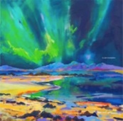  To imitate the piece of art using a range of drawing techniques. Using oil – pastels for effect and texture. Experimenting with different colour backgrounds (white and black).  (D2, D4, P3, P5, P6)  Evaluate the piece of Art. Using questioning and sentence stems.  (GE3, KU1, KU2) | 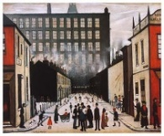  To imitate the piece of art using a range of drawing techniques concentrating on one-point perspective drawing. Experimenting with block colour painting techniques and a range of implements (pencil, marker, paint). (D2, D4, P1, P3, P5, P6)  Evaluate the piece of Art. Using questioning and sentence stems.  (GE3, KU1, KU2) | 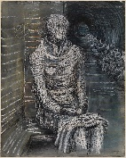  To imitate the piece of art using a range of drawing techniques focusing on body proportion. Using a range of implements to create texture using shading and toning.  (D2, D4, D5)  Evaluate the piece of Art. Using questioning and sentence stems.  (GE3, KU1, KU2)
Innovation | To innovate the previous piece of art using water colour crayons and paints, creating depth and texture using shading and tint for effect.  (DM1, D2, D5, P3, P5, P6, GE3, KU3) | To innovate the previous piece of art using, charcoal, different grades of pencil and markers to create texture and pattern. Implementing shade and tone for effect.  (DM1, D2, D4, D5, GE3, KU3) | To innovate the previous piece of art using clay to create a 3D sculpture. Experimenting with a range of paint to create effect and texture.  (DM1, 3D1, 3D2, P1, P6, GE3, KU3)
Independent Application | Create a Landscape of Northern Lights using mixed media to create a real-life painting in the style of Julie Dumbarton.  (DM2, D2, D5, P3, P5, P6, GE3, KU3) | To create a modern-day London in the style of L.S Lowry using one-point perspective drawing. Using a range of drawing and painting tools to create effect and texture.  (DM2, D2, D4, P1, P3, P6, GE3, KU3) | 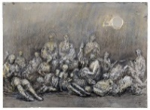  To create a collaborative 3D model art piece in the style of Henry Moore. (DM2, 3D1, 3D2, P1, P6, GE3, KU3)

