12th September 2023

Dear Parents/Carer,

**Solihull Metropolitan Borough Council – Appointment/Election of Parent Governor at CHS**

I am writing to inform you that we have a vacancy for the role of parent governor on our School Governing Body and invite parents/carers of registered pupils to put their name forward for election.

The governing body, with the headteacher, has overall responsibility for the running of the school. Governing bodies have three core strategic functions:

* Ensuring clarity of vision, ethos and strategic direction;
* Holding the headteacher to account for the educational performance of the school and its pupils; and
* Overseeing the financial performance of the school and making sure its money is well spent.

If you wish to know more please read the “Who are the Governors and what do they do for the school?” information sheet which can be found on the school website under the governor section. This should help you make your decision as to whether to become a governor or not.

**The role and expectations of a parent governor**

No special qualifications are needed - the most important thing is to have a keen interest in the school and be prepared to play an active part in the governing body’s work, ensuring the board is connected with, and is aware of the views of parents and the local community.

To be a parent governor you should have:

* A strong commitment to the role and to improving outcomes for children
* Good inter-personal skills, curiosity, and a willingness to learn and develop new skills
* The specific skills required to ensure the governing body delivers effective governance
* Legal skills would be an advantage but not essential.

Our expectations are:

* Attendance at meetings - we hold four Full Governing Body meetings per year (5.00pm–7.00pm – some virtual) and a number of Committee meetings each term.
* Maintaining confidentiality
* Committing to training
* Visiting the school.

All parents over the age of 18 are eligible to stand for election and to vote with the exception of:

1. those who are elected members of the Solihull Metropolitan Borough Council
2. those who are employed to work at the school for more than 500 hours in an academic year
3. those who are ineligible as listed overleaf.

If you would like to put your name forward, please complete and return the attached form by

**Monday 25th September 2023.**

It may be that you would wish to propose another parent to serve as a parent governor. Please note that in this case the parent in question should complete the nomination form after you have discussed this possibility.

If it is necessary for there to be an election I will provide further details of the arrangements.

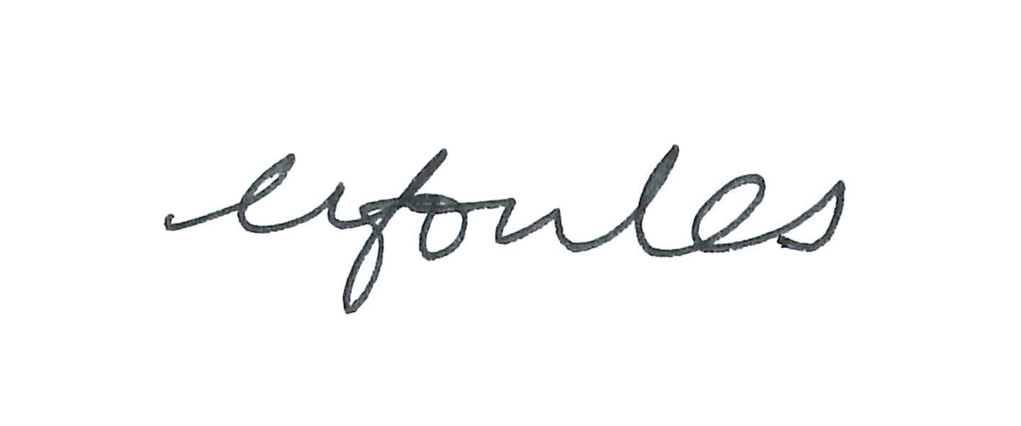Yours sincerely,

Miss N Fowles

Headteacher

**You are ineligible to serve as a school Governor if you:**

* are an un-discharged bankrupt;
* are liable to be detained under the Mental Health Act 1983;
* have in the previous 5 years (or since becoming a governor) been sentenced to 3 months or more in prison (whether this was suspended or not) without the option of a fine;
* have in the previous 20 years been sentenced to imprisonment for 2½ years or more;
* have at any time been sentenced to imprisonment for 5 years or more;
* have been fined for causing a nuisance or disturbance on school premises during the 5 years prior to, or since, appointment or election as a governor;
* are subject to a disqualification order under the Company Directors Disqualification Act 1986(a), or to an order made under Section 429(2)(b) of the Insolvency Act 1986(b);
* have been removed from a charity trusteeship by the Charity Commission or High Court on the grounds of misconduct or mismanagement;
* are included in the list of teachers or workers prohibited or restricted from working with children or young persons (currently named list 99);
* are unwilling to make an application for a Disclosure and Baring Service (DBS) check if asked by the clerk;
* have been disqualified from being an independent school proprietor, teacher or employee in any school by an Independent Schools Tribunal or the Secretary of State;
* also are the Clerk to your own Governing Body.

**PARENT GOVERNOR – APPLICATION FORM**

If you would like to put your name forward as a candidate please complete and return this form to:

Miss Fowles, Headteacher at Coleshill Heath School by **Monday 25th September 2023.**

We have a vacancy for a Parent Governor. If there is only one applicant then no election is necessary and the parent/carer will be informed within 5 school days. If we received more applications than vacancies then details of the candidates will be circulated to all eligible parents and an election by secret ballot will take place.

|  |  |  |
| --- | --- | --- |
| Name: | Address: | |
| Parent of: | | Tutor/Year Group: |
| Signed: | | Dated: |

Please include a Personal Statement to support your nomination stating what skills you can bring to the school and why you wish to become a governor. This will be shared with the Governing Board and with parents if a ballot is required.

|  |
| --- |
| **Personal Statement - max 200 words *(continue on a separate sheet if necessary)*** |

* the term of office is 4 years
* you must be over 18 and a parent of a student (part time or full time) registered at the school at the time of the election

|  |
| --- |
| I…………………………………………………………….(*name – please print*) support the above person’s application to be a parent governor.  Signed:…………………………………………………………..Dated:………………………………………… |