Expressive Arts & Design

- Singing familiar rhymes
- Sound walks
- Use thick chalks, broad pens, brooms and rollers to mark make
- Stacks, collects and lines up loose parts
- Messy play explorations and describing
Communication & Language
- Follow a one-step instruction
- Using a range of every day words
- Putting words together to make short sentences
- Singing simple nursery rhymes
- Understanding simple questions
- Developing attention on self-chosen task
- Joining in short circle-times and stories

Literacy - Writing
- Create large marks on vertical and horizontal surfaces
- Mark making on a variety of surfaces, e.g. floor, paper, screens, in messy materials

Literacy - Reading
- Looks at pictures in books
- Listens to short stories
- Joins in with rhymes and songs (Nursery Rhyme of the Week).
PSED
- Expressing self in role play
- Developing some impendence in own play
- Feeling secure
- Showing some control when turn taking
- Making own choices
- Loose parts exploration
- Comforting others, considering emotions
- Beginning to make friendships

Understanding of the World

- Noticing others in their environment
- Notices that people are all different e.g. hair and eyes
- Naming natural objects
- Textures – what things feel like?

Physical Development

- Riding a tricycle
- Climbing
- Scoop/dig/push using hands
- Using a range of movements in play (Crawls, crouches, lies down, reaches up)
- Pats, squashes, pokes, tears at playdough/malleable materials
- Pours and scoops with containers
- Block play

Mathematics

Number
- Singing number songs and rhymes
- Identifies significant numerals (1,2)
- Plays with small groups of objects (5 cars, 4 animals)
Shape, Space and Measure
- Puzzles and matching shape games
- Understanding now or later
- Filling and emptying containers

Nursery – Spring 1
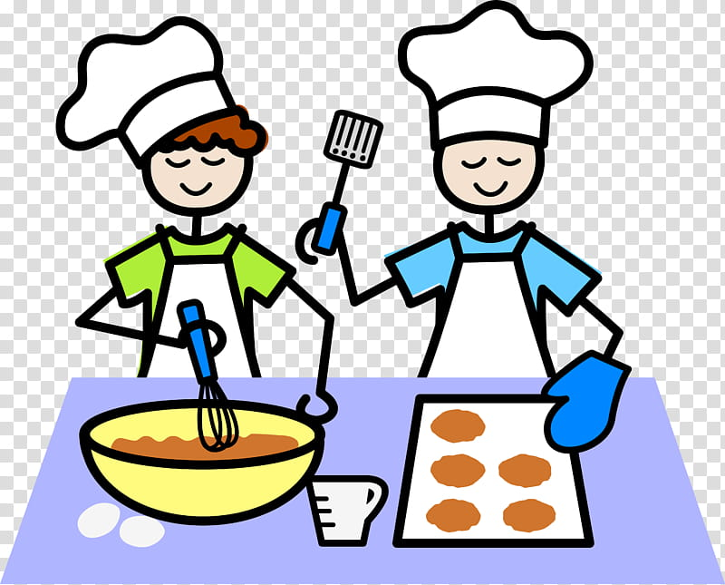

I love food

