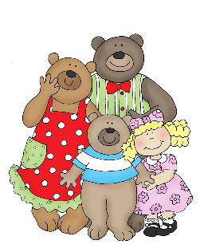

**Expressive Arts & Design**

* Mixing colours for a purpose.
* Tapping out a rhythm.
* Drawing settings and characters.
* Role-play activities in our home corner and in groups.
* Exploring feelings in drama.

**RECEPTION - Autumn 1**

**GOLDILOCKS AND THE THREE BEARS**

**Communication & Language**

* Listen to stories and join in with familiar phrases.
* Talk about what might happen next in stories we read.
* Learn new words and develop our vocabulary.
* Act out stories and role-play.

**Mathematics**

**Number Recognition**

* Recognise numerals from 1-10
* Sing number songs and rhymes.
* Find quantities of numbers and count objects correctly.
* Explores the composition of numbers up to 5 (part, part, whole model)
* Represent numbers with fingers, claps and objects.

**Understanding of the World**

* Sharing different celebrations and cultures.
* Talk about events and special times that you do with your family or friends.
* Look at the similarities and differences with your family and friends.

**Physical Development**

* Moving your body in different ways- jumping, hopping, climbing and rolling
* Using pincer grip skills through threading and pinching/twisting messy materials.
* Making large marks with brushes, chalks and sticks etc
* Practice sitting up straight and smartly on the carpet

**British Values**

* Who’s in my Family?
* To learn how family members are related to one another.
* Treating others as you would like to be treated yourself.

**Literacy**

* Talk For Writing (T4W) fiction text– we shall be learning *Goldilocks and the Three Bears* to tell as our main story. Talk for Writing non-fiction text is a recipe.
* Playing rhyming games to support VCOP (vocabulary and sentence skills).
* Noticing and discussing what happens at the start, middle and the end of stories.
* Discussing good and bad characters.
* Discuss what our favourite stories are.
* Sequencing stories.
* Begin learning the sounds of letters (RWI - phonics)

**Personal, Social, Emotional Development**

* Me being me in my world.
* My family and community.
* Rules and routines.
* Expressing emotions and feelings.
* Being kind to my friends.
* Jobs in the classroom.