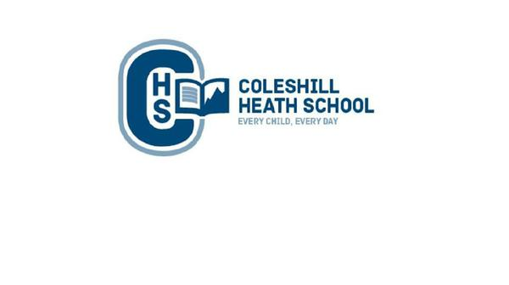

**Music**

**Autumn 1:** Call and Response – Copy and perform sound patterns

**Autumn 2:** Instruments - Listen to and describe changes in tempo and dynamics

**PE**

**Autumn 1:** Fundamentals and Sending/Receiving

**Autumn 2:** Dance and Invasion Games

**Science**

**Animals and their Needs**

We will describe the basic needs of animals, including humans and describe the importance for humans of exercise, eating the right amounts of different types of food and hygiene.

**Materials**

We will be finding out how the shapes of solid objects made from some materials can be changed by squashing, bending, twisting and stretching.

**Art**

We will be learning about the artist Steven Wiltshire and recreating pieces of his landscape Art.

**Design and Technology**

We will be making a moving vehicle This will consist of a moving mechanism.

**RE**

What is the good new Christians believe Jesus brings? (Gospel)

**Maths**

**Number:** Place Value

**Number:** Addition and Subtraction

**Measure**: Money

**Number:** Multiplication and Division

**English**

**Autumn 1**

**Fiction Text:** Kaseem and the Dragon – A warning Tale.

**Focus:** Characterisation

**Non-Fiction Focus:** Instructions

**Autumn 2**

**Fiction Text:** Arda’s Wish – A Wishing Tale  
**Focus:** Description of a setting

**Non-Fiction Focus:** Letter Writing

**History**

We will be learning about the significant people in Birmingham and London from both the past and present. We will also be learning about the Gunpowder Plot.

**Computing**

We will be learning about how to keep ourselves safe online.

**CHS Connecting Curriculum (PSHE and British Values)**

Our topic for this term is ‘Being me in my world’.

**Year 2 – AUTUMN**

**Bright lights, big city**

**Geography**

We will be learning about the significant cities within the United Kingdom. We will also be identifying the key geographical features and landmarks within Birmingham and London and how they have changed over time.