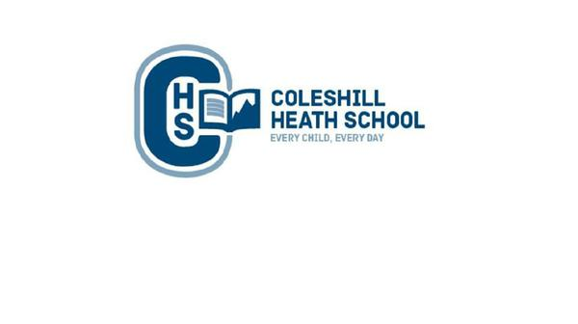

**Design and Technology**

We will be designing and baking Oat Cakes.

**PE**

**Autumn 1:** Fundamentals and Basketball

**Autumn 2:** Gymnastics and Hockey

**Art**

Research, explore and create sketches using different grades of pencil to achieve varied tones to design a cave painting to tell a story looking at the work of Banksy.

**RE**

**Autumn 1:** What is it like for someone to follow God? (People of God)

**Autumn 2:** What is the Trinity and why is it important for Christians? (Incarnation/ God)

**Music**

**Autumn 1:** Ukulele - Handling, positioning, string names.

**Autumn 2:** Ukulele - Listen, play and differentiate between major and minor chords

**Maths**

**Number: Place Value** – Understand the place value for one, two and three digit numbers.

**Addition and Subtraction** - Add and subtract numbers with up to three digits, using formal written methods of columnar addition and subtraction.

**Multiplication and Division** - Solve problems involving multiplication and division including using arrays and practical resources.

**English**

**Autumn 1**

**Fiction Text:** The Cave – A Warning Story

**Focus:** Description

**Non-Fiction Focus:** Non-chronological Report

**Autumn 2**

**Fiction Text:** Elf Road  
**Focus:** Portal Story

**Non-Fiction Focus:** Recount – Diary Entry

**Science**

**Rocks:** Children will learn about different types of rocks including: igneous, sedimentary and metamorphic. They will work in groups to sort a variety of rocks according to their properties including: grain size, mineral pattern, size, colour and hardness.

**Light:** In this topic we will be investigating light, distinguishing between sources and reflectors of light. We will be looking at how light travels and shadows are formed.

**History**

We will be investigating the changes, which took place in Britain during the Stone Age to Iron Age period.

**Computing**

**Online safety** – Understand how to stay safe online and where to get help when necessary.

**Touch-typing** – develop skills using a keyboard.

**CHS Connecting Curriculum (PSHE and British Values)**

**Being me in my world.** Children will learn about how they can affect other people’s feelings.

**Celebrating Differences-** We will be learning about other cultures: celebrating similarities and differences.

**Geography**

We will learn to describe and understand physical geography, including location and place using atlases. We will investigate how early man used land for settlements and crops. Additionally, children will learn about trade and how it has changed over time.

**Year 3 – AUTUMN**

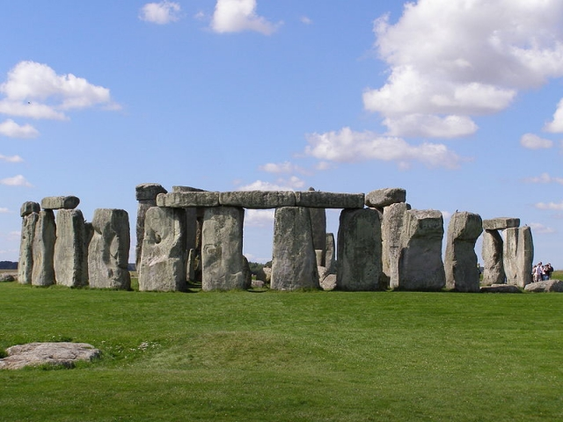

**Stone Age To Iron Age**