
RE
Spring 1: What do Hindus believe God is like?
Spring 2: Why do Christians call the day that Jesus died ‘Good Friday’?

Art
Artist: Jamie Hageman
3D modelling: Mountain sculptures made of clay

Maths

Number: Multiplication and division
We will be multiplying 2- and 3-digit numbers using formal written methods. Then we will divide 2- and 3-digit numbers with remainders. We will also be learning how to solve word problems.

Measure: Area
We will be finding area by counting squares and counting half squares.

Number: Fractions
We will be finding out about mixed and equivalent fractions. Then we will add and subtract fractions

Number: Decimals
We will be writing decimals in hundredths, tenths, fractions and sequences. We will then divide 1- and 2-digit numbers by 10 and 100

Music
Spring 1: Changes in pitch, tempo and dynamics
Spring 2: Haiku music and performance

Science
Classification
We will be learning about branching data bases, food chains, sources of food and predators and prey. We will be learning about sea pollution, plastic in the environment and the global environment.

Geography

We will learn what mountains are, their key features (such as peaks, ridges, valleys), and how tectonic activity creates different types of mountains around the world.

We will locate major mountains and ranges in the UK and globally (e.g., Ben Nevis, Andes, Himalayas) using maps, compass points, and grid references.

We will discover the characteristics of mountain biomes and compare a UK mountain region with one in South America.

We will identify the five main oceans, learn about ocean layers, and explore marine habitats like coral reefs and estuaries.

We will investigate how global warming affects mountains and oceans, including melting ice caps and rising sea levels, and discuss why these changes matter

English

Fiction Texts: The King of the Fishes – Wishing tale

Non-Fiction Texts: Information text
Discussion text
Cross-curricular writing:
Sea pollution
Effects of pollution on the environment.
Design and Technology
Inventor: Doug Tompkins
DT Strand: Textiles – Making bags

PE
Spring 1: KDDK and Relax Kids
Spring 2: KDDK and Relax Kids

Computing

Spring 1: Programming – Repetition in Shapes
Spring 2: Data Logging

Connecting Curriculum – PSHE

We will be learning about our Dreams and Goals and what we would like to become when we become an adult. Our second topic, Healthy Me is about knowledge of how to keep healthy and the different elements of this.
Year 4 Spring
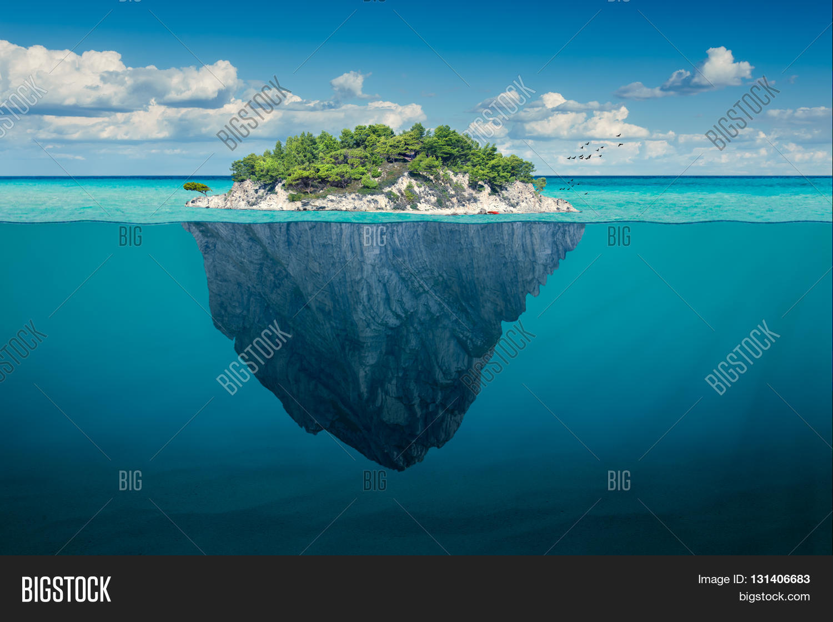
From the depths to the summit

