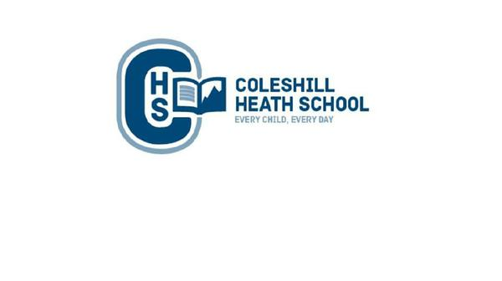

**Music**

**Autumn 1:** Composition

**Autumn 2:** Blues

**PE**

**Autumn 1:** Gymnastics and Swimming

**Autumn 2:** Dance and Swimming

**Geography**

We will be using maps to locate the origins of the Anglo Saxons and Vikings. We will be exploring land use from this time. We will compare the similarities and differences between Anglo Saxons and Viking settlements.

**RE**

**Autumn 1:** What does it mean if Christians believe God is Holy and loving? (God)

**Autumn 2:** What does it mean to be a Muslim in Britain today? (Islam)

**Design and Technology**

We will be learning about mechanisms, creating a pop up book.

**English**

**Autumn 1**

**Fiction Text:** Eadric and the Amulet – A Losing Tale

**Focus:** Description & Openings and Endings

**Non-Fiction Focus:** Recount – Diary Entry

**Autumn 2**

**Fiction Text:** Wild Dragon Cliff – Warning Tale

**Focus:** Dialogue

**Non-Fiction Focus:** Non-Chronological Report

**Maths**

**Number**: Place Value

**Number**: Addition and Subtraction

**Number**: Multiplication and Division

**Geometry**:Perimeter and Area

Roman Numerals

**Art**

We will be creating Anglo Saxon patterns and building a Viking longboat.

**History**

We will be learning about the Anglo Saxons and Vikings. We will be looking at the invasion of Britain and how they developed their livelihood here. We will also investigate the legacy left by the Anglo Saxons and Vikings, which is still evident in modern Britain.

**Computing**

We will be learning how to stay safe online and how to create databases.

**Connecting Curriculum (PSHE and British Values)**

**Connecting to Me.** We will be exploring how to make others feel welcome, how to best learn and behave at school and bullying.

**Science**

**Properties and changes of materials:** We will be comparing and grouping together materials based on their properties. We will be understanding the term ‘dissolving’ and identifying soluble and insoluble materials. We will be demonstrating that dissolving, mixing and changes of state are reversible changes.

**Living things and their habitats:** We will be describing the life process of reproduction in some plants and animals.

**Year 5 – autumn**

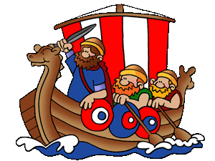

**invaders and traders**