
PE
Spring 1: Badminton/ Hockey.
Spring 2: Basketball/Fitness.

Maths
Multiplication and Division.
We will multiply a 4-digit number by a 2 digit number using formal written methods. We will then divide a 4-digit number by a 1-digit number using the short division method with remainders.
Fractions.
We will identify and write equivalent and improper fractions of a given number. Add and subtract fractions with the same denominator.
Decimals and Percentages
We will read, write and compare numbers with up to 3 digits. Round decimals to the nearest whole number and solve problems which require knowing percentage and decimal equivalents.
Geography

We will be learning about historical castles and investigating how they have been built, what they were used for, where they were mostly located and why. We will study the location of the monarchy and human geography focusing on the structure of Tudor buildings.
History

We will be learning about the Tudors. We will be looking at how events during this era have influenced life today, including religion and divorce (the Reformation). We will focus on crime and punishment during this era and how it compares to modern day. We will also be looking at the links between the Tudors and the Anglo-Saxons and Vikings.
English

Fiction Text: The Manor House – Writing suspense stories with a focus on flashbacks.

Non-Fiction Text: Journalistic Writing – The Manor House Mystery

Science

Living Things and their Habitats
We will be describing the differences in the life cycles of a mammal, an amphibian, an insect and a bird.

Animals including Humans
We will be looking at the life cycle of humans and comparing gestation periods of animals to their size.
Connecting Curriculum

Our units are Connecting to Respectful Relationships and Connecting to Global Communities. We will be looking at how to stay safe, friendships and protecting the environment.
Computing
Spring 1: Video Production
Spring 2: Programming – Selection in physical computing

Art
We will be studying Charles Mackintosh - sewing textiles to create a Tudor rose. We will be learning how to sew a running stitch.

Design and Technology
We will be developing our sewing skills further by creating a Tudor purse using a whipstitch/overcast stitch.
Music
Spring 1: South and West Africa Music.
Spring 2: Composition to represent the festival of colour.

RE
Spring 1: Why is the Torah so important to Jewish people? (Judaism)
Spring 2: Creation and science, conflicting or complimentary? (Creation/ Fall)

Year 5 – Spring
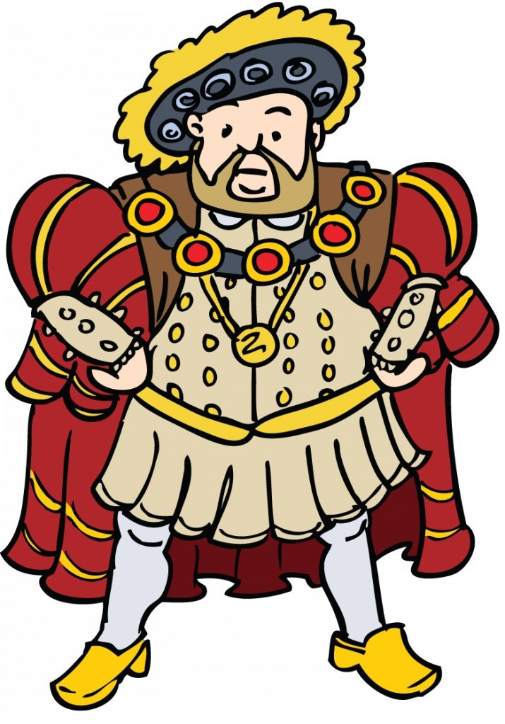
Off with her Head!

