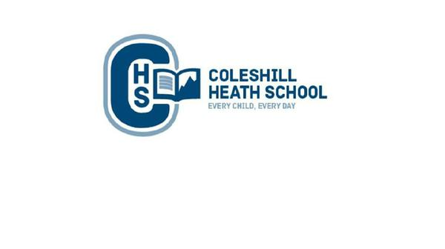

**PE**

**Autumn 1:** Badminton and Handball

**Autumn 2:** Gymnastics and Outdoor Adventurous Activities

**Maths**

* Place Value (numbers up to ten million).
* Four Operations (addition, subtraction, multiplication and division).
* Fractions
* Geometry: Position and Direction

**English**

**Autumn 1**

**Fiction Text:** Zelda Claw and the Rain Cat - A Journey Tale

**Focus:** Suspense

**Non-Fiction Focus:** Journalistic Writing

**Autumn 2**

**Fiction Text:** The Explorer – Character Flaw  
**Focus:** Character Description

**Non-Fiction Focus:** Instructions

**Geography**

We will use our map skills to identify: the worlds 7 continents, 5 oceans, The Tropic of Cancer, The Tropic of Capricorn, Equator and the Greenwich Meriden. We will identify the countries within the Arctic Circle, learn about the position of locations through Longitude and Latitude lines and the human and physical geography of the world’s polar regions – The Arctic and the Antarctic. As well as this, we will explore the impacts of tourism on the Polar Regions. Global warming and renewable and non-renewable energy.

**RE**

**Autumn 1**: Christians and how to live: what would Jesus do? (Gospel)

**Autumn 2:** Why do Christians believe that Jesus was the Messiah? (Incarnation)

**Key Question:** What is the best way for a Muslim to show commitment to God?

**Religions:** Islam

**Science**

**Living things and their habitats**

* Describe how living things are classified into broad groups according to common observable characteristics
* Give reasons for classifying plants and animals based on specific characteristics

. **Evolution:**

* Recognise that living things change over time.
* Identify how animals and plants are adapted to suit their environment.
* Understand that adaptation may lead to evolution.

**Connecting Curriculum (PSHE and British Values)**

**Connecting to Myself:** We will be exploring school rules, behaviour, racism, school values, online safety, recognising emotions and learning behaviours.

**Computing**

We will be learning about how to stay safe online and how to create games using coding.

**Art, Design and Technology**

In Art, we will be learning about the artist Julie Dumbarton and use her skills to create our own piece of the Arctic’s Northern Lights, using a variety of mediums.

In Design and Technology, we will be designing a product for a specific purpose. We will be using our sowing skills to create a protype sleeping bag designed for Arctic explorers.

**History**

We will be learning about the historic race to the South Pole between Roald Amundsen (British Polar Explorer) and Robert Scott (Norwegian Polar Explorer). We will also be using our historical enquiry skills to investigate the reliability sources.

**Music**

**Autumn 1:** Dynamics, pitch and texture

**Autumn 2:** Film

**Year 6 – AUTUMN**

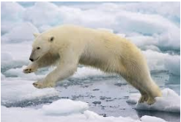

**frozen Kingdom**

**Frozen KIngdom**