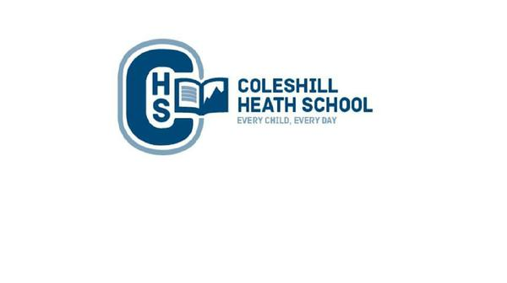
Geography

We will identify and locate the spread of the British Empire throughout Queen Victoria’s reign. We will use maps to name and locate cities which spread during the Victorian era.

We will learn about the how Britain changed during the Victorian era and how land over time changed and how economic activity and trade developed.
History

We will be using timelines to understand the chronologically of when Queen Victoria became a Monarch in England. We will use sources to understand what Queen Victoria was like as a monarch and then compare this to Henry VIII. We will then study timelines to understand the chronologically of the industrial revolution in Britain and use a range of sources to understand what the living and working conditions were like in Britain before, during and after the revolution.
PE
Spring 1: Parkour and Basketball
Spring 2: Golf and Tennis

Maths

In Maths, we will be learning about decimal numbers, how to find a percentage of an amount, converting units (such as meters to kilometres, grams to kilograms), finding the perimeter of a compound shape, finding the area of various compound shapes and exploring what a ‘ratio’ is.

Connecting Curriculum
To recognise when people are trying to gain control and power and to understand how to take responsibility for your own safety and wellbeing.
Year 6 – Spring
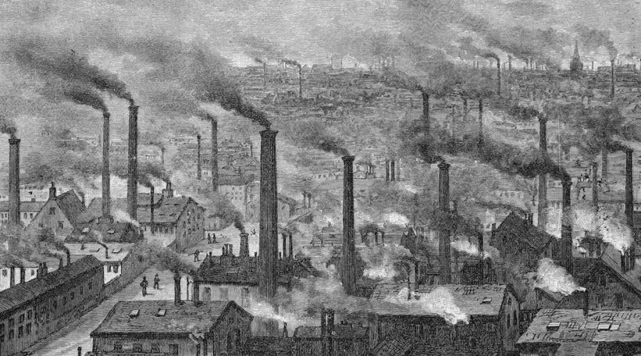
Revolution

Computing
Spring 1: Webpage creation
Spring 2: Introduction to Spreadsheets

English
Fiction Text:
Kidnapped – Tale of Fear with a Flashback/ The Caravan – A warning story.
Non-Fiction Text:
Recount of Kidnapped – Diary Entry from character’s perspective
Oliver Twist - Playscript

Art
We will be creating perspective drawings based on the Artist L.S.Lowry.

Design and Technology
We will be creating our own structures through designing a bridge. We will then test the bridge and evaluate it.

RE
Spring 1: Hinduism - Why do Hindus want to be good?
Spring 2: Christianity - What difference does the resurrection make to Christians? (What do Christians believe Jesus did to ‘save’ people?) (Salvation)

Science
Animals including Humans
We will identify and name the main parts of the human circulatory system, and describe the functions of the heart, blood vessels and blood. We will be learning to recognise the impact of diet, exercise, drugs and lifestyle on the way our body’s function and describe the ways in which nutrients and water are transported within animals, including humans.
Music
Spring 1: Themes and Variations
Identifying the sounds of different instruments and discussing what they sound like. Making reasonable suggestions for which instruments can be matched to art pieces. Name and copy rhythms accurately.

Spring 2: Baroque (glockenspiels)
Defining key features of Baroque music (recitative, anon, ground base and fugue). Complete vocal improvisation based on Baroque recitative. Compose and notate a ground bass pattern. Know and recall some well-known Baroque composers.

