**Expressive Arts & Design**

* How to attach two things together using glue or other materials
* Colour mixing
* Creating role-play objects from junk, e.g. houses, making masks
* Learning Nursery Rhymes
* Moving to music and hearing a beat

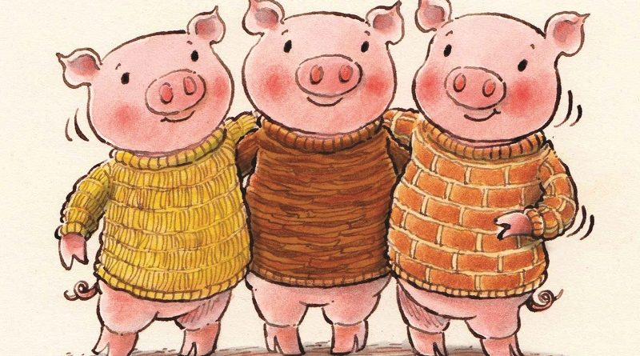

**Nursery – Autumn 1**

**My Family**

**3 Little pigs**

**Understanding of the World**

**My Family**

* Familiar adults, significant events, home
* Talking about our families
* People who help us
* Turn on and operate simple ICT equipment
* Solving problems
* Discovery RE – What Makes People Special?

**Mathematics**

**Number**

* Knowing that each objects counts as one.
* Counting up to 5 and 10
* Recognising numbers
* Combining groups to make 5
* Singing number songs

**Shape, Space and Measure**

* Putting events into order
* Filling and emptying containers
* Making pictures from shapes
* Repeating patterns

**PSHE**

* Who…Me?!
* How am I feeling today?
* Being at Nursery
* Gentle hands
* Our Rights
* Our Responsibilities
* Thinking of and talking about our families
* Talking about emotions and feelings
* Confidence to ask for help
* Offering support and comfort to others who are upset
* Making friendships and beginning to share and take turns.

**Physical Development**

* How to keep yourself safe
* Moving confidently in a range of ways
* Using tools for purpose
* Good handwashing technique
* Fine motor - threading and sewing, strengthening hand muscles

**Communication & Language**

* Listening to and retelling Nursery rhymes in the correct order.
* Understanding and using prepositions.
* Begin to understand ‘how’ and ‘why’ questions.
* Talk while pretend playing
* Listening and recall games
* Story Maps
* Story telling using Pie Corbett actions

**Literacy - Writing**

* Giving meaning to marks that they make while drawing and writing
* Drawing story maps

**Literacy - Reading**

* Identifying and continuing rhyming strings
* Enjoy and range of books
* Recall stories and anticipate key events