**Expressive Arts & Design**

* Singing familiar rhymes
* Sound walks
* Role play and small world play
* Talking about what they have drawn
* Feeling proud and celebrating their creations
* Puppet play
* Dancing and moving to music

**PSED**

* Talking about emotions sad/happy
* Forming friendships
* Understanding that actions have consequences
* Turn taking/stop and wait
* Loose part play
* Using kind hands



**Communication & Language**

Asking simple questions

Engaging in conversations

Talking about their own experiences

Following 2 step instructions

Listening to and repeat lines and phrases from the stories they have heard

**Literacy - Writing**

* Create large marks on vertical and horizontal surfaces
* Mark making on a variety of surfaces, e.g. floor, paper, screens, in messy materials
* Makes intentional marks on objects
* Drawing circles

**Literacy - Reading**

* Looks at pictures in books
* Listens to short stories
* Joins in with rhymes and songs (Nursery Rhyme of the Week).
* Sharing books with others
* Small world play linked to stories
* Page turning with an adult

**Physical Development**

* Transporting large and small items
* Pushing, throwing and kicking balls
* Climbing with control
* Mark making
* Drawing and painting on different surfaces
* Poking, prodding materials

**Mathematics**

**Number**

* Counting objects 1,2,3
* Signing number songs and rhymes
* Counting our body movements claps, jumps

**Space and Measure**

* Recognising size big/little
* Explores differences in weight heavy
* Recognises, names, and matches colours Positioning and connecting items by ordering

**Understanding of the World**

* Talking about my family
* Looking after my friends
* Textures – what things feel like?
* What can we see, hear in our environment?
* Experimenting with water

**Nursery – Summer 1**

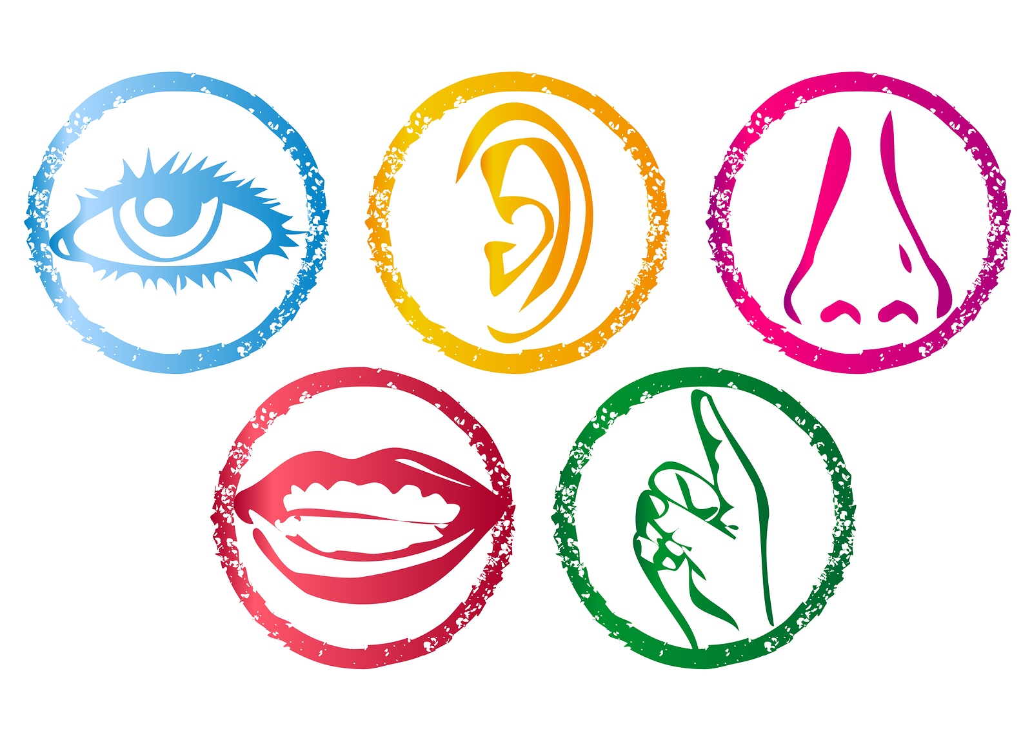

**What can i find?**