**Communication & Language**

* What do I like and dislike
* Using and/because
* Using some language from the Little red Hen story
* Uses vocabulary learned through experiences in their play
* Predicting in stories
* Listening to a talk partner, takes turns in conversations
* Knows some rhymes and short stories by heart
* Answers simple questions about stories

**Literacy - Writing**

* Writing some sounds
* Name writing
* Explains own marks and drawings Draws and creates recognisable representations of objects

**Literacy - Reading**

* Retelling stories with expression
* Innovating a story
* Rhyme and alliteration
* Describes characters, settings and events
* Continue to learn RWI – Phonics
* Talks and understands about stories they know
* Oral blending

**PSED**

* Rules and boundaries role play
* Talking about and understanding our emotions
* Giving compliments to our friends
* Making friendship groups
* Knows what keeps us healthy visit from the dentist
* Begins to explain why they enjoy certain things and why they dislike
* Getting myself ready for home time
* Playing with my friends inviting them to play
* Playing in the role play area with my friends (farm shop and dentist)
* Talks to a range of other children using the classes ‘talk guidelines’
* Taking a lead in play

**Expressive Arts & Design**

* Using purposeful colours
* Representing movement, loud noises and emotions in their drawings and paintings
* Painting on different textures
* Loose parts play, small and large block play
* Puppet making
* Making up songs and rhymes
* Looking at Wassily Kandinsky – Circle Artist
* Moves expressively in time to music



**Understanding of the World**

* Looking after living things (animals and plants)
* Describes simple life-cycles (caterpillar)
* Sorting and comparing natural items
* Insect hunts
* Forest school walks
* Planting and growing seeds and bulbs
* Fruit tasting

**Mathematics**

**Number**

* What makes up a number?
* Problem solving
* Subitise to 2
* Counting to 10 what comes next?
* Identifies numerals 1-5, and matches with amounts correctly

**Shape, Space and Measure**

* Identify 2D and 3D shape names and properties
* Comparing capacity
* Understand directional language
* Can continue a simple AB pattern and make my own

**Nursery – Summer 2**

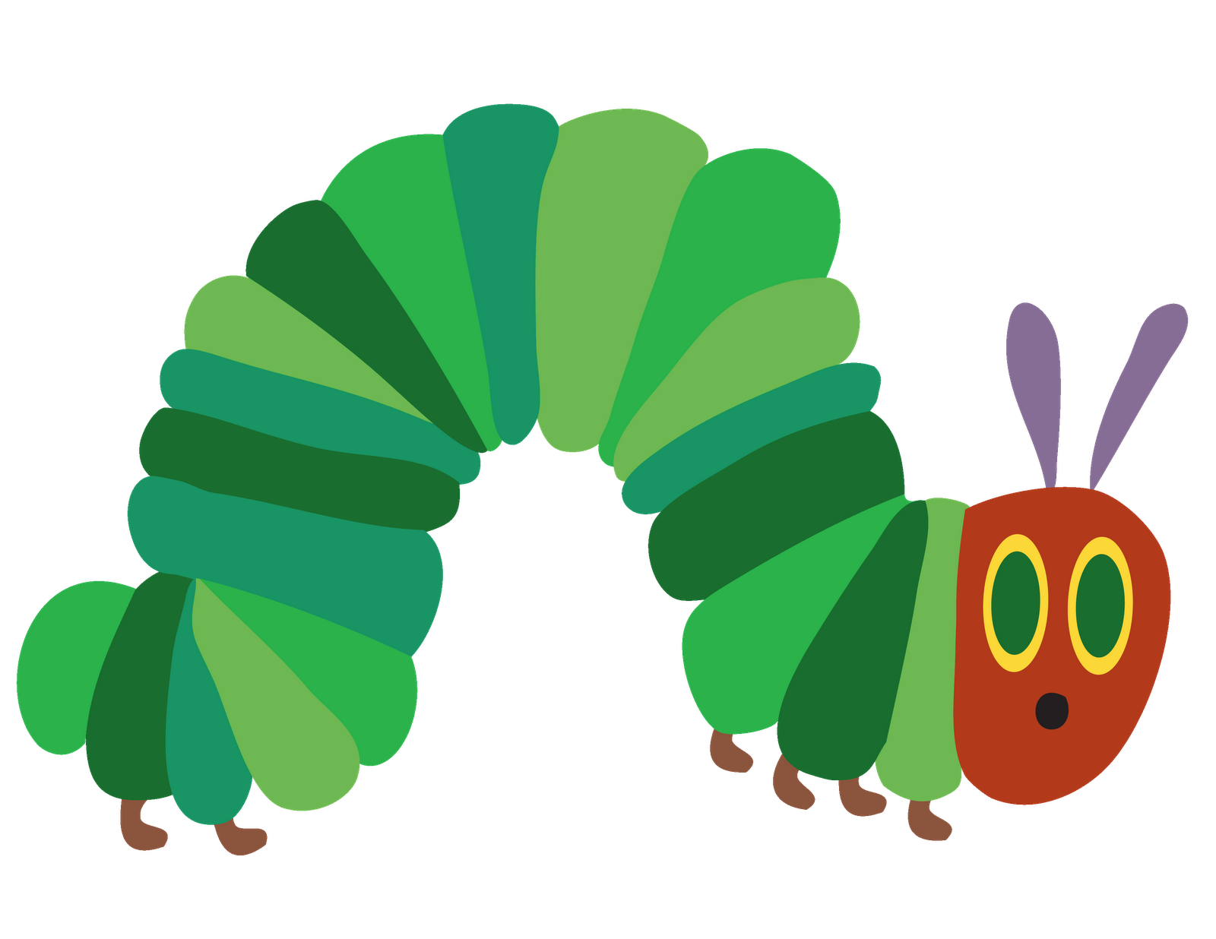

**The hungry caterpillar**

**Insects**

**Physical Development**

* Planning my creations
* Using large construction to build safely
* Balancing
* Uses large brushes to make intentional strokes on vertical and horizontal surfaces
* Moving my body in different ways
* Climbing safely
* Pencil control
* Name writing
* Cutting with scissors
* Using a knife safely to cut