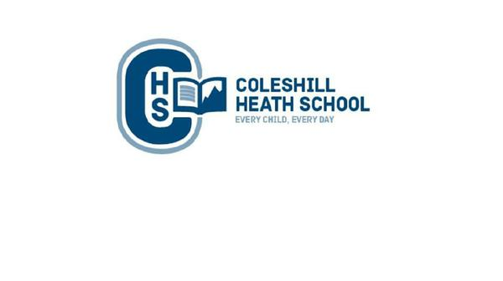

**Science**

**Plants**

Identify and name a variety of common wild and garden plants, including deciduous and evergreen trees

Identify and describe the basic structure of a variety of common flowering plants, including trees

observe the growth of bulbs and/or seeds

**Music**

Singing, creating and playing music.

Christmas Performance songs

**Maths**

Block 1: Place value (within 10)

Block 2 : Addition and subtraction (within 10)

Block 3: Shape

Block 4: Place value (within 20)

**English**

**Fiction Text:** Owl Babies – a losing tale

**Non-Fiction:** Information text about owls

**Cross-curricular writing:**

Write about their likes and dislikes about where we live in Geography.

Write about how they planted a seed in Science.

**History**

Realise change occurs over time.

How has Chelmsley Wood changed?

Ask questions about the past.

**Art, Design and Technology**

**Art** – Create a landscape in the style of Janette Summerfield

**Design and Technology –** Design and make sandwiches for a picnic

**RE**

We will learn about the Creation story

**CHS Connecting Curriculum (PSHE and British Values)**

**Connecting to myself** - Children will learn about the importance of self-respect and how to show respect to other people.

**Connecting to my communities** – Children will know the importance of family and how we can celebrate everyone’s differences.

**Computing**

**Online safety** – Learn how to use technology safely and when to ask for help if necessary

**Pictograms** – Learn how to represent information using pictures in a graph.

**Geography**

Use simple fieldwork and observational skills to study the geography of where we live.

Look at key human and physical features.

Ask geographical questions (e.g. what is it like to live in this place?)

Express their own views about people, places and environment (E.g. litter in the school)

**Year 1 – AUTUMN**

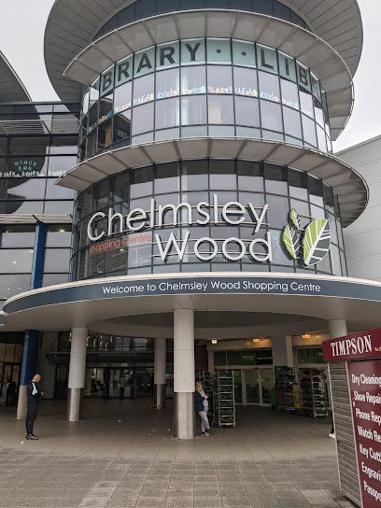

**Where i live**