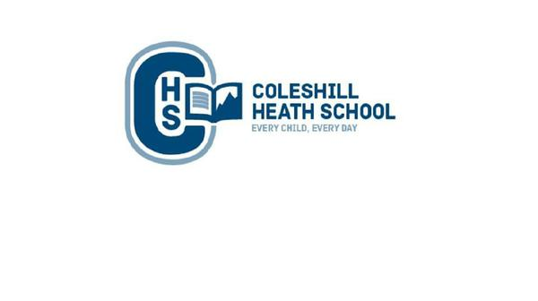

**Year 2 – AUTUMN**

**Bright lights, big city**

**Music**

We will learning about how to use different instruments.

**RE**

Christianity - What did Jesus Teach?

**CHS Connecting Curriculum (PSHE and British Values)**

Our topic for this term is ‘Being me in my world’.

**Computing**

We will be learning about how to keep ourselves safe online.

**Art, Design and Technology**

We will be learning about the artist Steven Wiltshire and recreating pieces of his landscape Art.

**Science**

**Animals and their Needs**

* We will be learning about animals, including humans, and their offspring.
* We will also describe the basic needs of animals, including humans and describe the importance for humans of exercise, eating the right amounts of different types of food and hygiene.

**Geography**

We will be learning about the significant cities within the United Kingdom. We will also be identifying the key geographical features and landmarks within Birmingham and London and how they have changed over time.

**English**

**Fiction Text:** *Kaseem and the dragon- Warning story*

**Non-Fiction Text:**  A n*on-chronological report about a dragon.*

**History**

We will be learning about the significant people in Birmingham and London from both the past and present. We will also be learning about the Gunpowder Plot.

**Maths**

**Place Value:** We will be learning to recognise the place value of each digit in a two-digit number. We will be using place value and number facts to solve problems.

**Addition and Subtraction:** We will be learning addition and subtraction bonds to 20. We will also be using concrete and pictorial materials to solve addition and subtraction number and word problems.