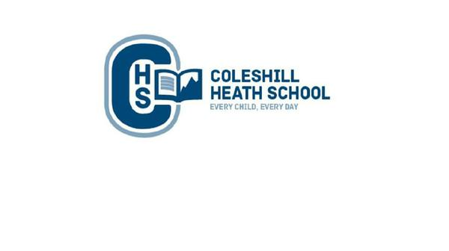

**English**

**Fiction Text:**

The Hare and the Tortoise - Character Flaw (Fable)  
 **Non-Fiction Text:**Lion’s diary entry *(linked to the Lion and the Mouse fable)* – Recount

**Cross-curricular writing:**

Write a report about the Bronze Age in History

Recount of underground journey in Science

**Maths**

**Number: Place Value** – Understand the place value for one, two and three digit numbers.

**Addition and Subtraction** - Add and subtract numbers with up to three digits, using formal written methods of columnar addition and subtraction.

**Multiplication and Division** - Solve problems involving multiplication and division including using arrays and practical resources.

**Science**

**Rocks:** Children will learn about different types of rocks including: igneous, sedimentary and metamorphic. They will work in groups to sort a variety of rocks according to their properties including: grain size, mineral pattern, size, colour and hardness.

**Light:** In this topic we will be investigating light, distinguishing between sources and reflectors of light. We will be looking at how light travels and shadows are formed.

**Music**

**Christmas Carols**

We will learn how to use different instruments to accompany traditional carols.

**RE**

Hinduism - Understand why Diwali and Christmas are celebrated.

**Art, Design and Technology**

Research, explore and create sketches using different grades of pencil to achieve varied tones to design a cave painting to tell a story.

**Computing**

**Online safety** – Understand how to stay safe online and where to get help when necessary.

**Touch-typing** – develop skills using a keyboard.

**CHS Connecting Curriculum (PSHE and British Values)**

**Being me in my world.** Children will learn about how they can affect other people’s feelings.

**Celebrating Differences-** We will be learning about other cultures: celebrating similarities and differences.

**Geography**

We will learn to describe and understand physical geography, including location and place using atlases. We will investigate how early man used land for settlements and crops. Additionally, children will learn about trade and how it has changed over time.

**History**

We will be investigating the changes, which took place in Britain during the Stone Age to Iron Age period.

**Year 3 – AUTUMN**

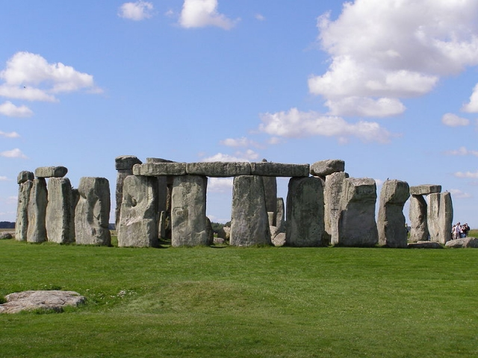

**Stone Age To Iron Age**