

**English**

**Fiction Text:** Wild Dragon Cliff (A warning story)

We will be using speech to move action forward and creating suspense through a setting description.

**Non-Fiction Text:** Komodo Dragons (Information Text)

**Cross-curricular writing:**

* Beowulf’s tale (a Viking letter)
* Comparative writing (Anglo Saxons vs Vikings)

**Music**

We will be learning how to play musical instruments and creating our own music to play.

**RE**

We will be looking at how Sikhs show commitment to their religion and what the Christmas story means to Christians.

**Art, Design and Technology**

We will be creating Anglo Saxon patterns and building a Viking longboat.

**Computing**

We will be learning how to stay safe online and how to create databases.

**Connecting Curriculum (PSHE and British Values)**

**Connecting to Me.** We will be exploring how to make others feel welcome, how to best learn and behave at school and bullying.

**Science**

**Properties and changes of materials**

We will be comparing and grouping together materials based on their properties. We will be understanding the term ‘dissolving’ and identifying soluble and insoluble materials. We will be demonstrating that dissolving, mixing and changes of state are reversible changes. We will use our knowledge of solids, liquids and gases to decide how mixtures might be separated, including through filtering, sieving and evaporating.

**Geography**

We will be using maps to locate the origins of the Anglo Saxons and Vikings. We will be exploring land use from this time. We will compare the similarities and differences between Anglo Saxons and Viking settlements.

**History**

We will be learning about the Anglo Saxons and Vikings. We will be looking at the invasion of Britain and how they developed their livelihood here. We will also investigate the legacy left by the Anglo Saxons and Vikings, which is still evident in modern Britain.

**Maths**

In the Autumn term, we will cover a number of units. Children will be exploring numbers up to 1 000 000.

* **Number**: Place Value
* **Number**: Addition and Subtraction
* **Number**: Multiplication and Division
* **Geometry**:Perimeter and Area
* Roman Numerals

**Year 5 – autumn**

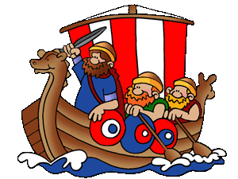

**invaders and traders**