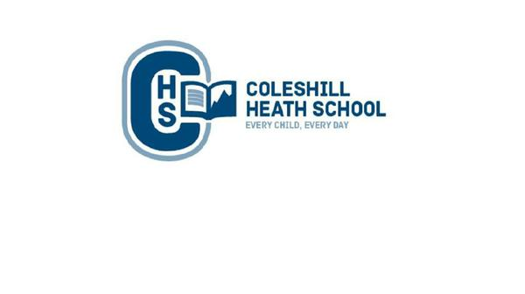

**Science**

**Living things and their habitats**

* Describe how living things are classified into broad groups according to common observable characteristics
* Give reasons for classifying plants and animals based on specific characteristics

. **Evolution:**

* Recognise that living things change over time.
* Identify how animals and plants are adapted to suit their environment.
* Understand that adaptation may lead to evolution.

**Maths**

During the Autumn Term, we will be learning a variety of units which include:

* Place Value (numbers up to ten million).
* Four Operations (addition, subtraction, multiplication and division).
* Fractions
* Geometry: Position and Direction

**Connecting Curriculum (PSHE and British Values)**

**Connecting to Myself:** We will be exploring school rules, behaviour, racism, school values, online safety, recognising emotions and learning behaviours.

**Computing**

We will be learning about how to stay safe online and how to create games using coding.

**Art, Design and Technology**

In Art, we will be learning about the artist Julie Dumbarton and use her skills to create our own piece of the Arctic’s Northern Lights, using a variety of mediums.

In Design and Technology, we will be designing a product for a specific purpose. We will be using our sowing skills to create a protype sleeping bag designed for Arctic explorers.

**History**

We will be learning about the historic race to the South Pole between Roald Amundsen (British Polar Explorer) and Robert Scott (Norwegian Polar Explorer). We will also be using our historical enquiry skills to investigate the reliability sources.

**English**

**Fiction Text:** Zelda Claw and the Rain Cat.

**Focus:** Building suspense through setting description.

**Non-Fiction Text:** Why should tourists avoid the Arctic?

Focus: Persuasion through a Magazine Article.

**Holiday/Winter Poetry:** T’was the Night Before Christmas.

**Cross-curricular writing:**

* Diary entry of explorer Robert Scott in the Arctic.
* Debate/Discussion about the impact of Tourism on the Polar Regions.

**Music**

We will be learning how to sign the song ‘Happy’ by Pharrell Williams as well as using instruments.

**RE**

We will be looking at the following key questions: What are the best ways Muslims show commitment to God? What is the significance of Mary being Jesus’ mother?

**Key Question:** What is the best way for a Muslim to show commitment to God?

**Religions:** Islam

**Geography**

We will use our map skills to identify: the worlds 7 continents, 5 oceans, The Tropic of Cancer, The Tropic of Capricorn, Equator and the Greenwich Meriden. We will identify the countries within the Arctic Circle, learn about the position of locations through Longitude and Latitude lines and the human and physical geography of the world’s polar regions – The Arctic and the Antarctic. As well as this, we will explore the impacts of tourism on the Polar Regions. Global warming and renewable and non-renewable energy.

**Year 6 – AUTUMN**

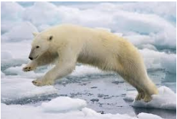

**frozen Kingdom**

**Frozen KIngdom**