**Physical Development**

* We will be experimenting with different ways to move a ball in a game using their hands and feet.
* We will have a really good pencil grip and be able to form all letters correctly with consistent letter size.
* We will be really independent in looking after our own needs. We will try hard at fastening our own buttons and tying our shoelaces.
* We will talk confidently about different ways to keep healthy.

**Expressive Arts & Design**

* We will be looking at the art by Eric Carle to inspire some of our own artwork and techniques.
* We will be making models using clay, as we develop our moulding and sculpting skills.
* We will have lots of opportunities to choose from a range of materials and think of ways how materials can be combined and changed.
* Our role play opportunities will continue as we encourage children to act out roles and play in a storyline.

**Communication & Language**

* We will have attentive and sustained attention during activities and stories and answer questions about why things happened.

**Literacy**

**Writing**

* We will write simple sentences all by ourselves using our phonic skills.
* We will use ‘Fred fingers’, finger spaces and take care over the size and formation of the letters we write.
* We will try hard to write ‘green’ words and ‘red’ words.

**Reading**

* Learn our new T4W story – The Very Busy Spider – A journey story.
* We will work hard to read our multi – syllabic words e.g. picnic, our high frequency words, and our tricky red words
* We will use our decoding skills to attempt to read new words.



**Mathematics**

**Number**

* We will learn to count reliably with numbers from one to 20 and recognise and write them.
* We will continue addition and subtraction.
* We will learn doubles of numbers up to 10.
* We will learn number bonds to 10.

**Shape, Space and Measure**

* We will compare quantities and objects and solve problems.
* We will use everyday language related to money in play situations

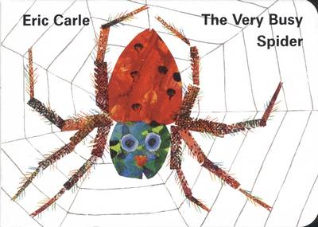

**Understanding of the World**

* We will be continuing to learn about how different people have places of worship that are special to them, and that different people have different celebrations. For example: Eid.
* We will learn about significant adults in the family and community.
* We will learn how to care for our animals, plants and environment by showing respect; and naming parts of plants and animals.

**Oracy**

* We will be working really hard on speaking in full sentences, and longer sentences.
* We will practice asking and answering **what, when, where, how** and **why** questions.
* We will learn to use gestures when talking and communicating.
* We will continue to retell stories and experiences and learn to put more expression in our T4W stories.

**PSED**

* We will continue to support the children in becoming resilient learners, taking feedback on board and thinking about how we can solve problems.
* We will resolve conflict with others using words, explaining their feelings, finding ways to compromise
* We will be confident when talking about activities and how they might adapt and change them.
* We will talk positively about our own abilities.

**rECEPTION –**

**The VERY BUSY SPIDER**