

**Computing**

**Spring 1 - Maze Explorers**

To be able to use the direction keys to complete the challenges successfully

To understand how to create and debug a set of instructions

**Spring 2 - Coding**

To give and follow instructions

To create programs

To debug programs that do not work.

**RE**

Jesus as a friend

What do we mean by God and Love? Learning about the story of Zacchaeus

**Art & Design and Technology**

**Art** – Jim Gary. Creating 3D dinosaur sculptures.

**D&T** – Make moving pictures using mechanisms

**Geography**

Use pictures and sources of information to understand what the world was like before humans lived.

**Connecting Curriculum**

**Spring 1 – Connecting to Respectful Relationships**

Learn about positive relationships and how to manage relationships online and in the real world.

**Spring 2 – Connecting to Global Communities**

Learn about our contributions to wider communities, think about our shared responsibilities and how to protect our planet

**Music**

Create music using instruments. Use pictures to notate music.

**English**

**Fiction Text:** The Little Green Dinosaur. A journey tale

**Non-Fiction Text:** Why did dinosaurs become extinct Account of a famous event

**Playscripts:** Jack and the Beanstalk

**Maths**

Geometry

Place Value within 20

Addition and Subtraction within 20

Place Value within 50

Length and Height

Measurement – Weight and Volume

Multiplication and Division

**Science**

**Animals including humans**

Identify and name a variety of common animals.

Identify and name animals that are herbivores, carnivores and omnivores.

Identify, name and label the basic parts of the human body.

**Year 1 Spring**

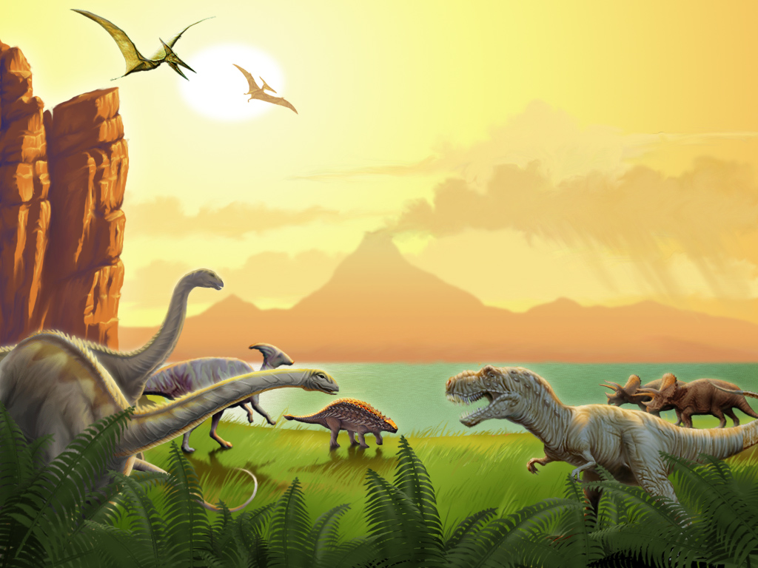

**Extinction!**

**TOPIC TITLE**

**History**

Understand that dinosaurs lived in the past, before people lived.

Learn about Mary Anning, who was a significant individual in contributing to the finding of fossils here in the UK.